India-Centre of Diversity of Horticultural Crops
Fruits
Primary centre
- Mango
https://www.gbif.org/species/3190638
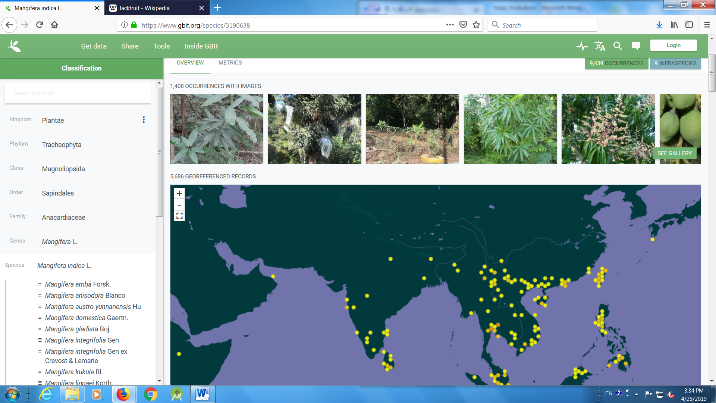
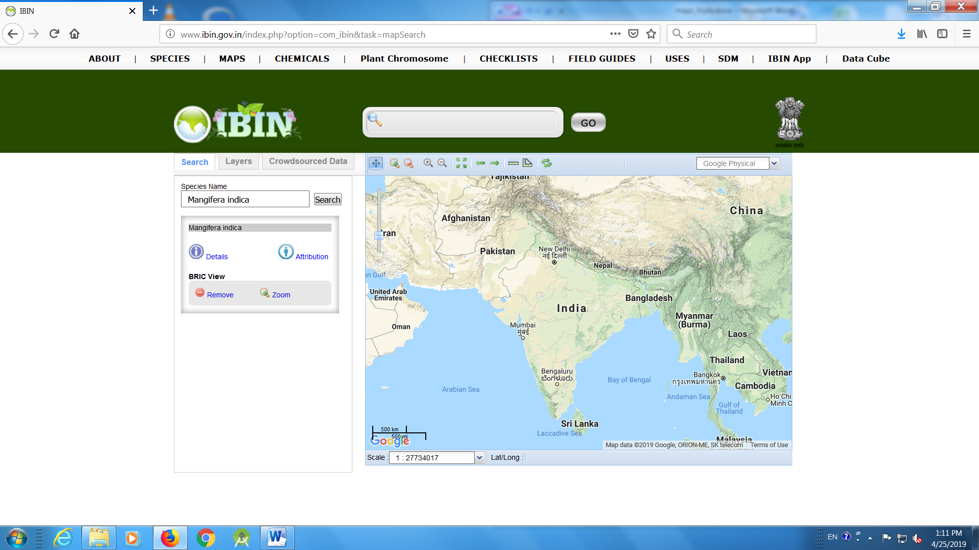
- Citrus
https://www.gbif.org/species/3190155

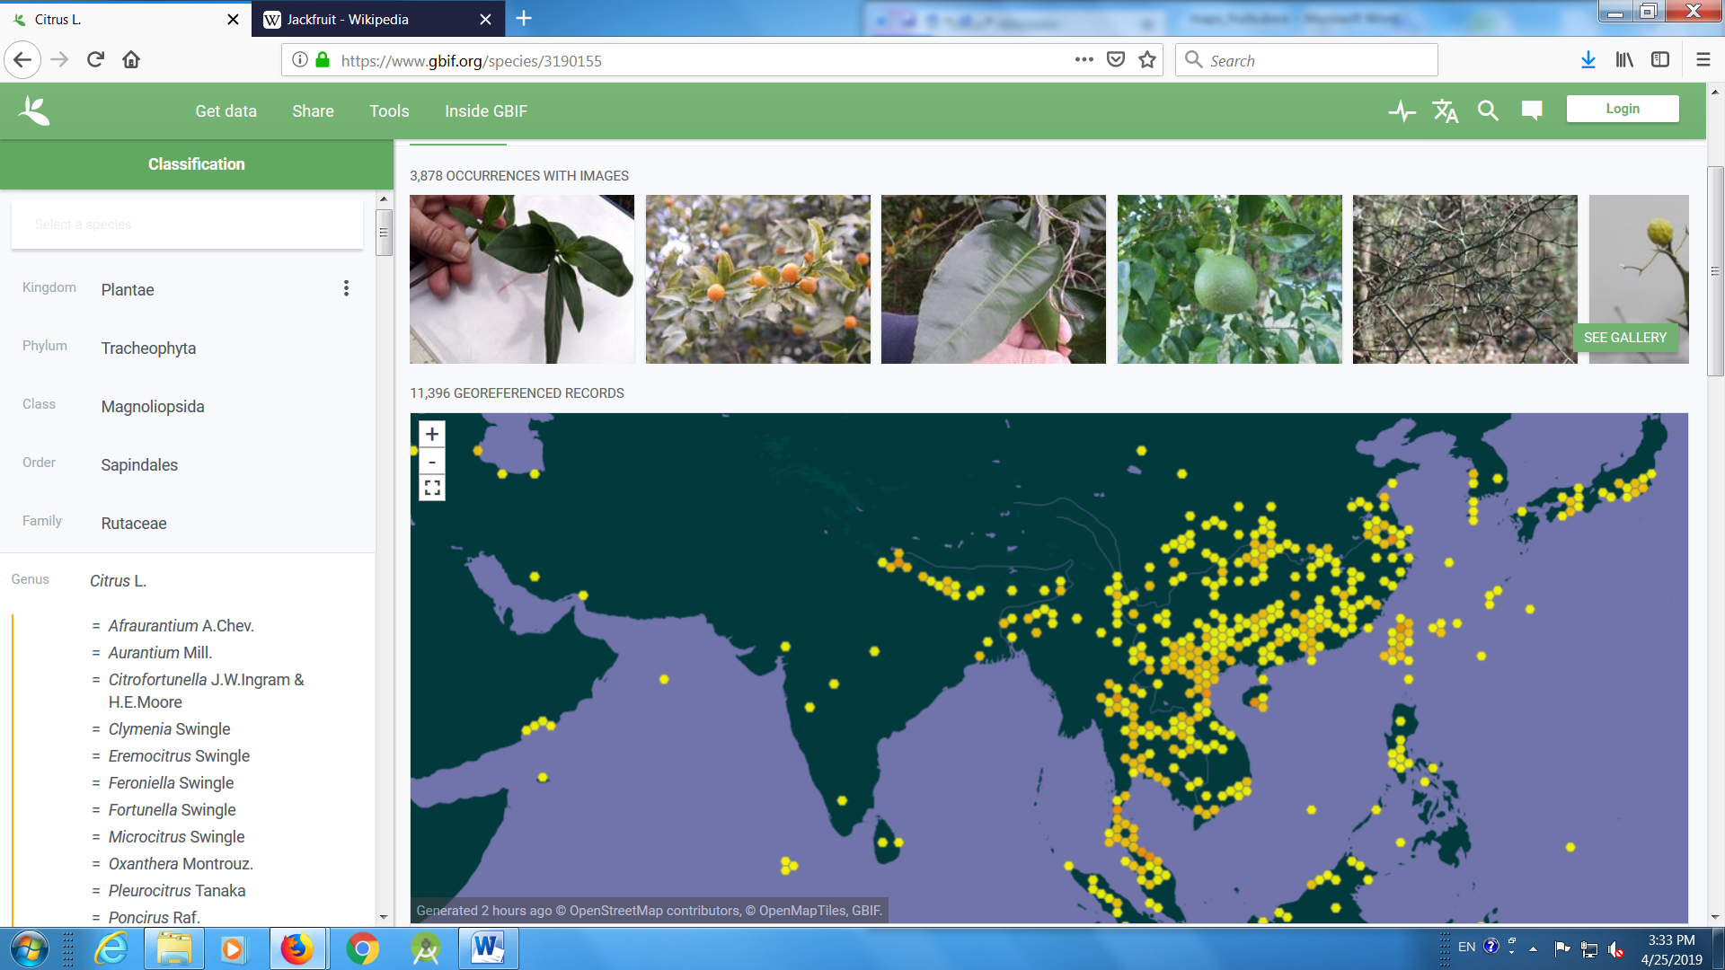
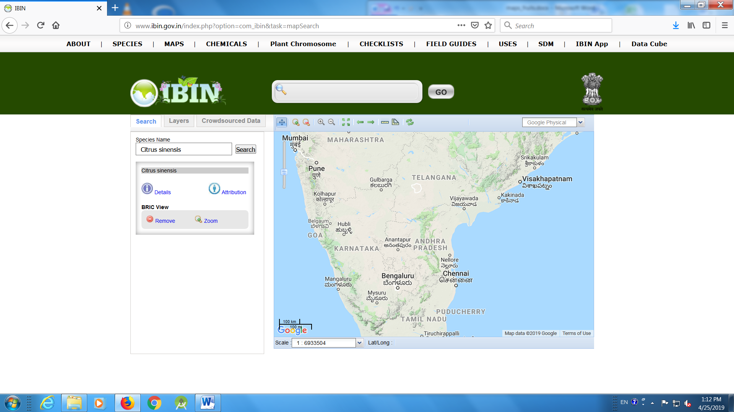

- Jack fruit
https://www.gbif.org/species/2984565

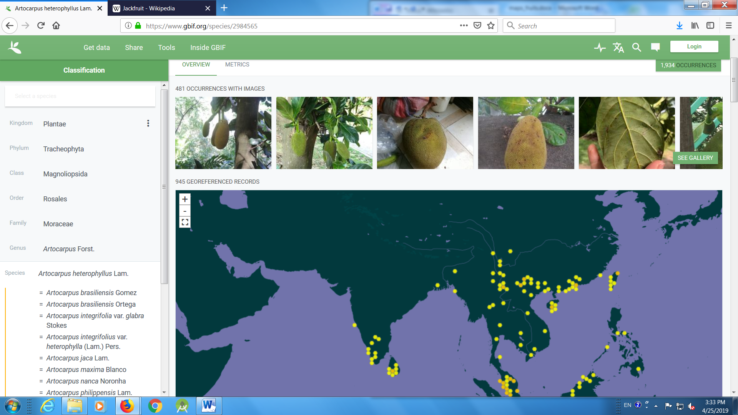
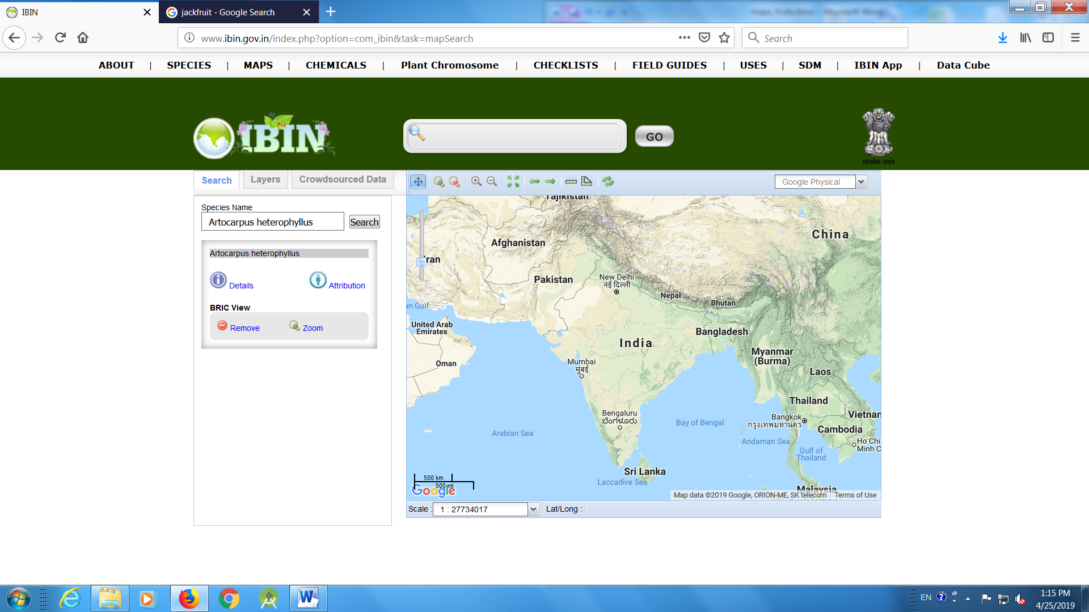

- Bael
https://www.gbif.org/species/5421195

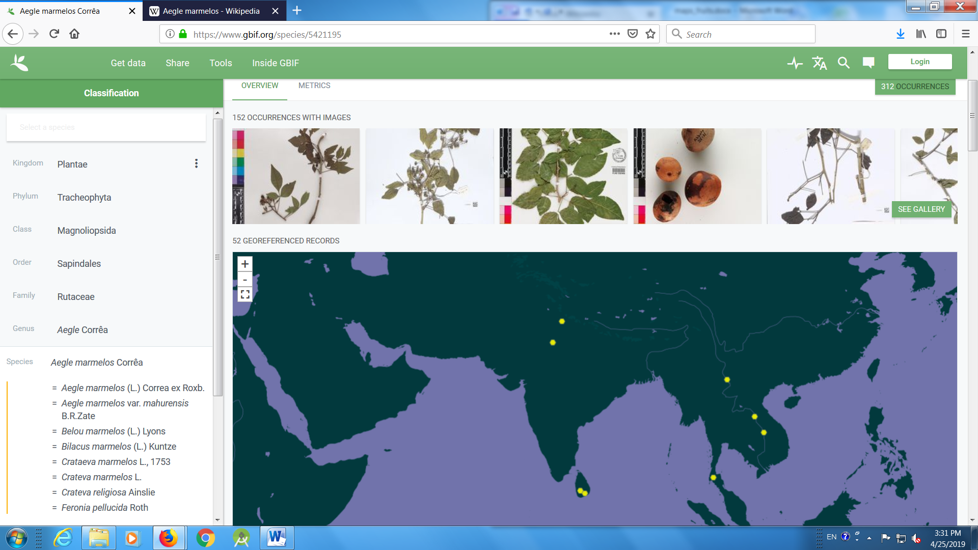
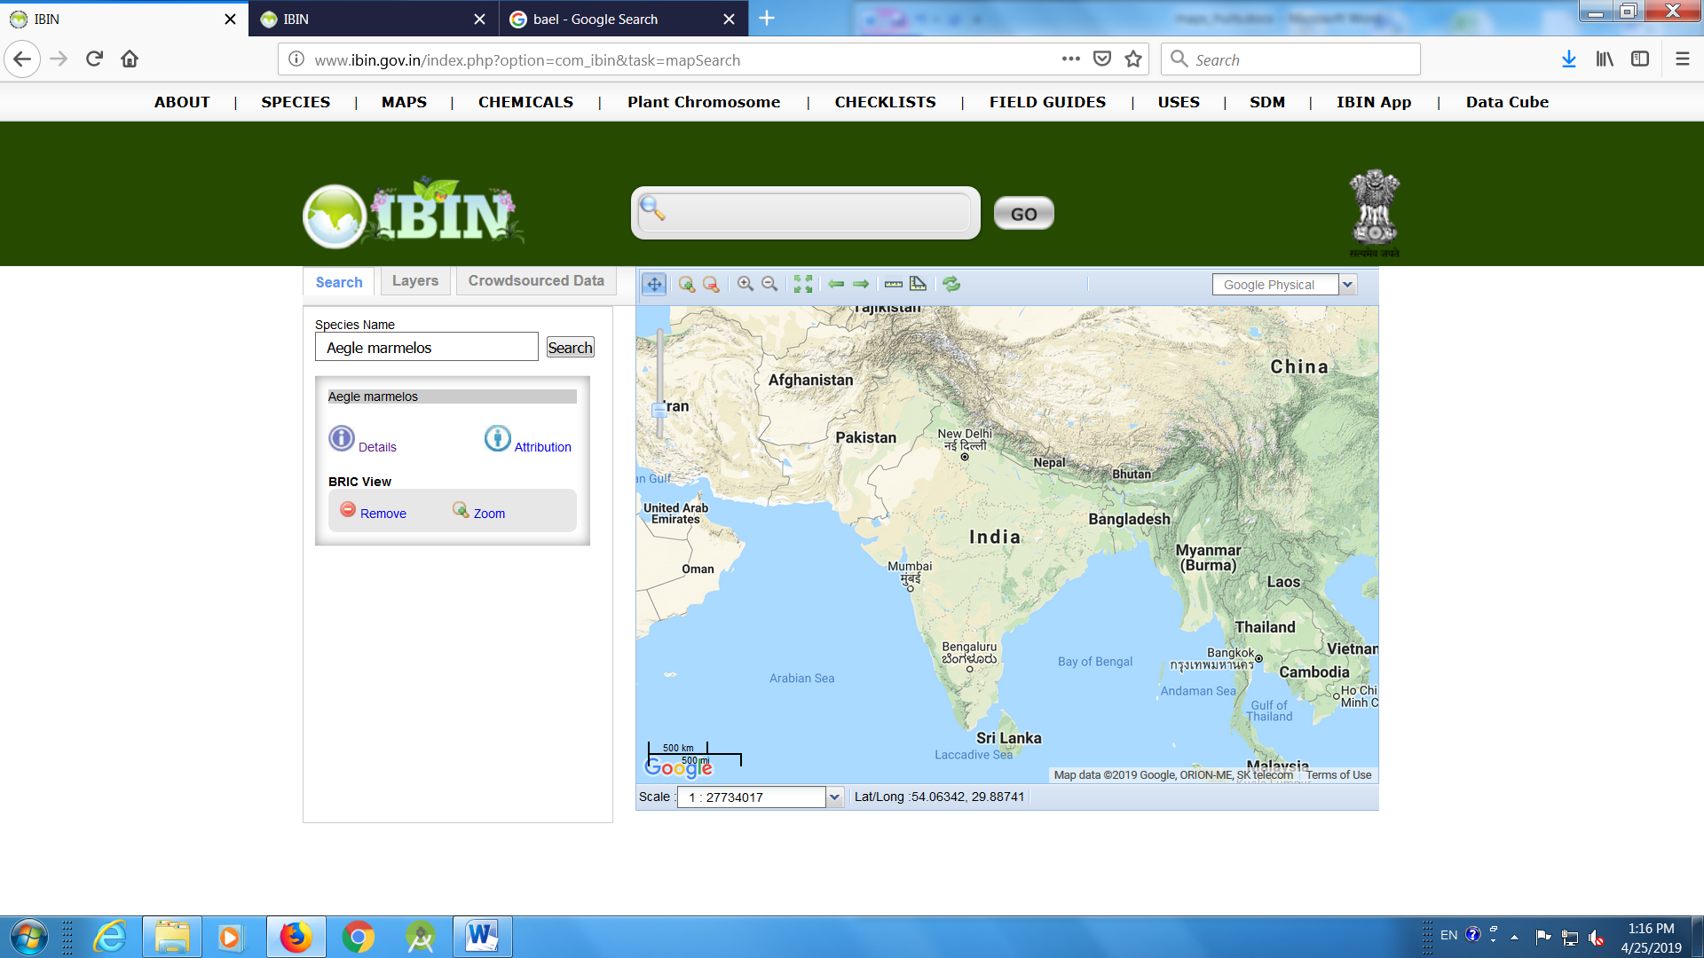

- Aonla
https://www.gbif.org/species/5381660
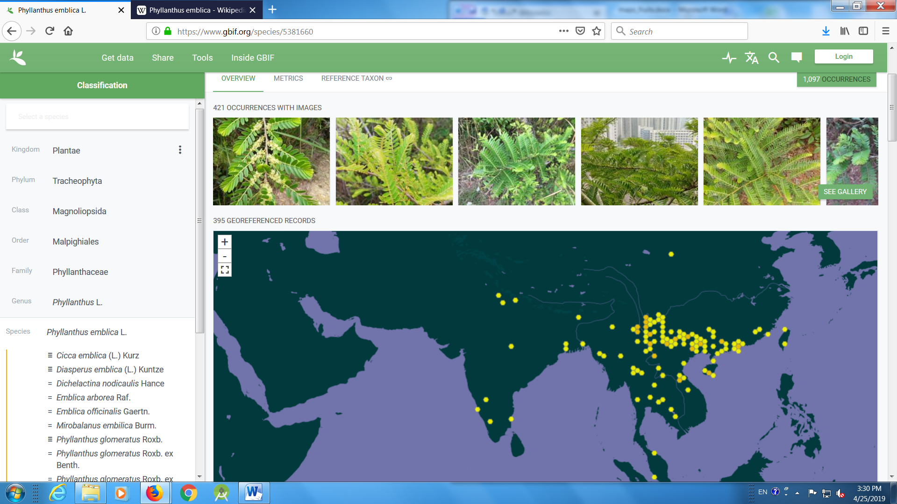
- Ber (Ziziphus mauritiana)
https://www.gbif.org/species/3039424

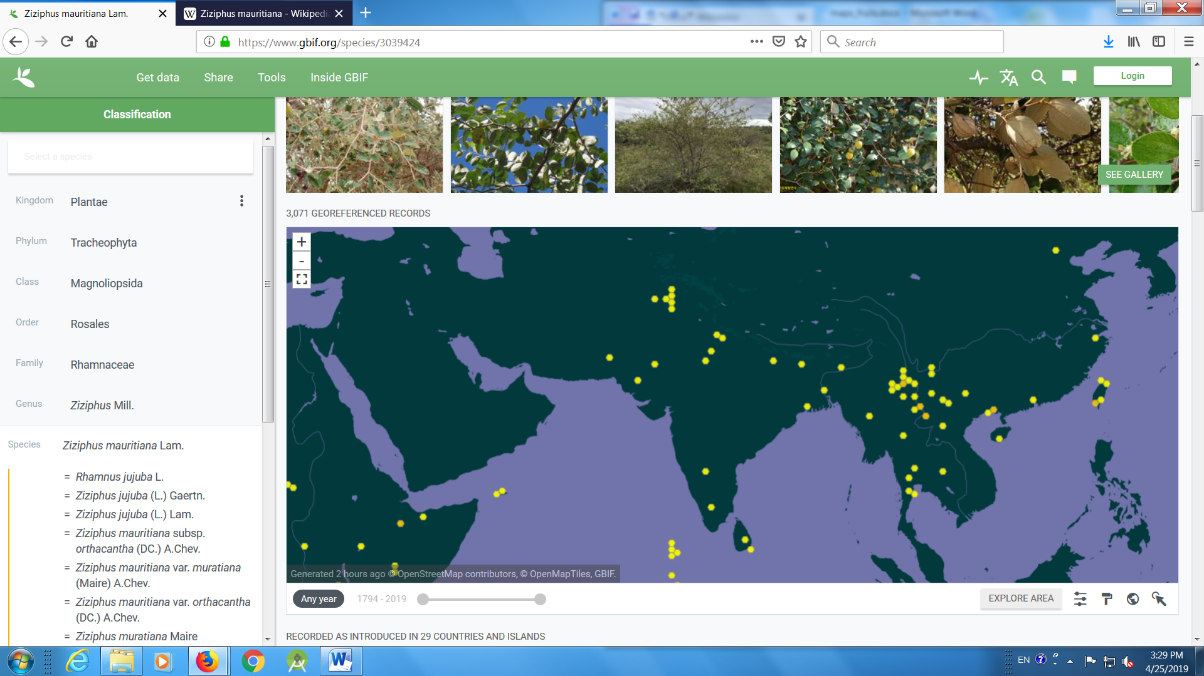
- Khejri (Prosopis cineraria)
https://www.gbif.org/species/5358521
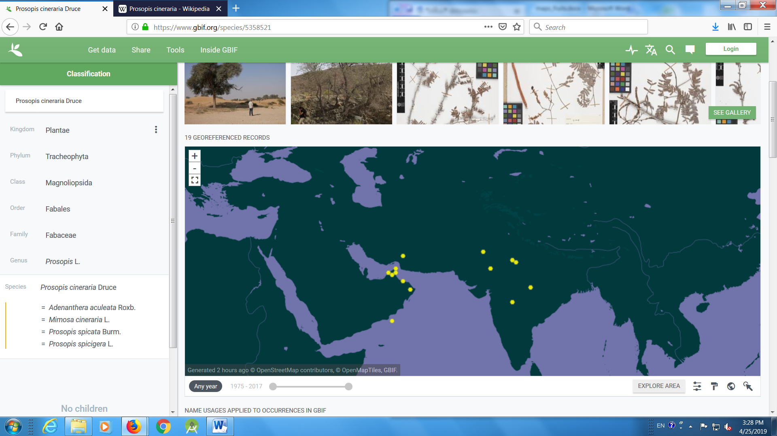
- Jamun (Syzygium cumini)
https://www.gbif.org/species/3183840
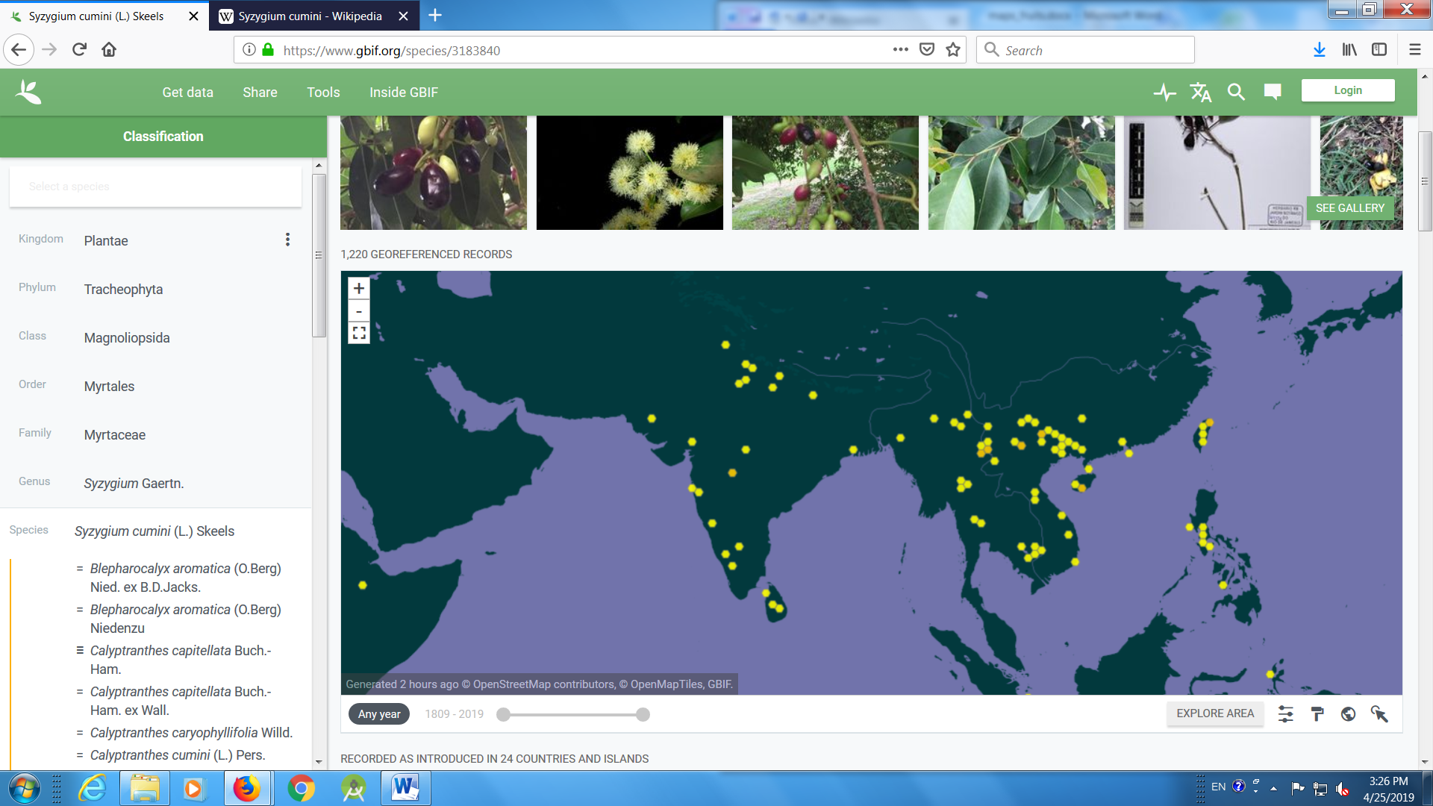

- Tamarind (Tamarindus indica)
https://www.gbif.org/species/2975768
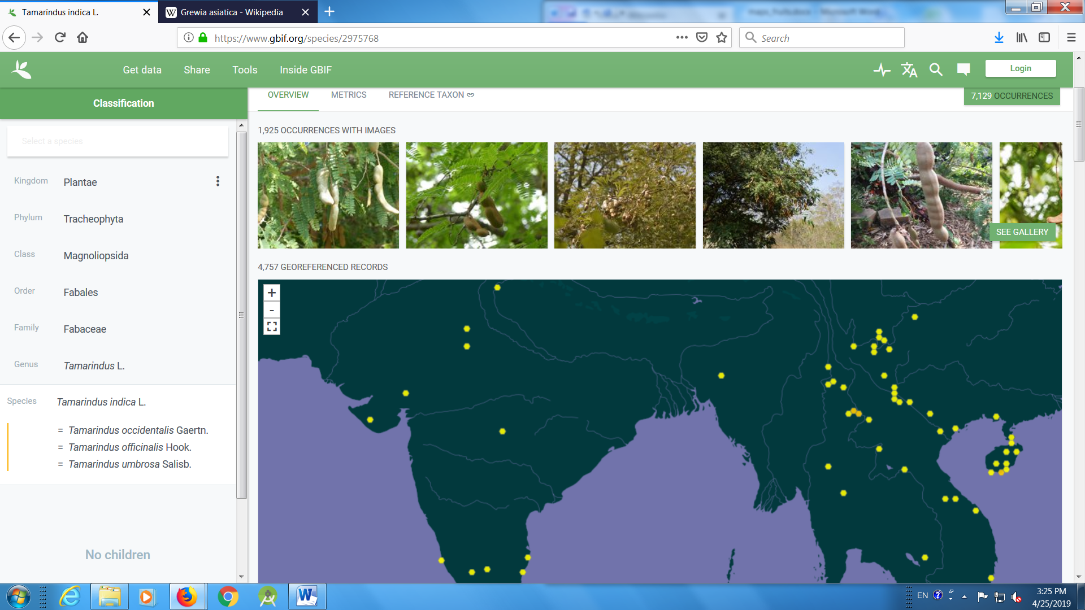
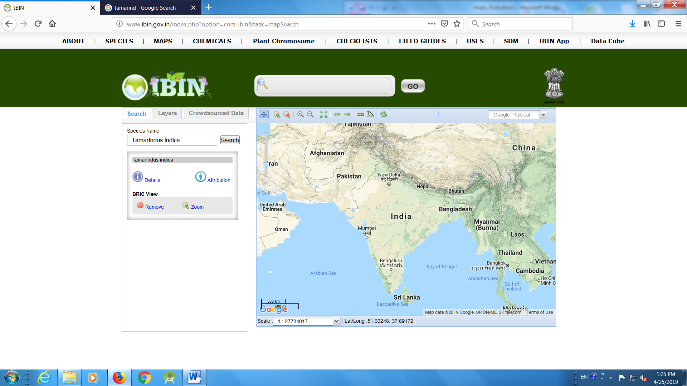

- Phalsa (Grewia asiatica)
https://www.gbif.org/species/3152080
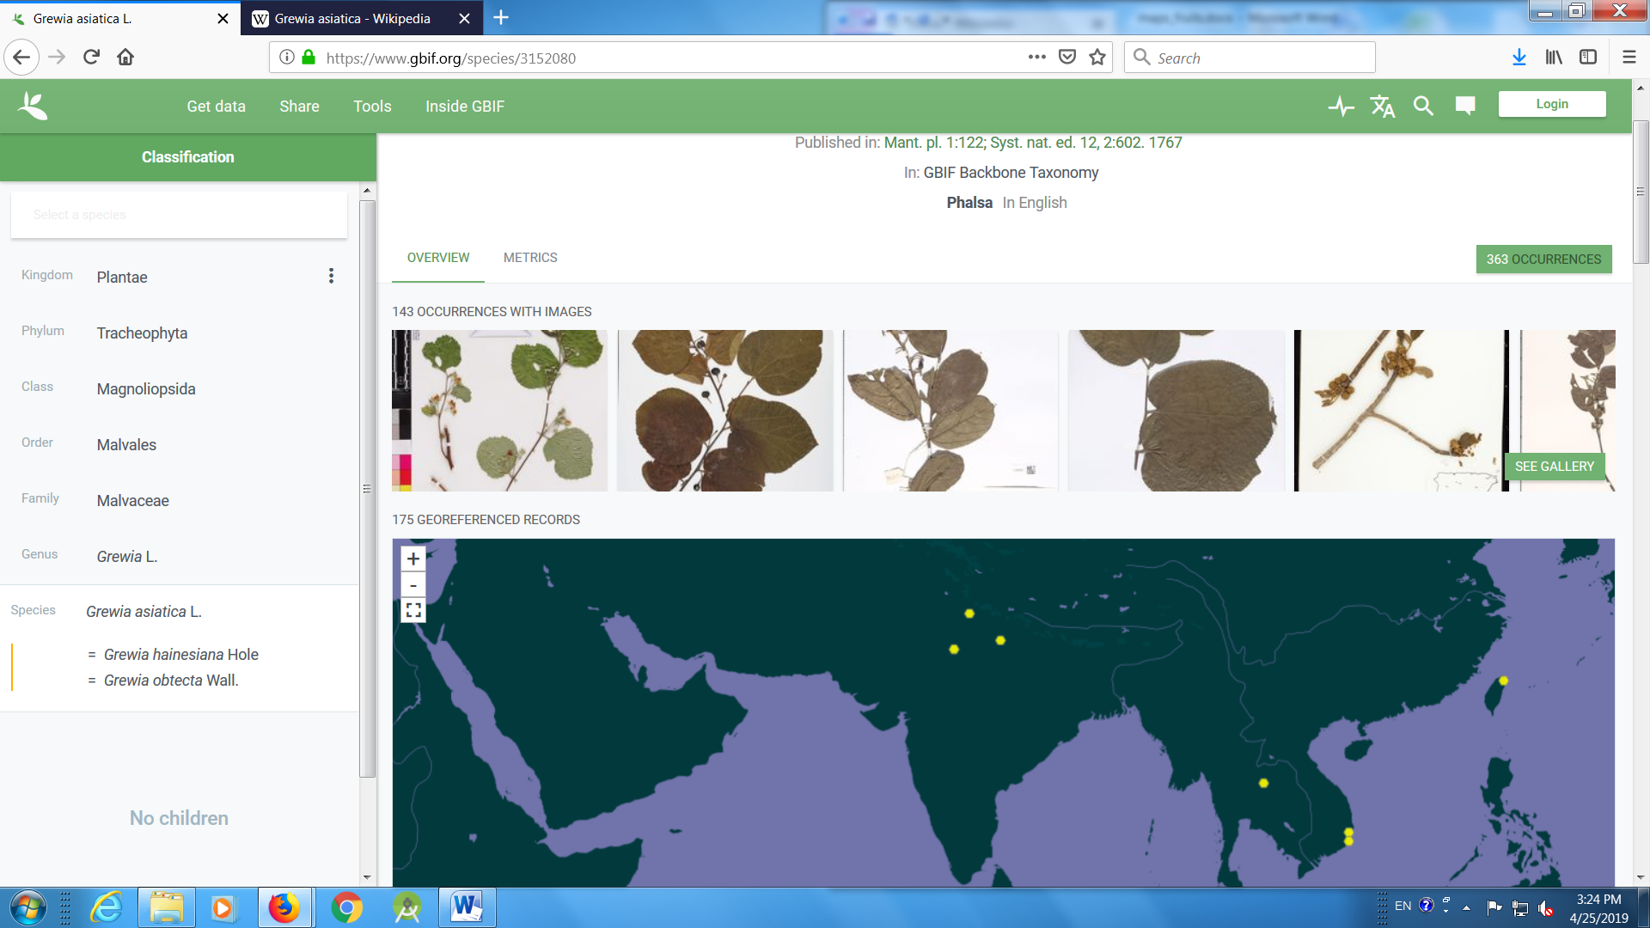
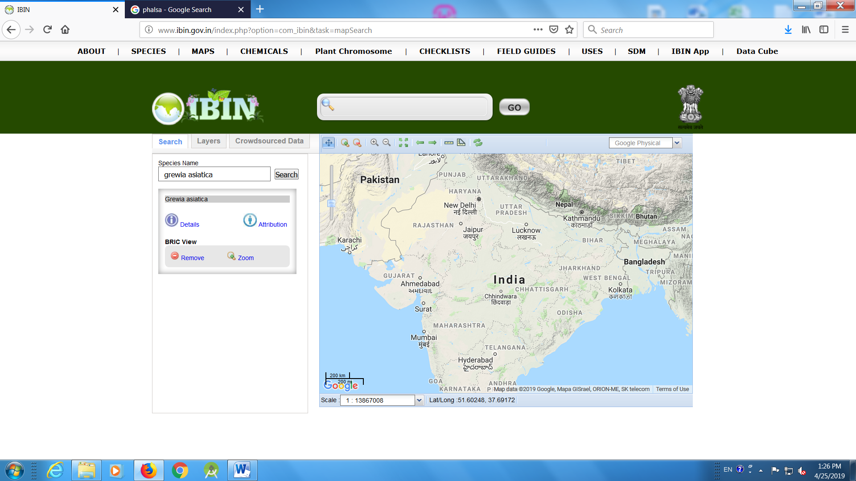

- Lasora (Cordia dichotoma)
https://www.gbif.org/species/5341270
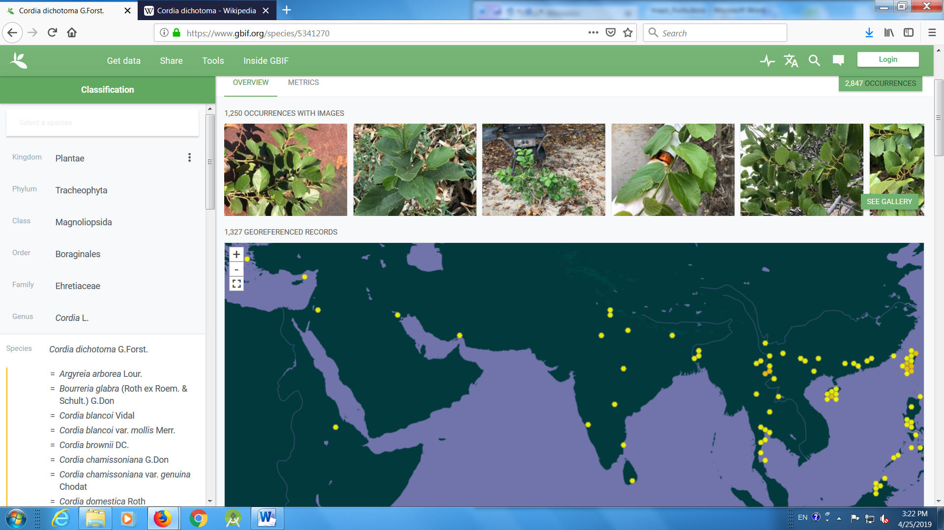
- Karonda (Carissa carandas)
https://www.gbif.org/species/5414419
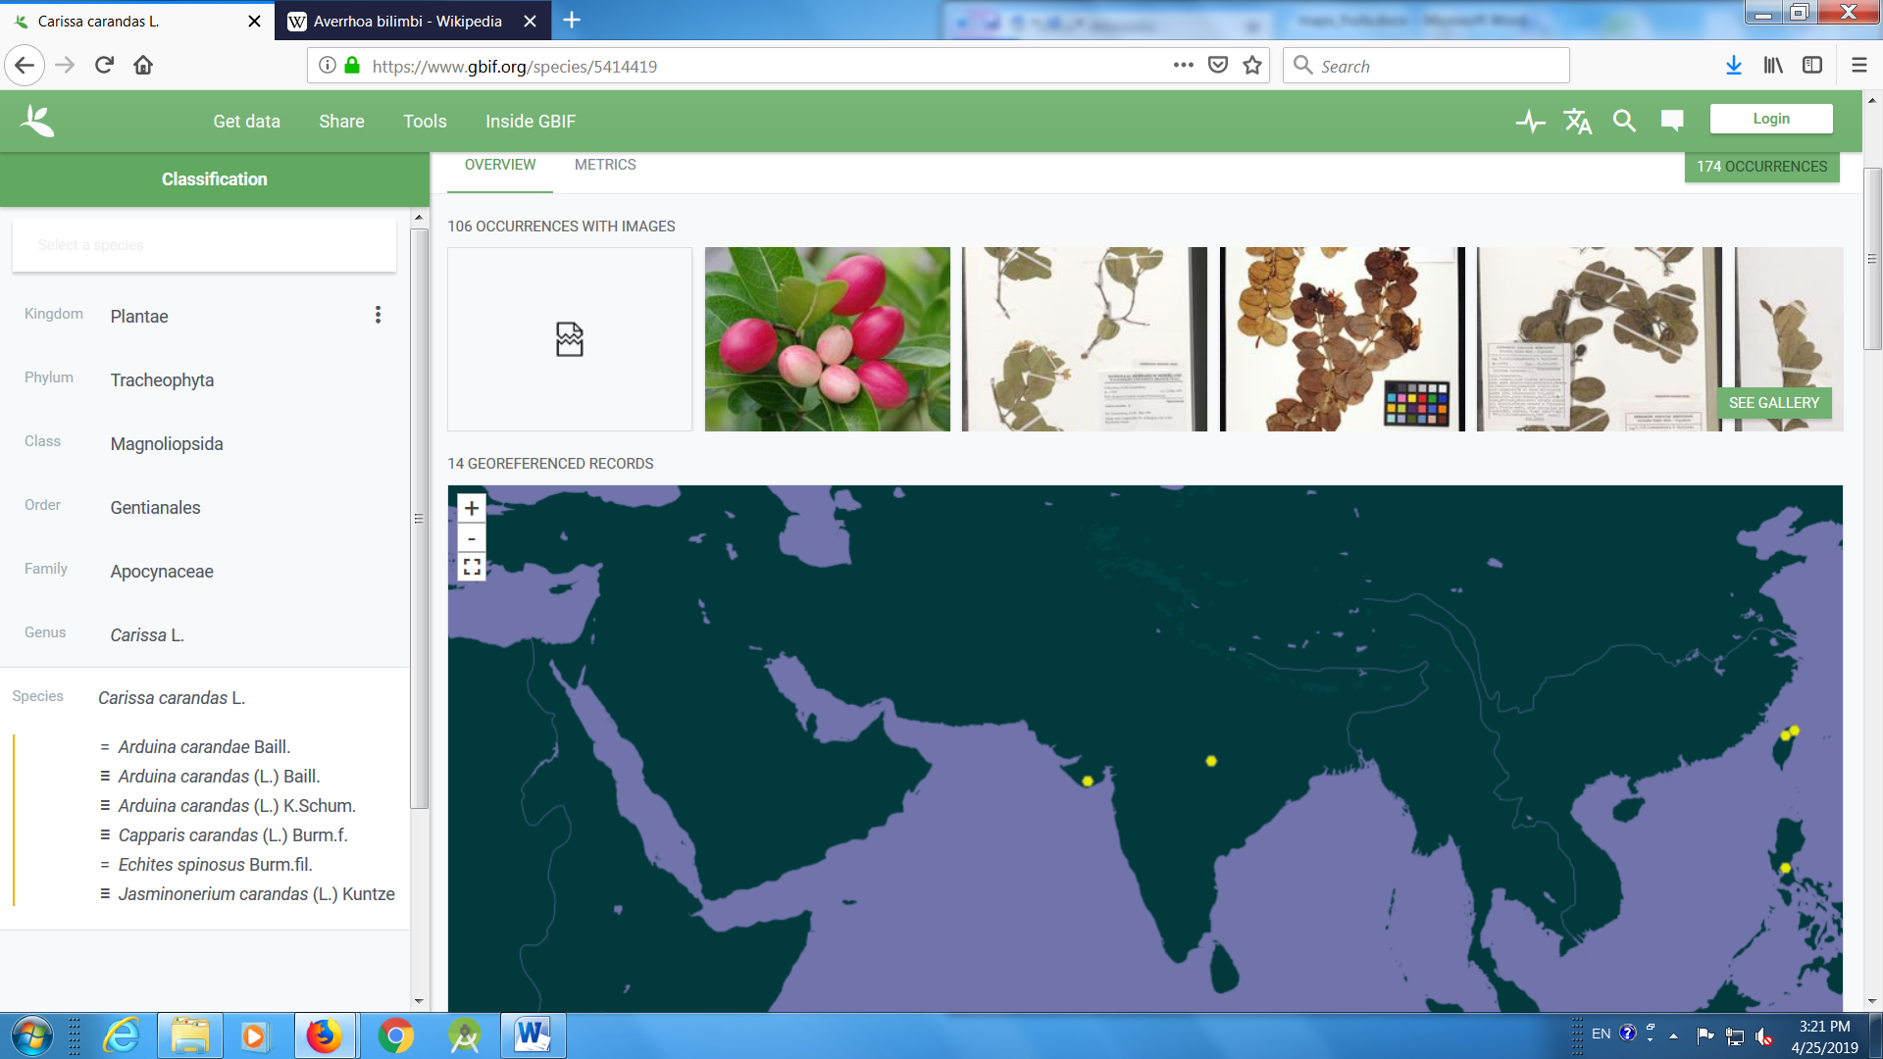

Carissa sp.

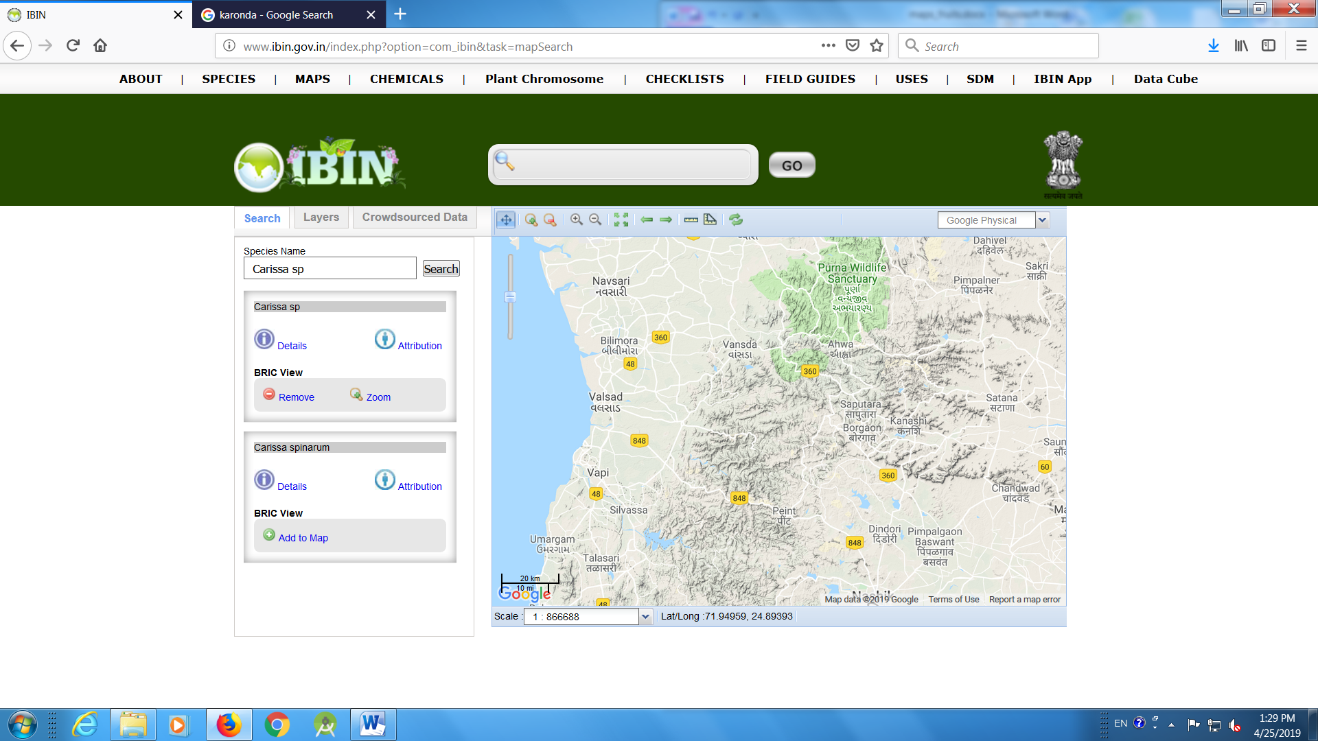

- Wood apple (Aegle marmelos)
Aegle marmelos Corrêa
https://www.gbif.org/species/5421195
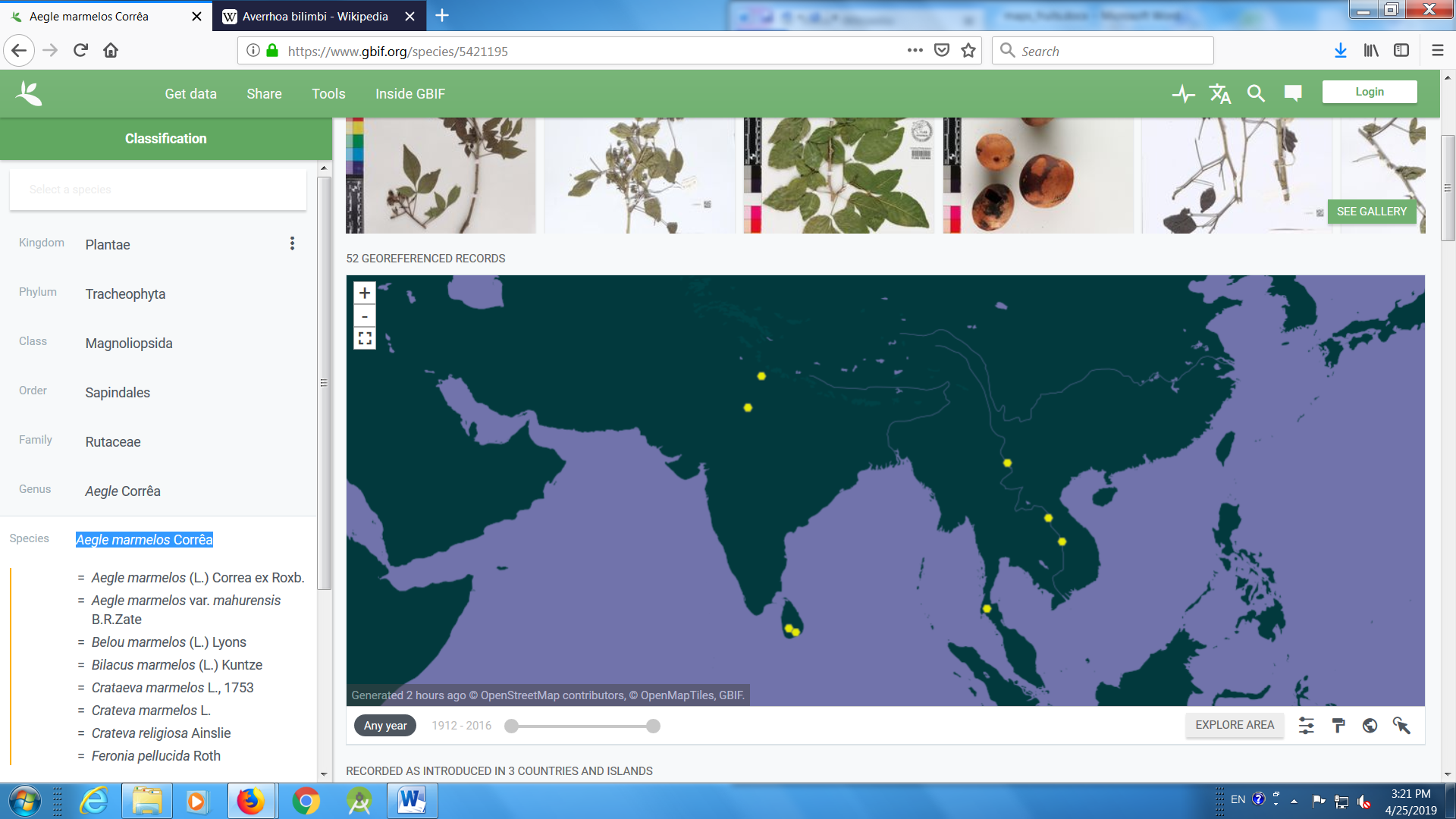
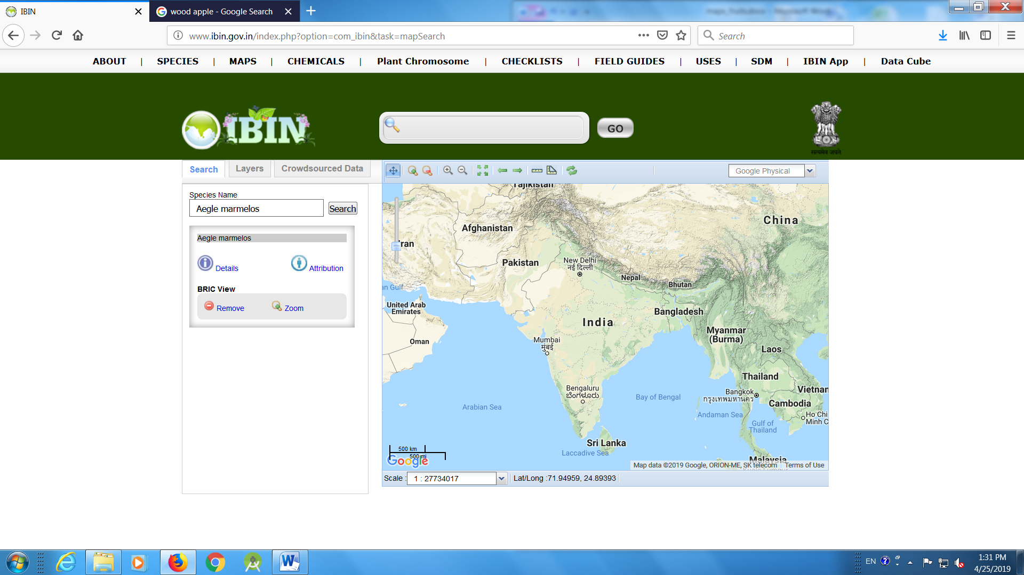

- Pilu (Salvadora persica)

https://www.gbif.org/species/5580727

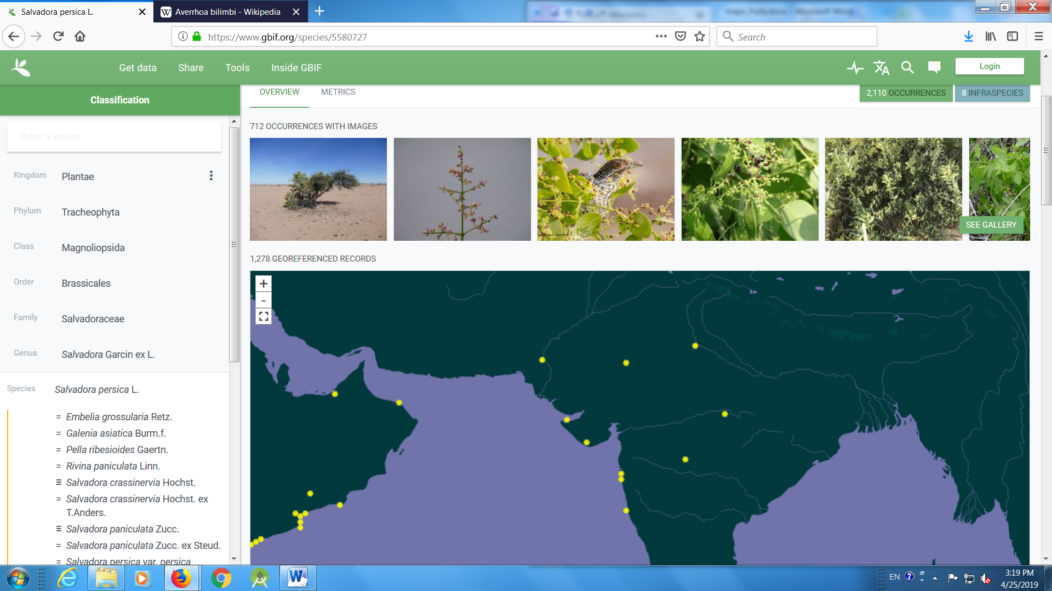
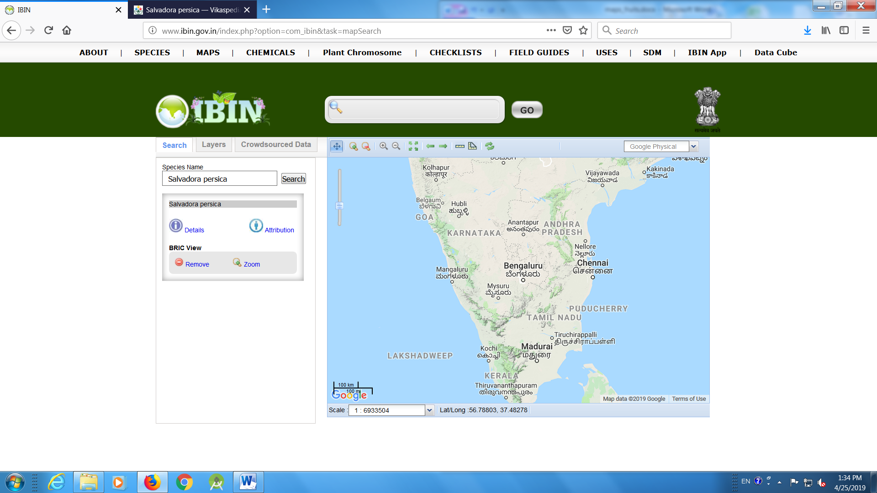

- Bilimbi (Averrhoa bilimbi)
https://www.gbif.org/species/2891640
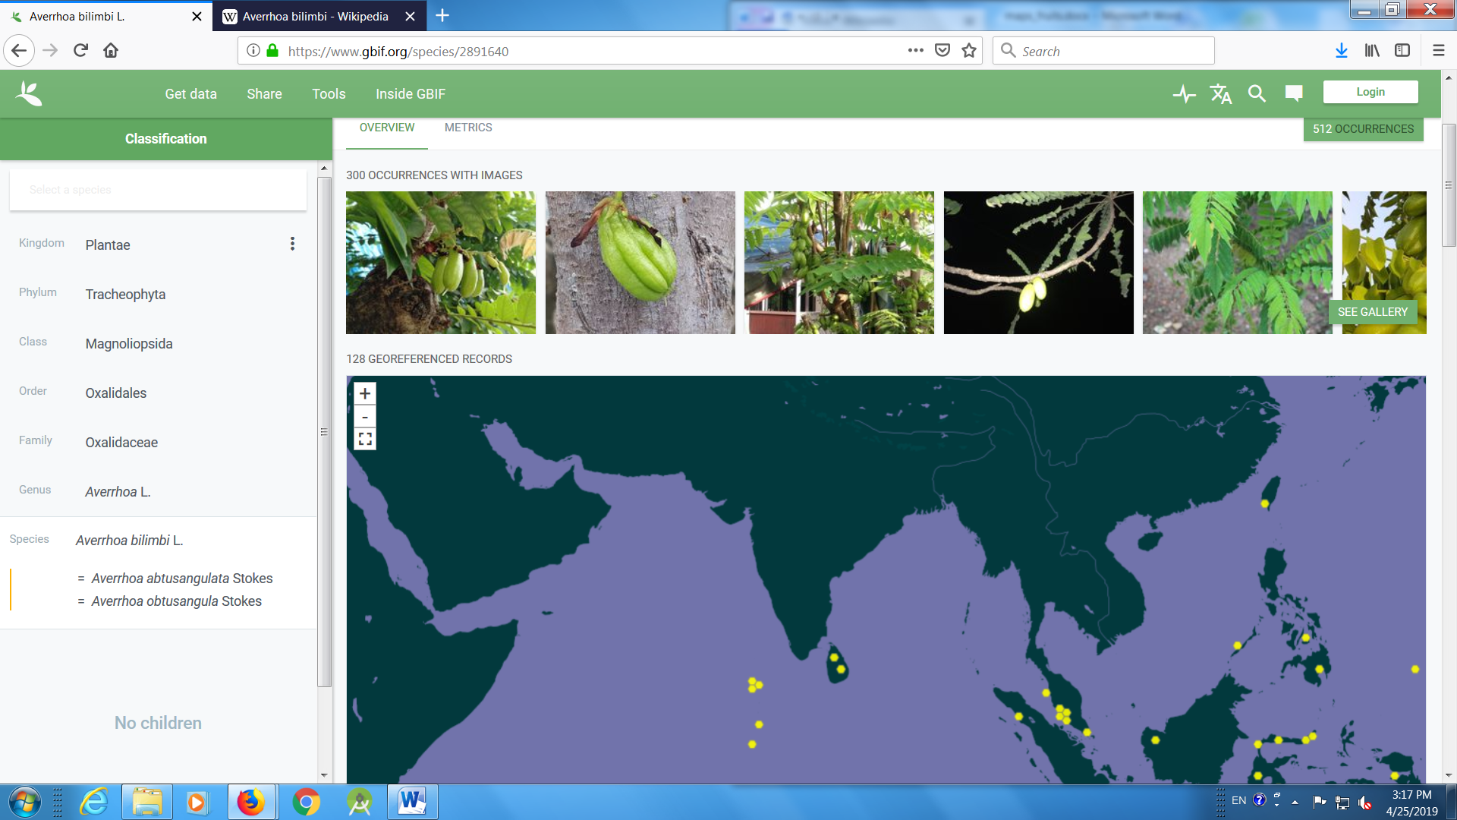
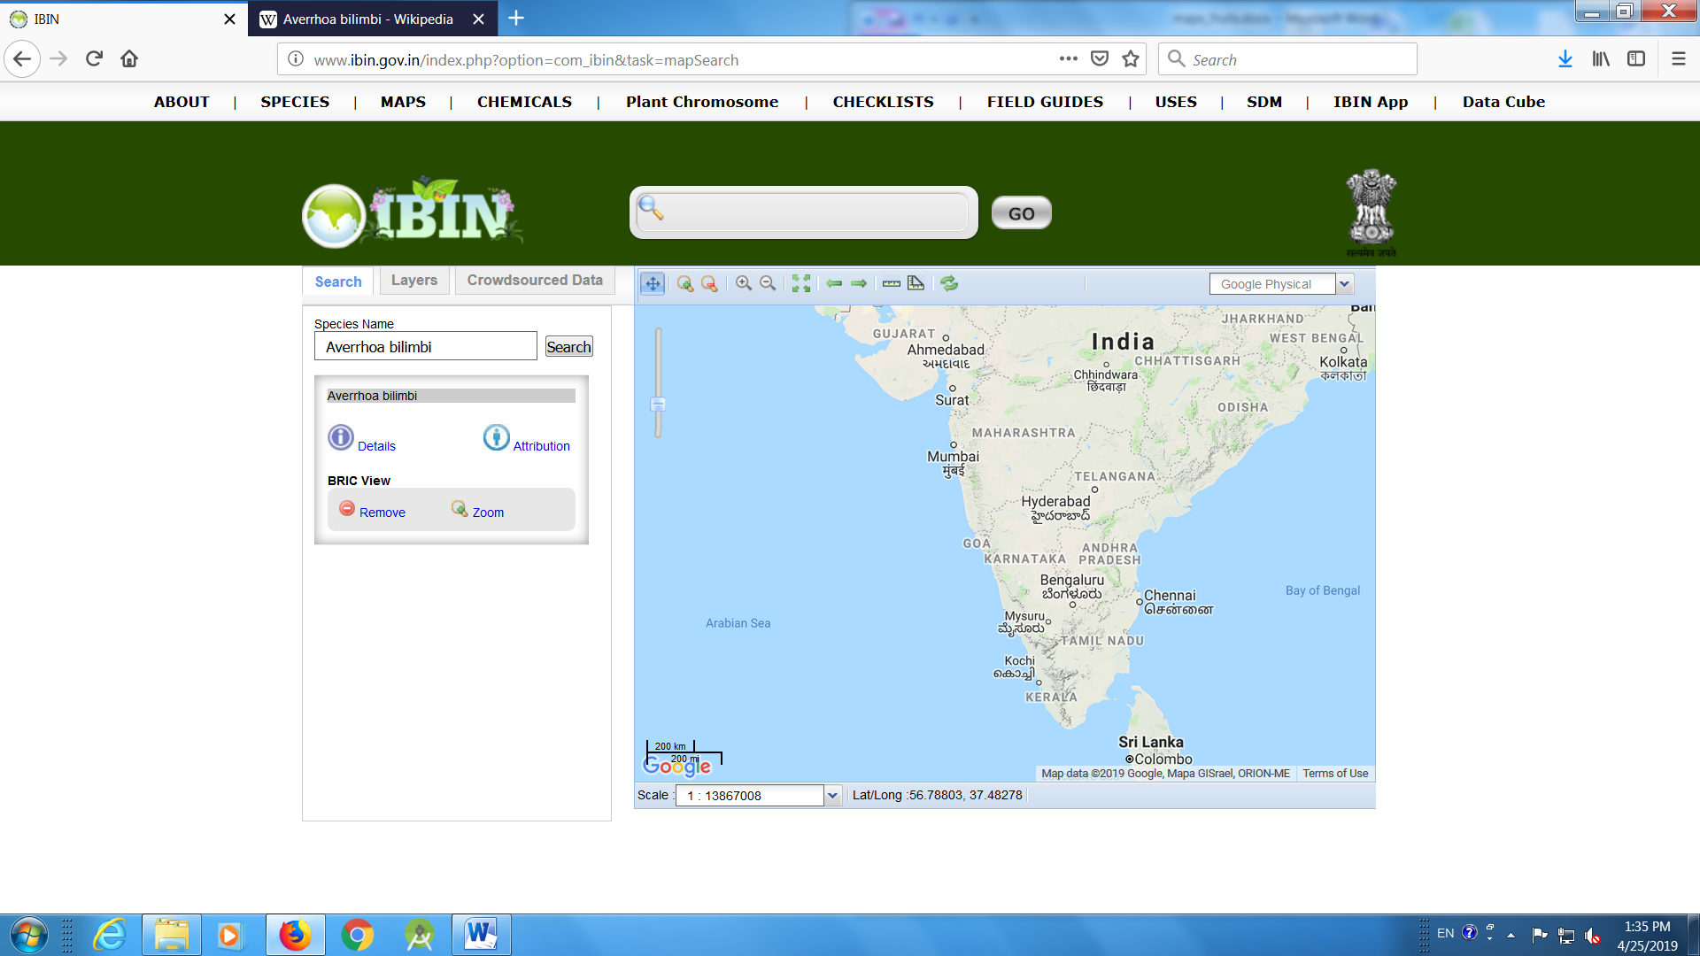

- Garcinia
https://www.gbif.org/species/3189556
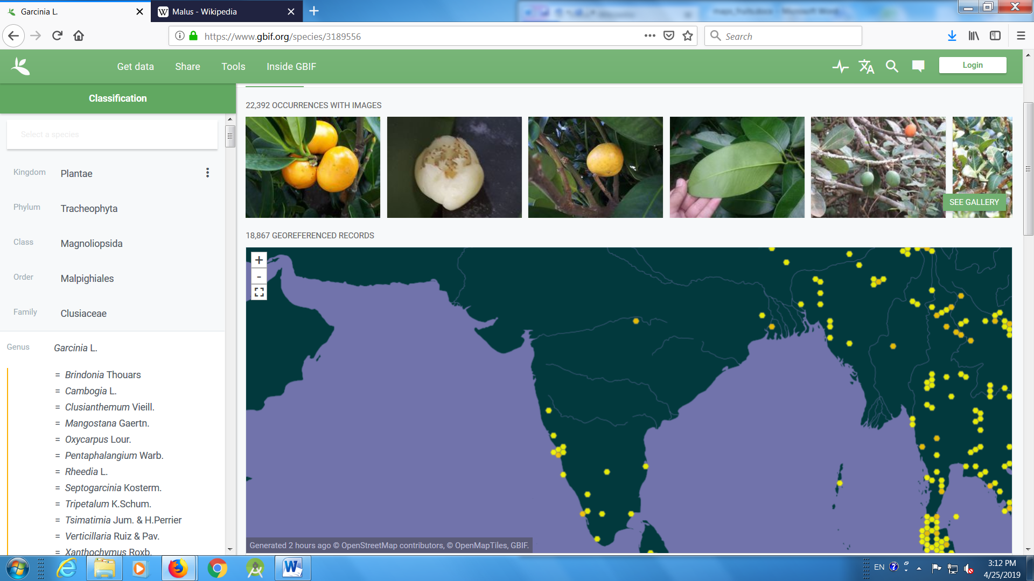

Garcinia mangostana

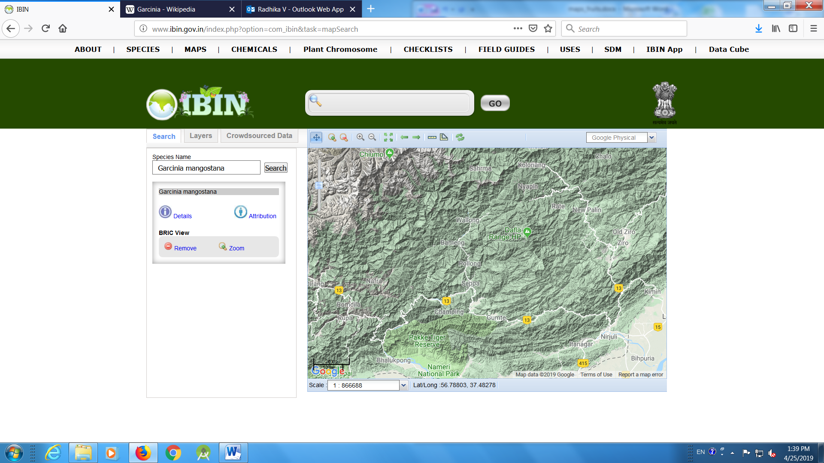
Secondary centre:
- Banana (Musa sp)
https://www.gbif.org/species/2760990
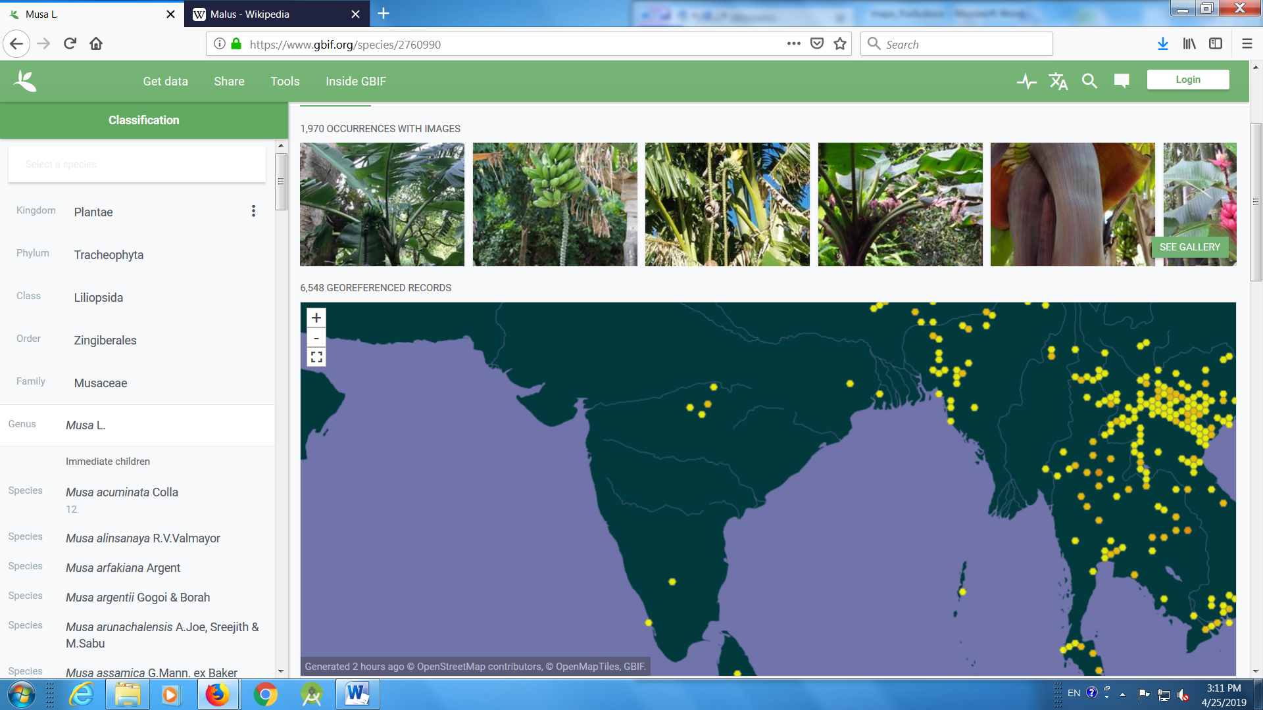
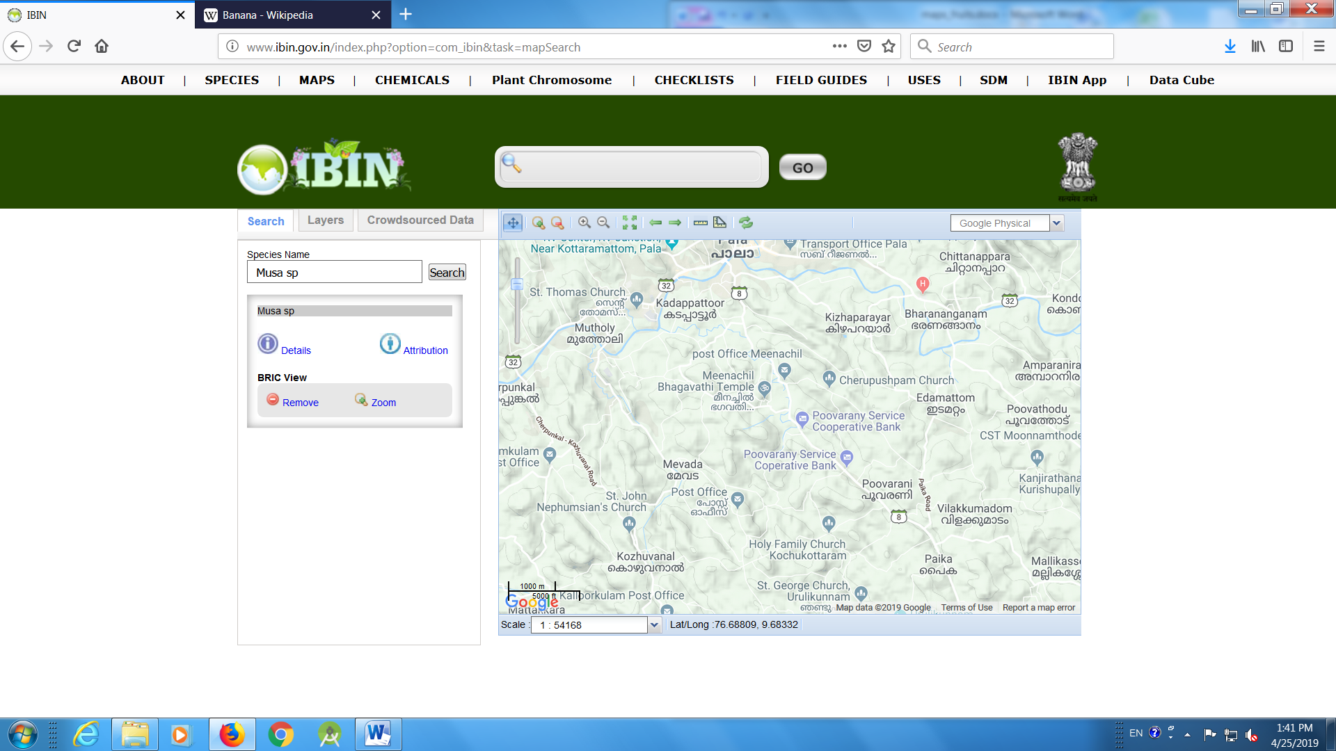

- Pomegranate (Punica granatum)
https://www.gbif.org/species/5420901
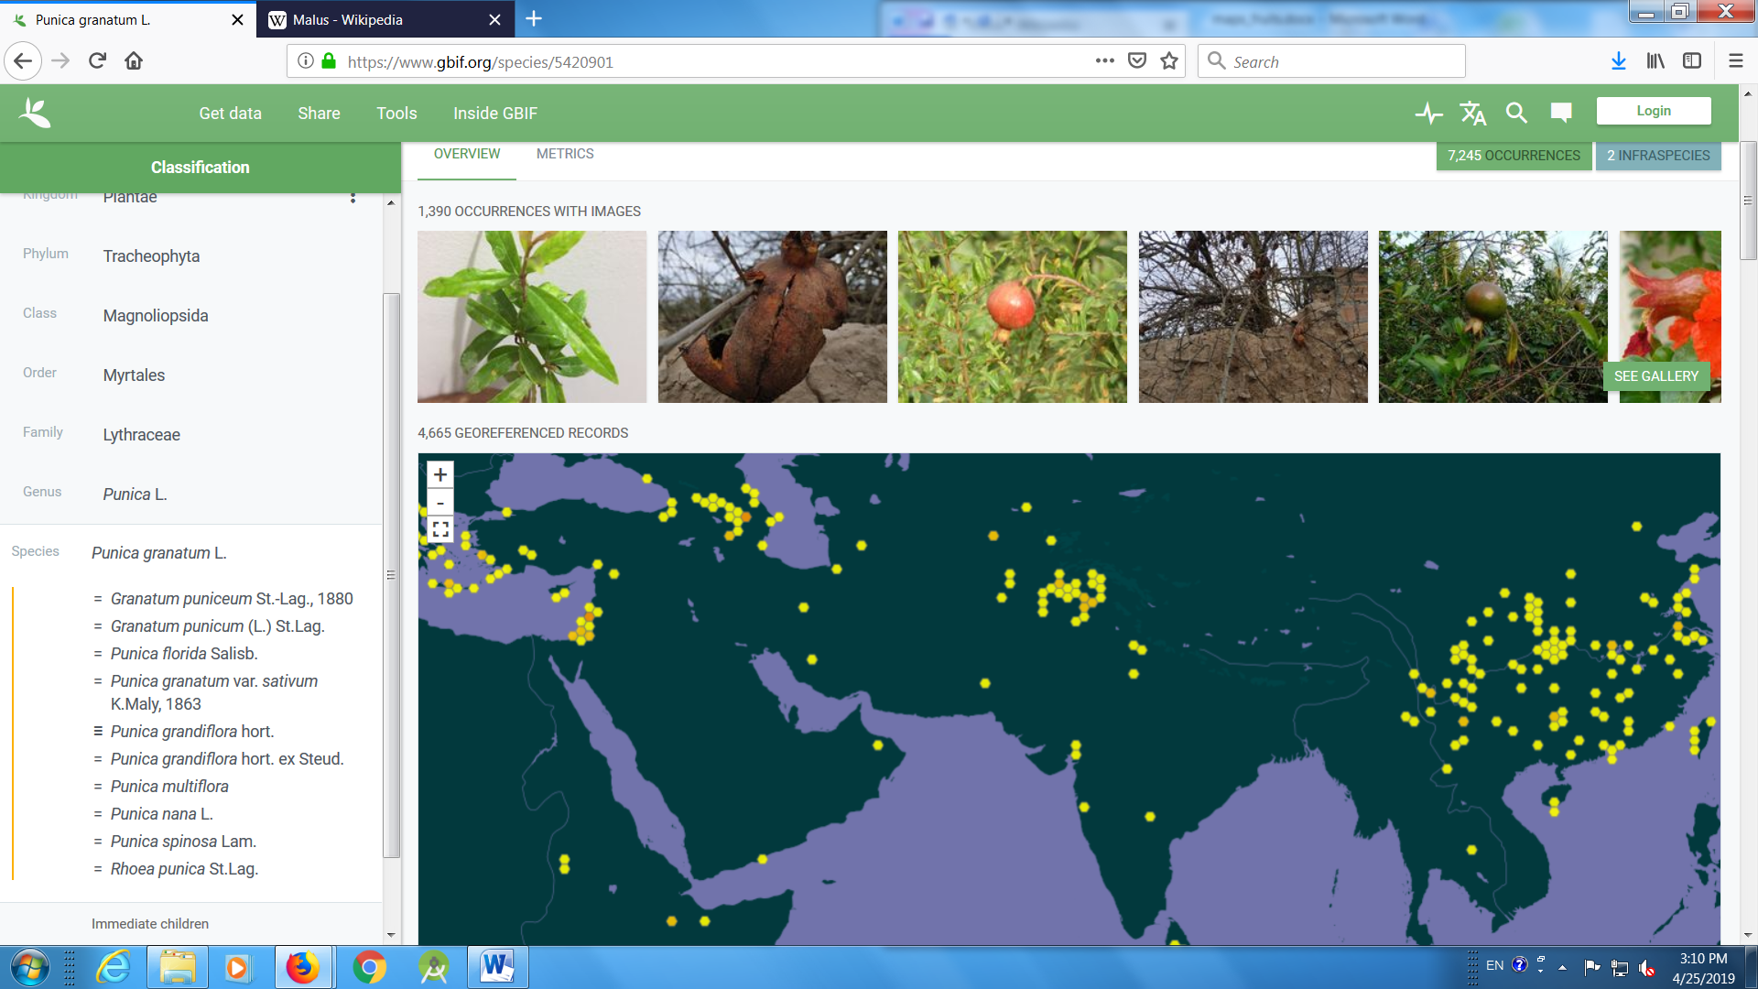
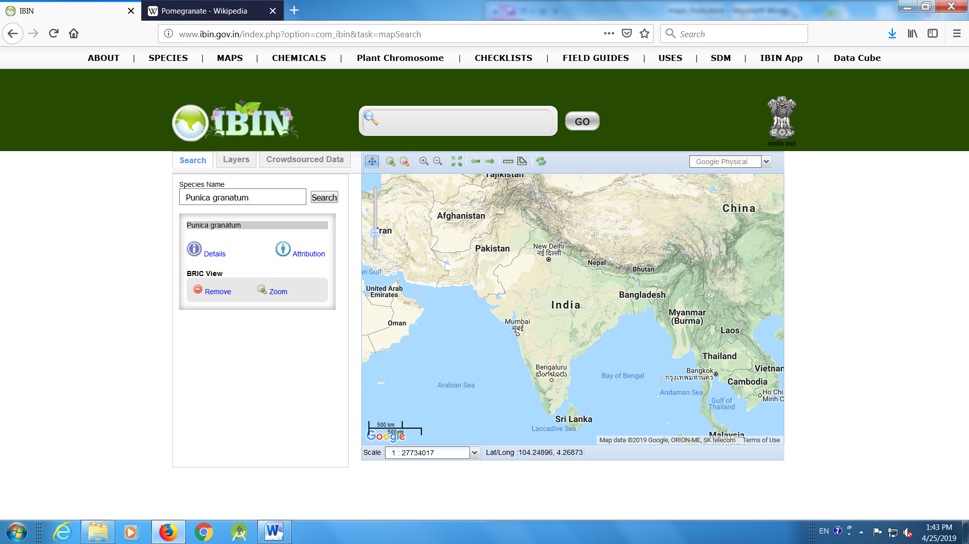

- Mulberry (Morus)
https://www.gbif.org/species/2984545
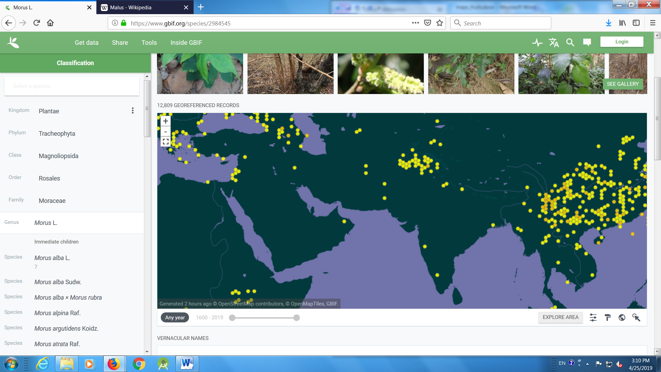
Morus indica
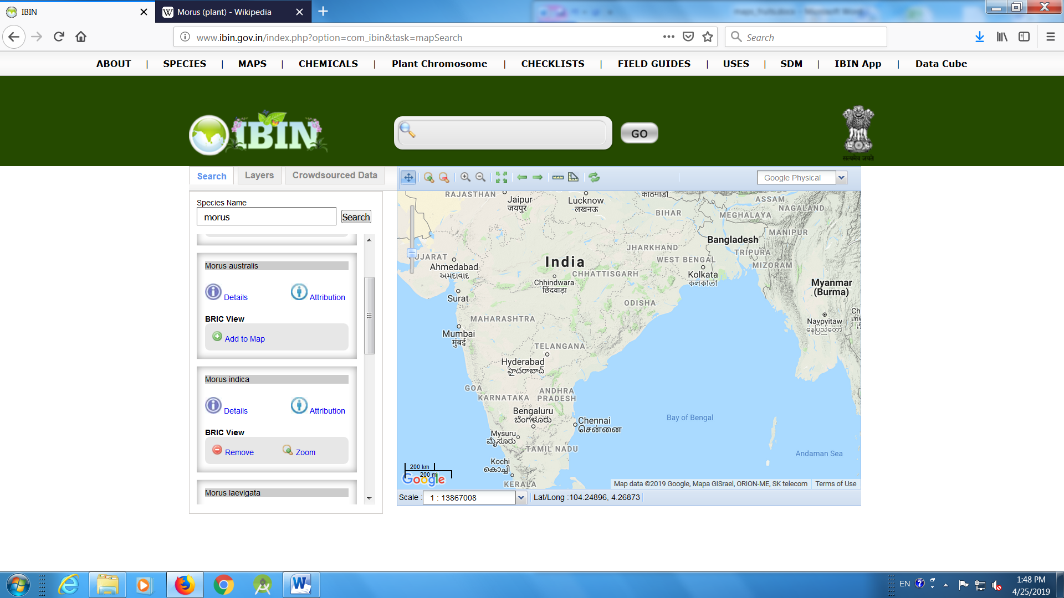

- Malus
https://www.gbif.org/species/3001068
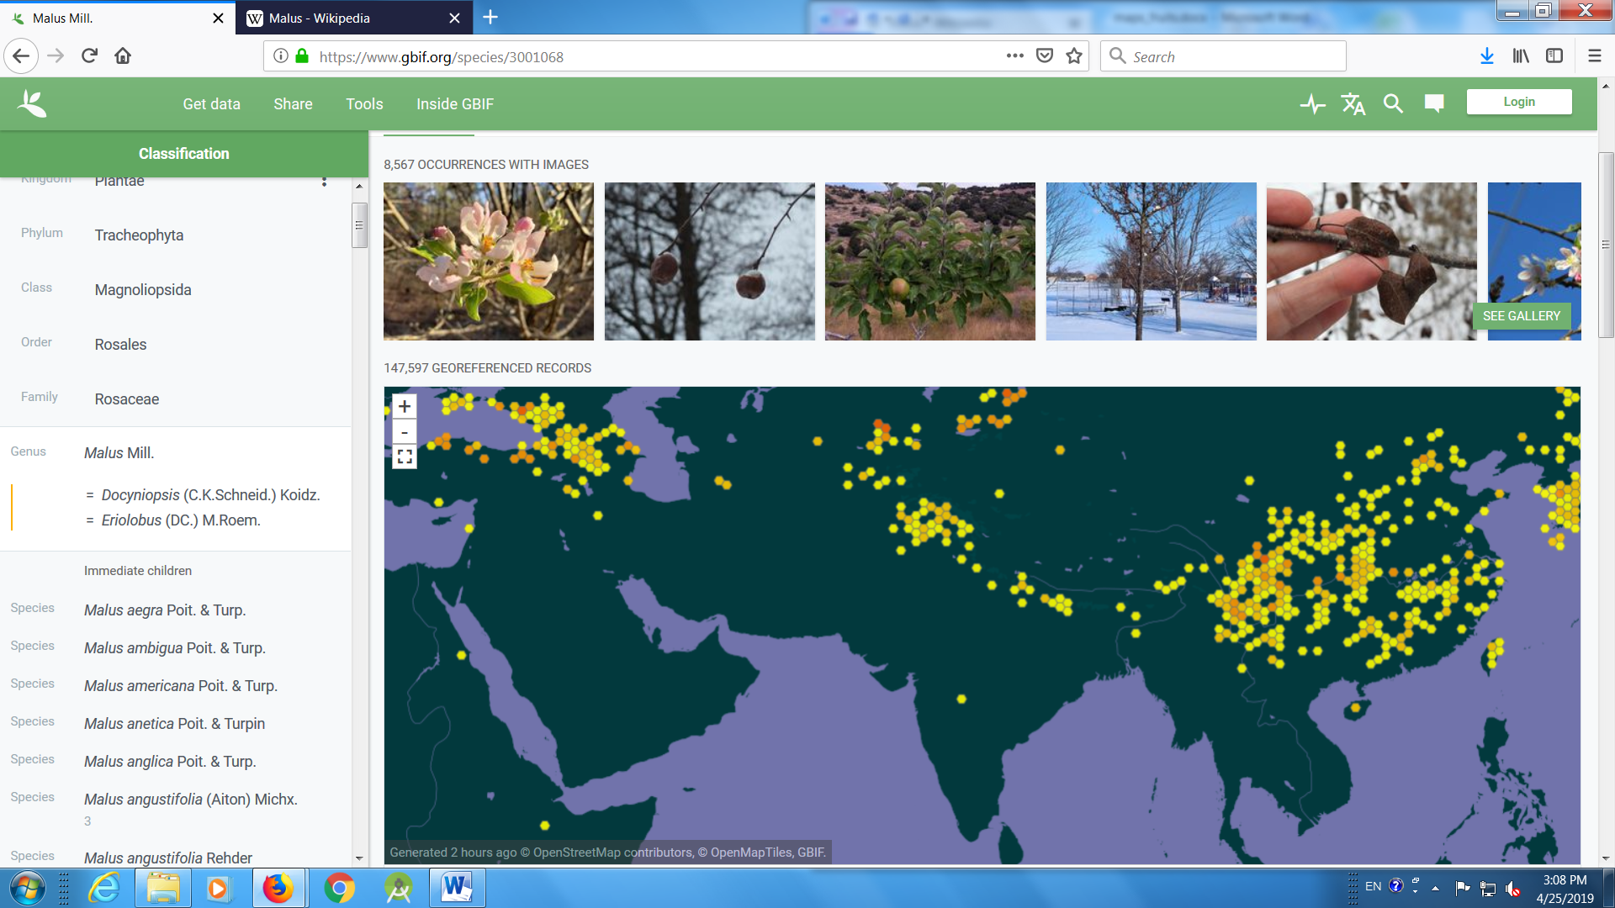
Malus baccata
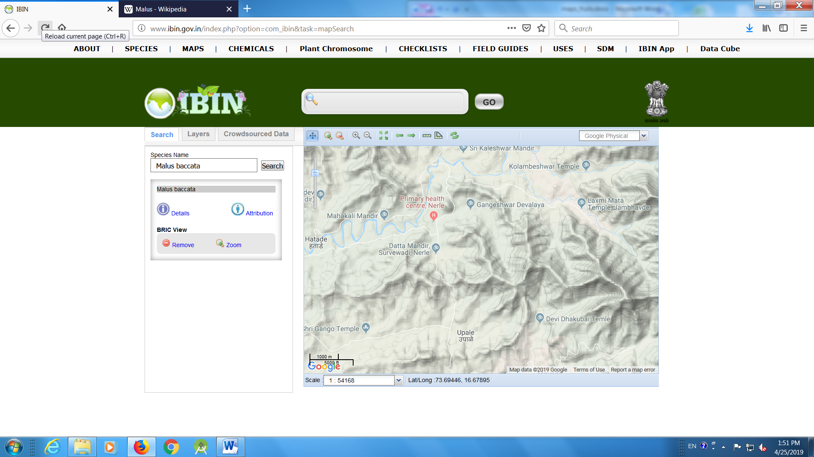

- Pyrus
https://www.gbif.org/species/2986532
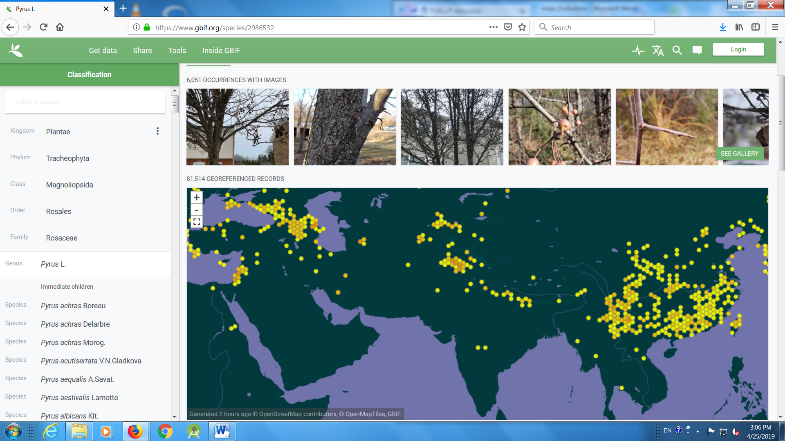
Pyrus pashia
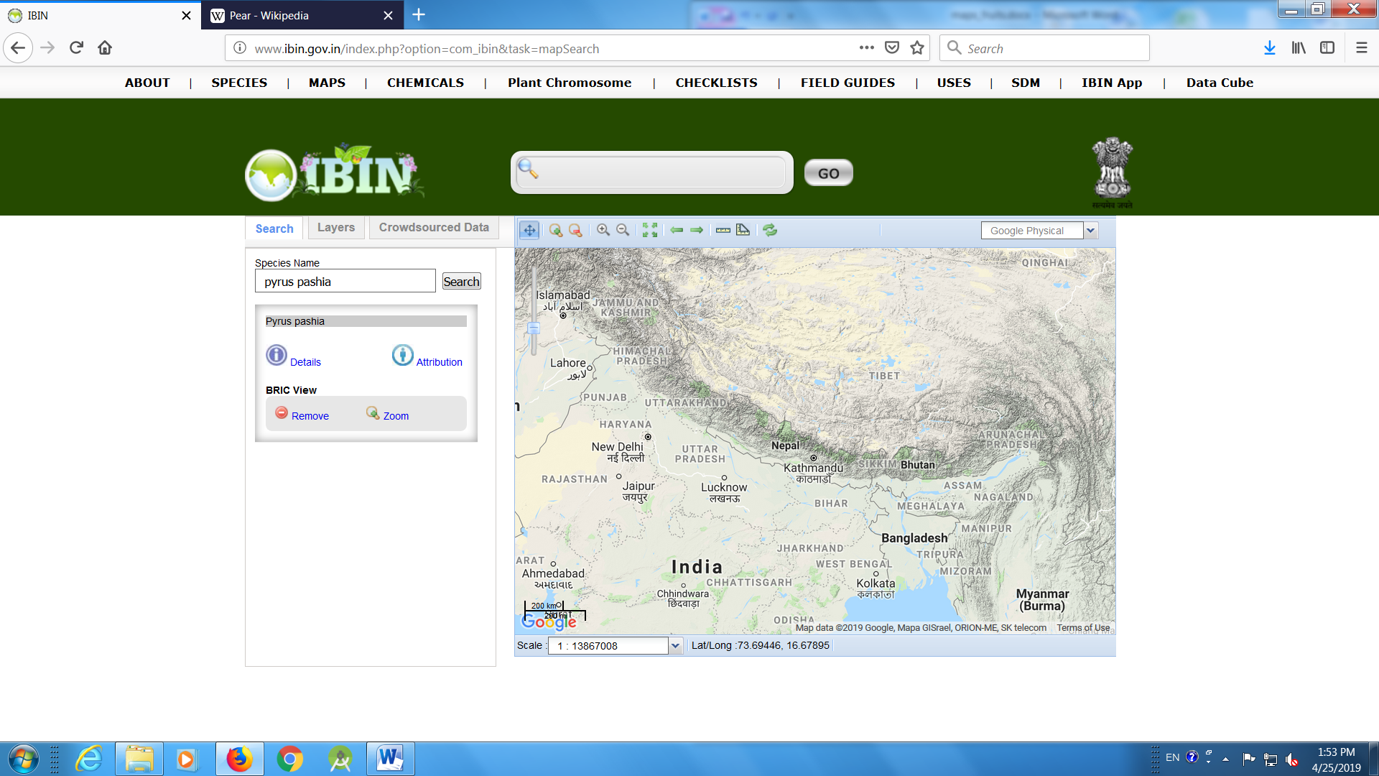

- Prunus
https://www.gbif.org/species/3020559
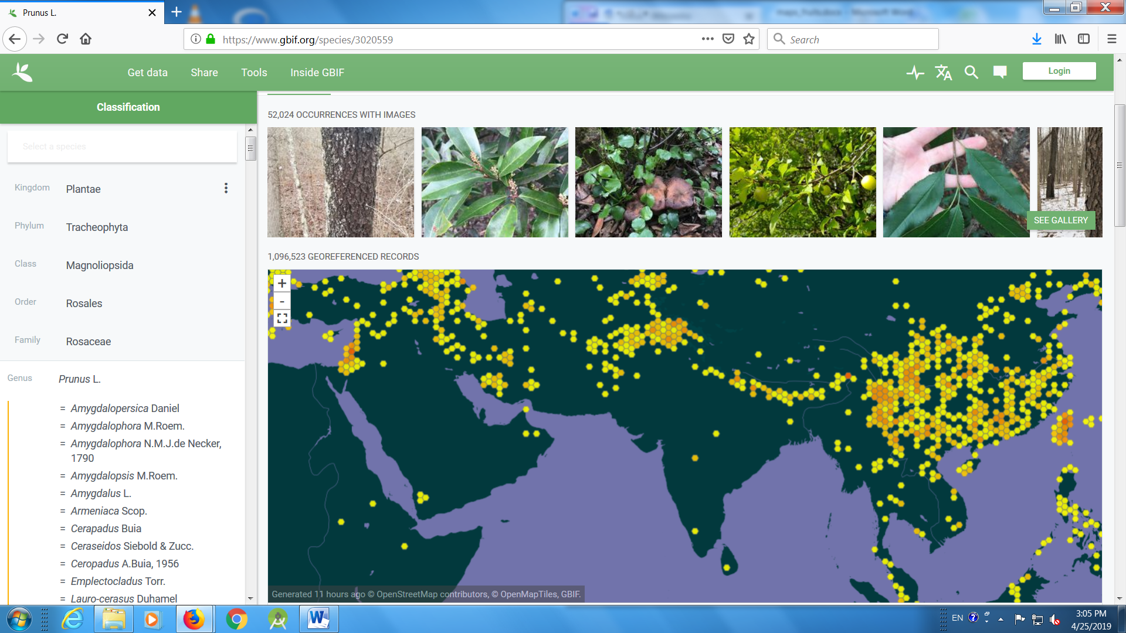
Prunus zippeliana
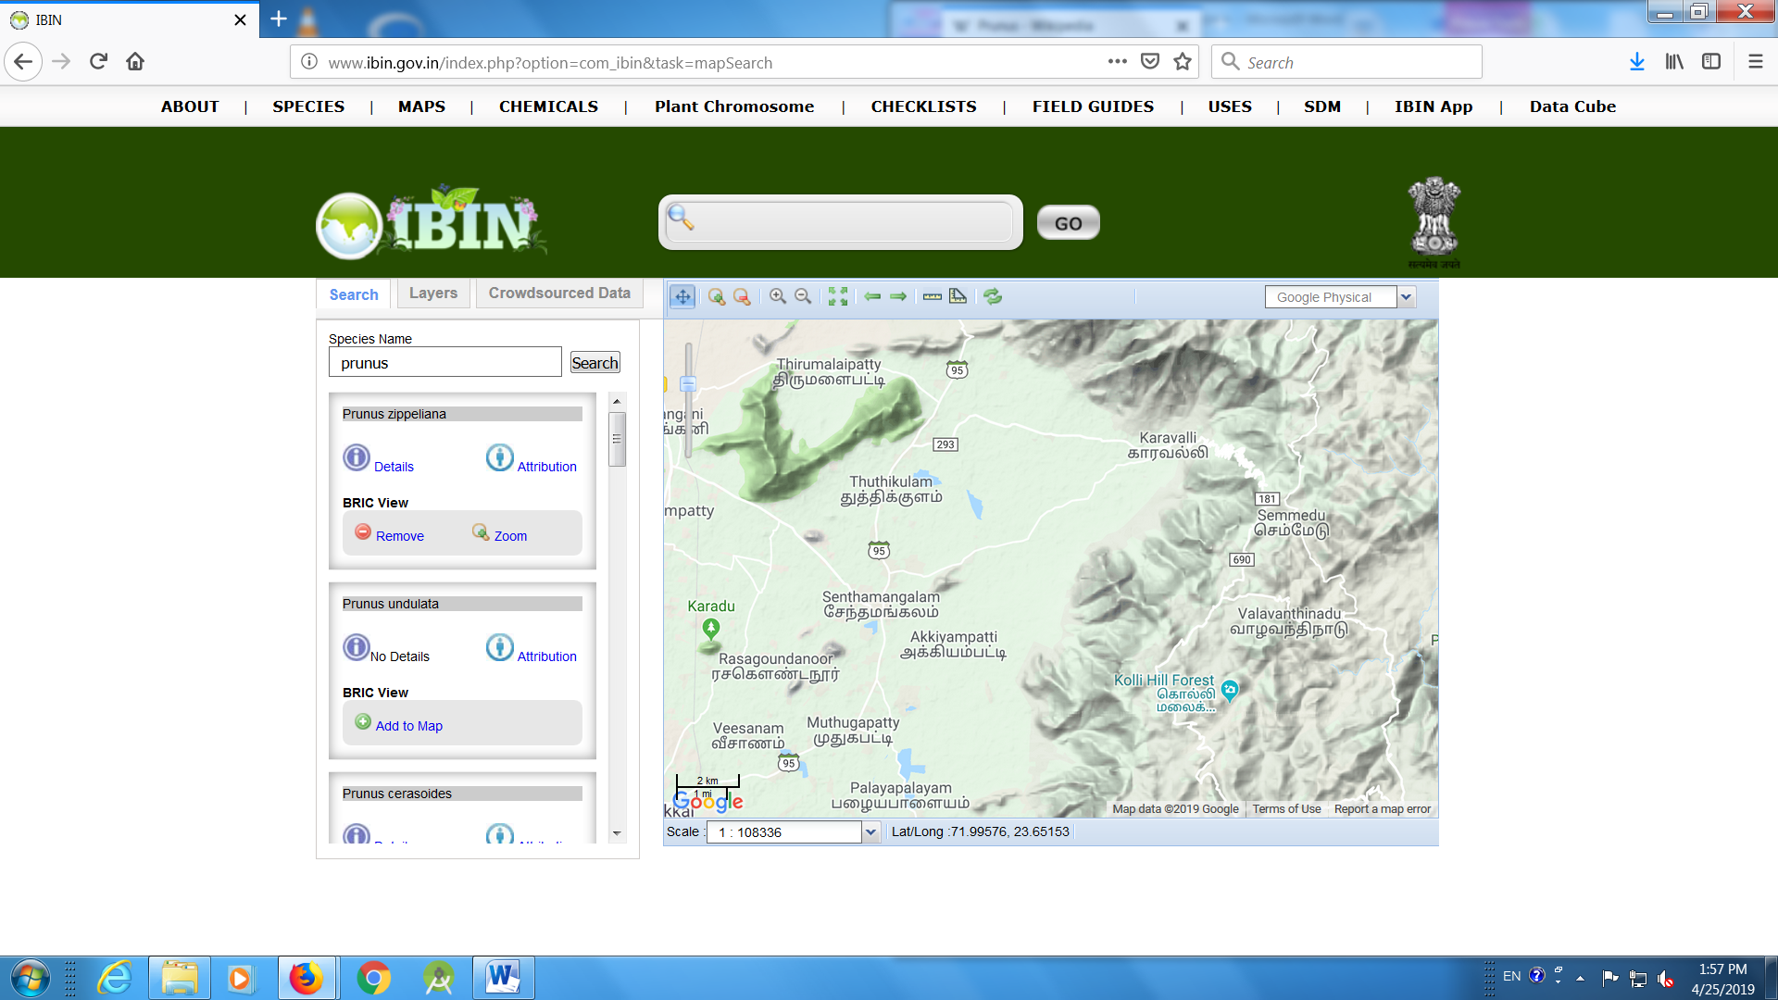

Prunus undulate
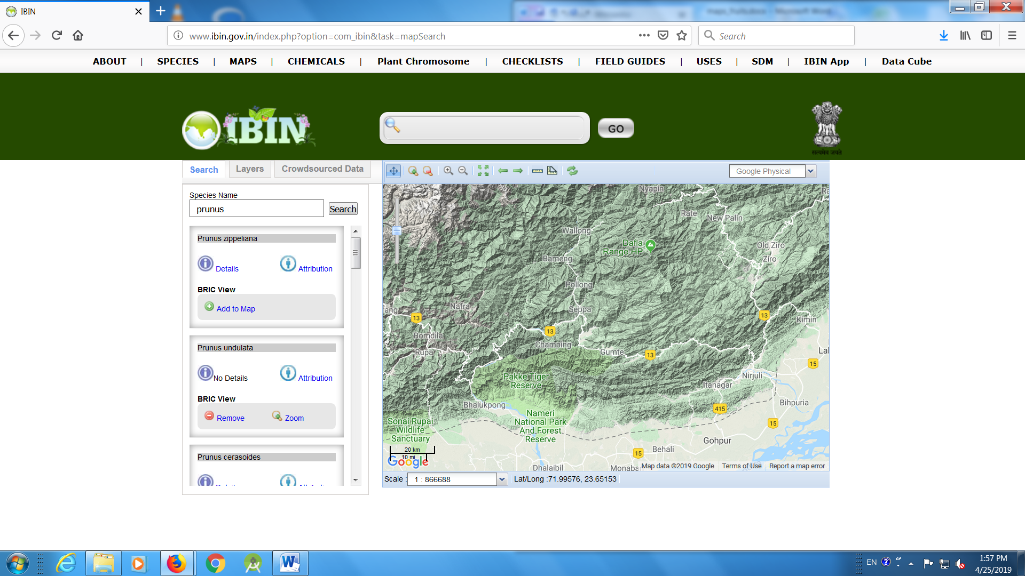

Prunus cerasoides
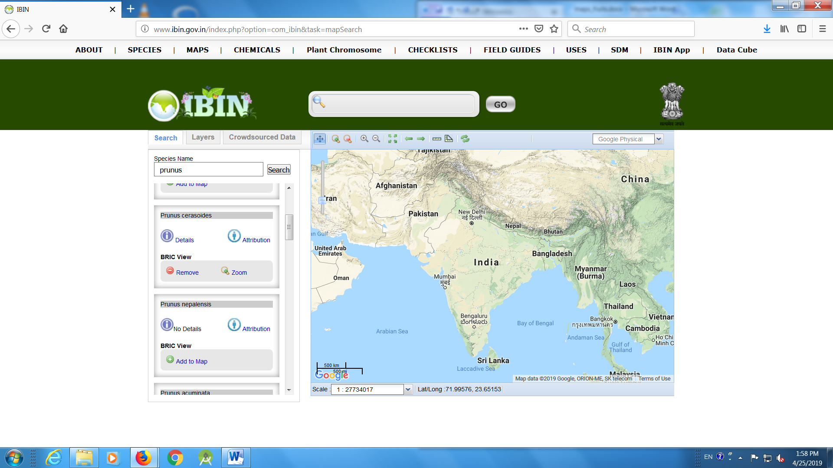

Prunus nepalensis
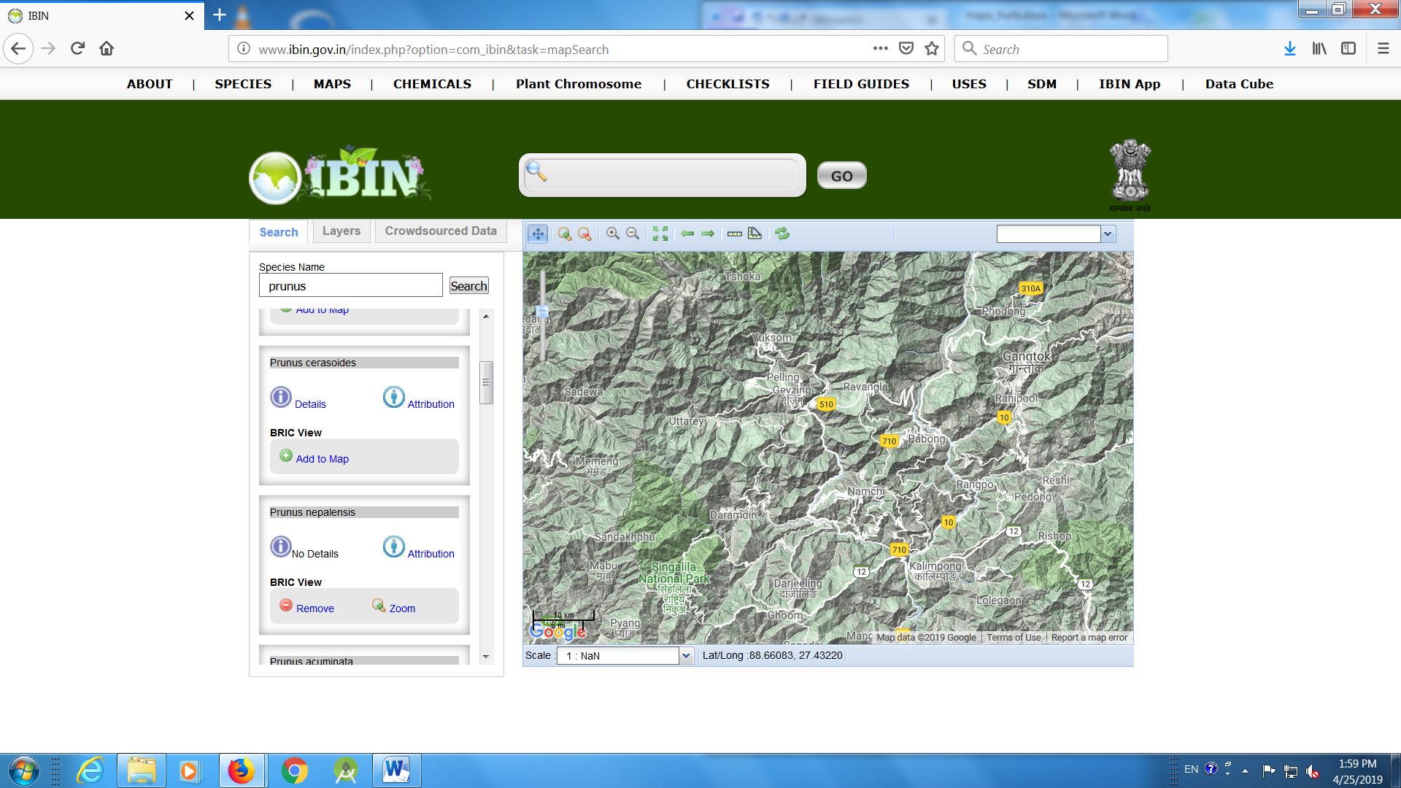

Prunus acuminate
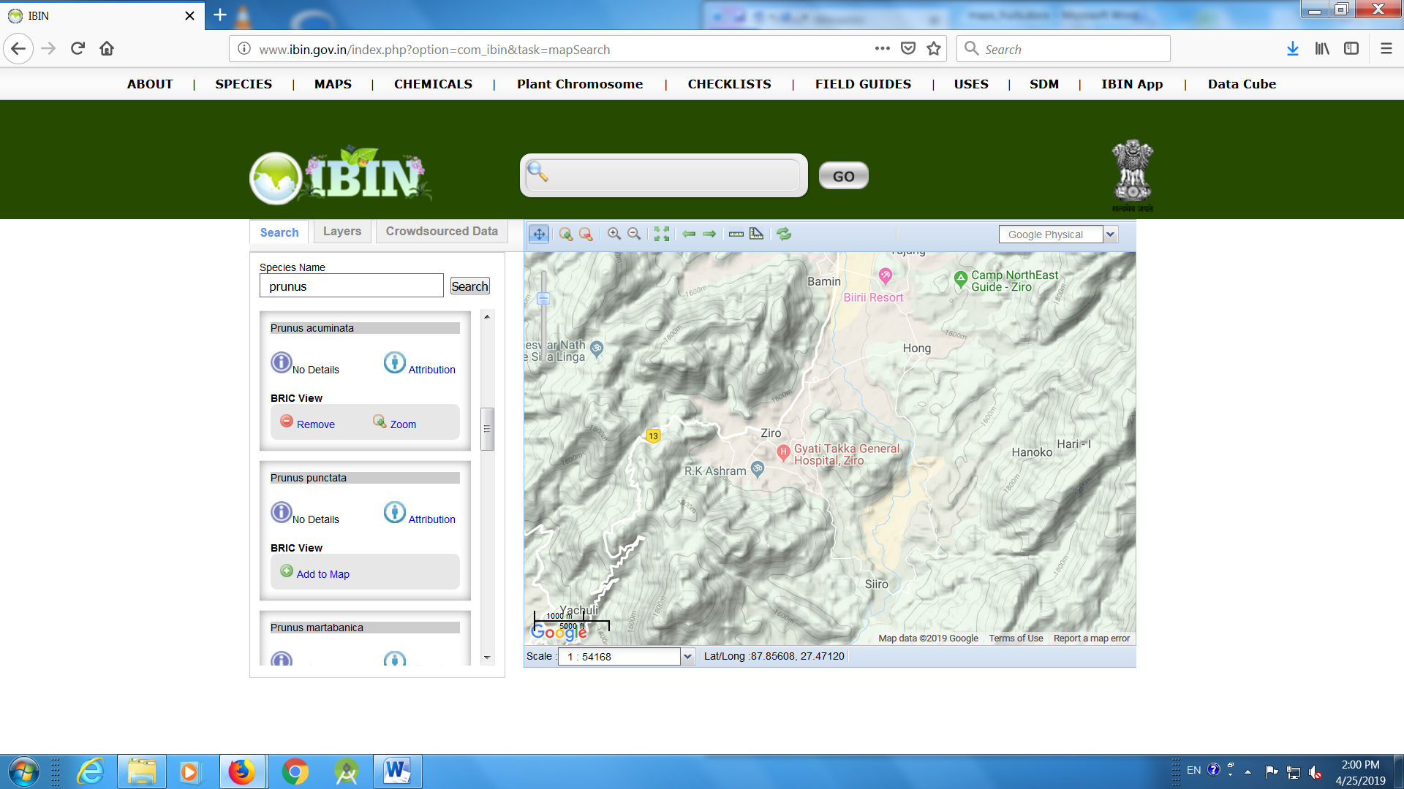

Prunus persica
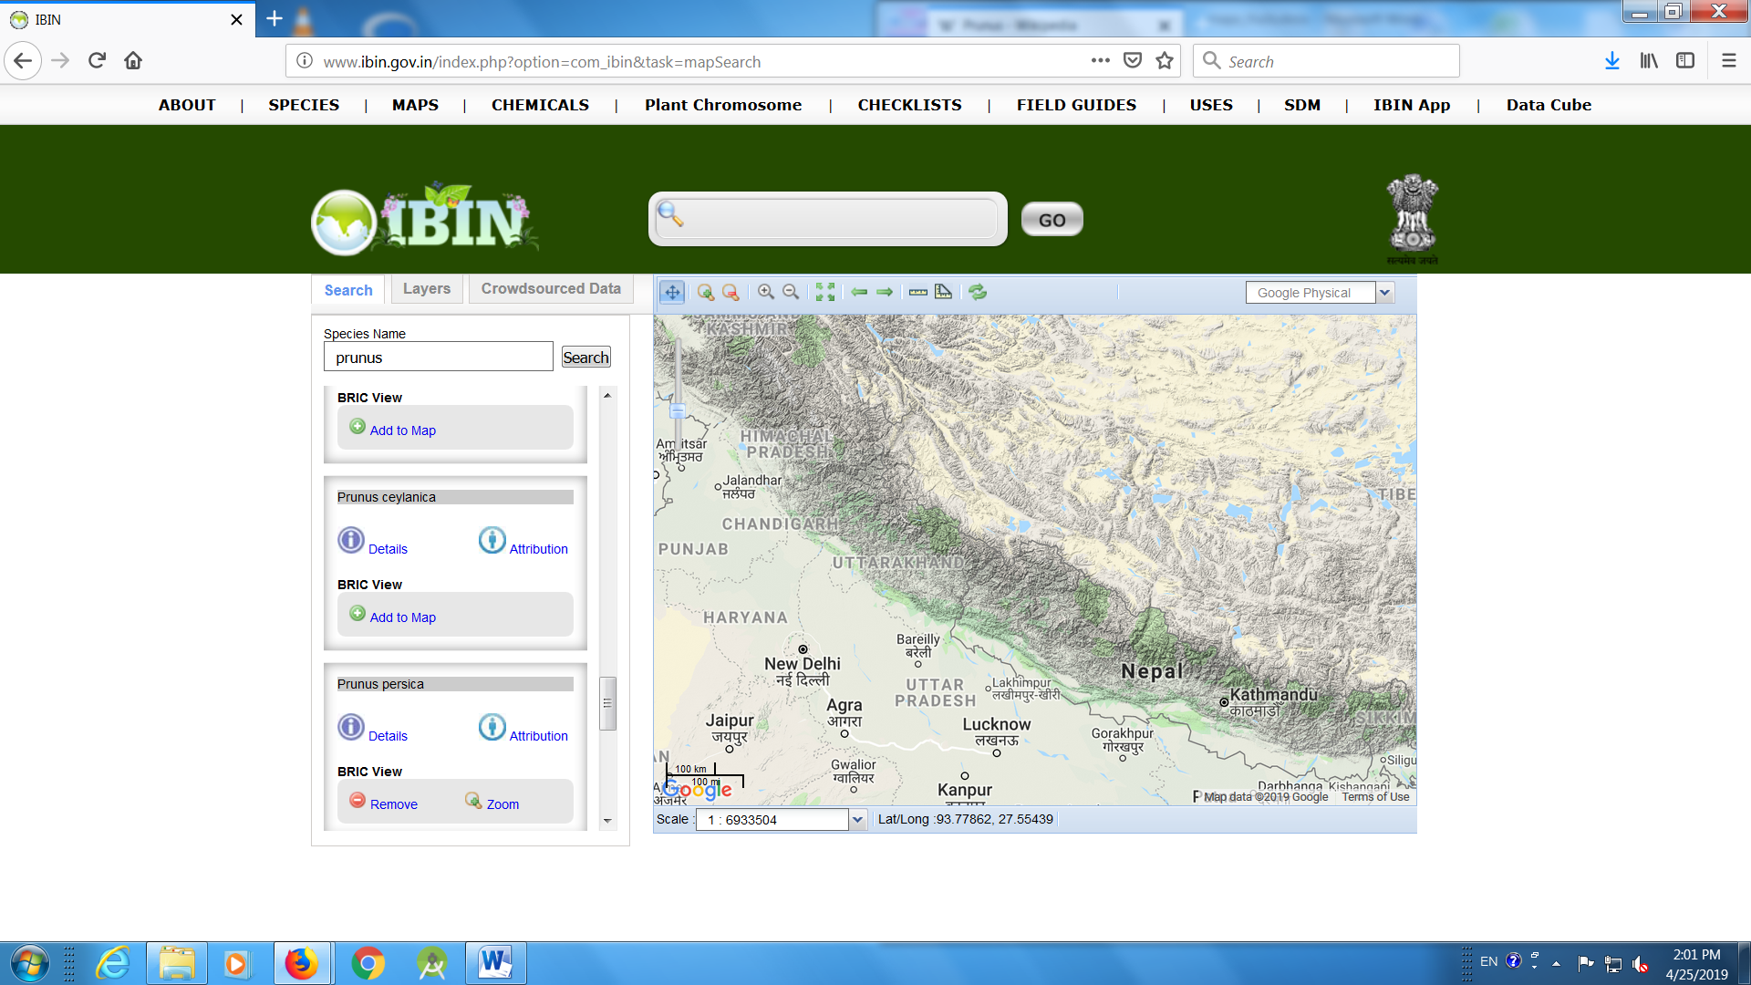

Prunus dulcis
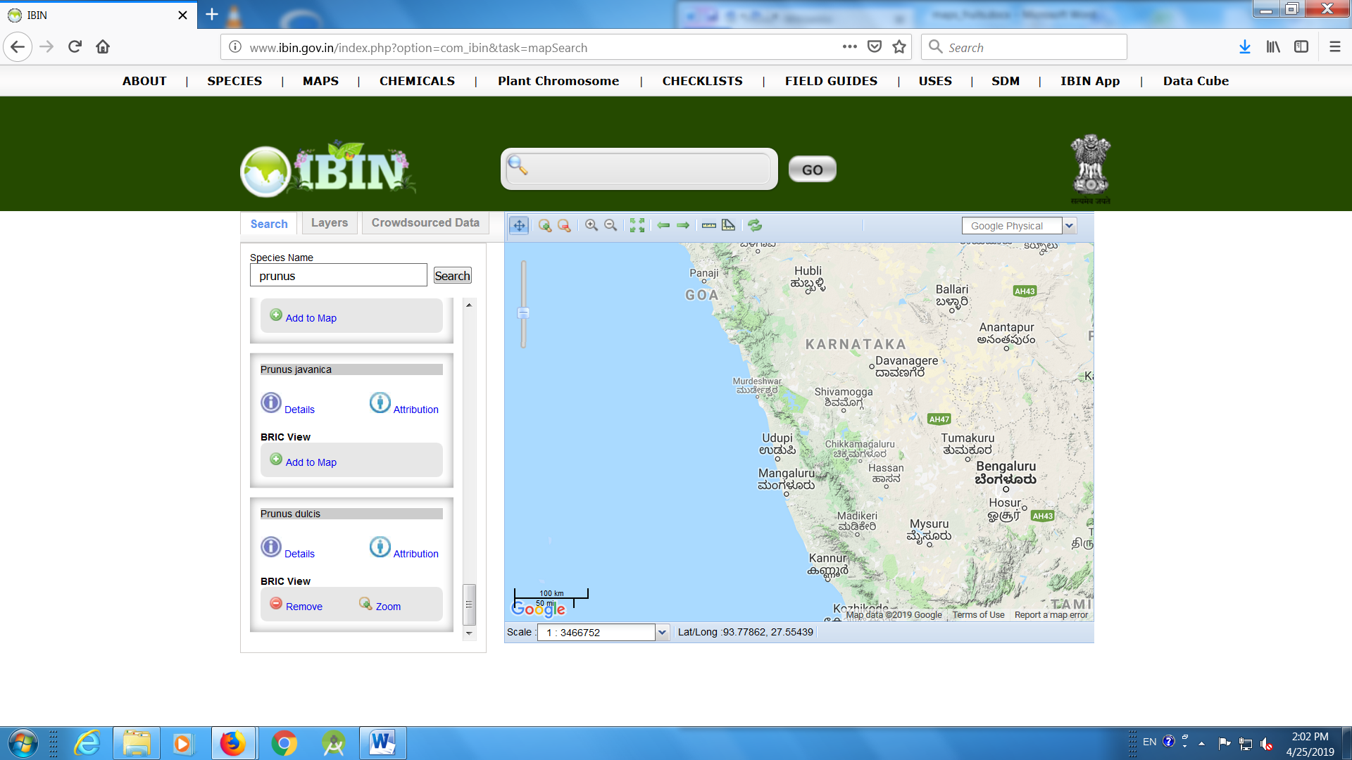

Prunus ceylanica
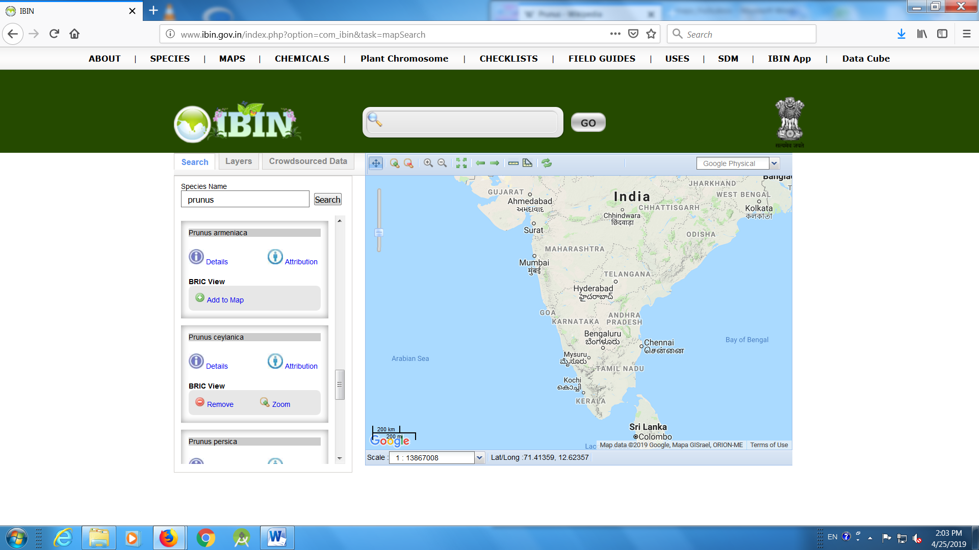

- Rubus
https://www.gbif.org/species/2988638
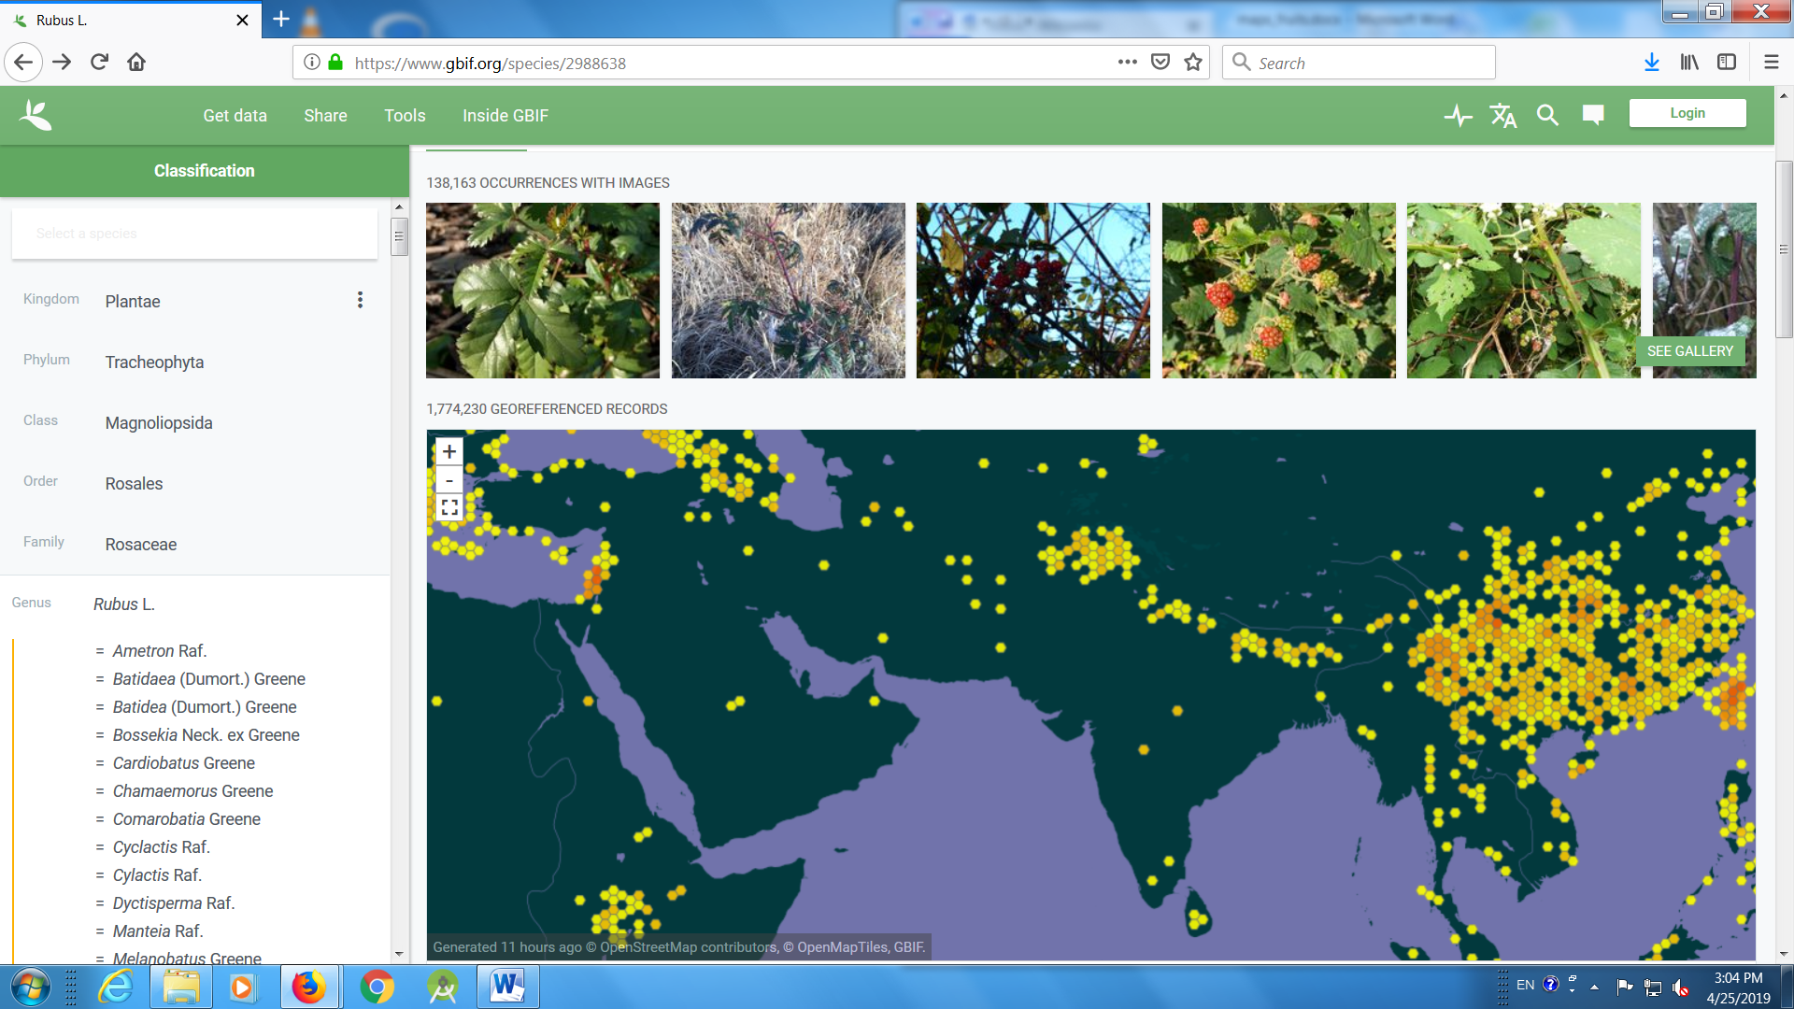

Rubus racemosus
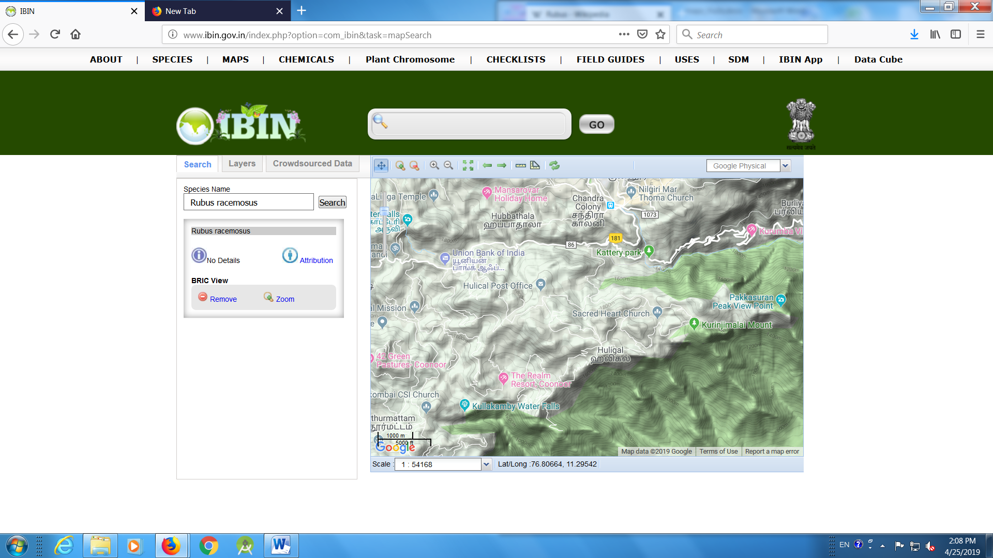
Rubus fockei
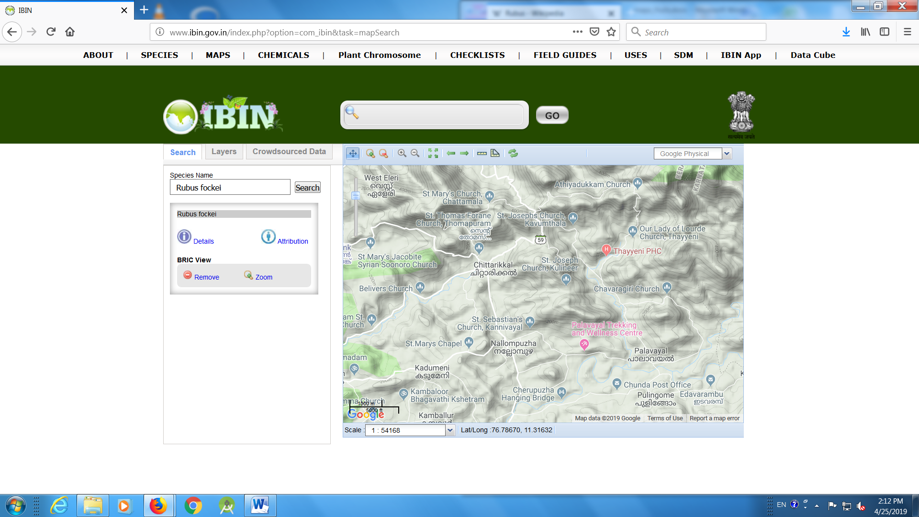

Rubus niveus
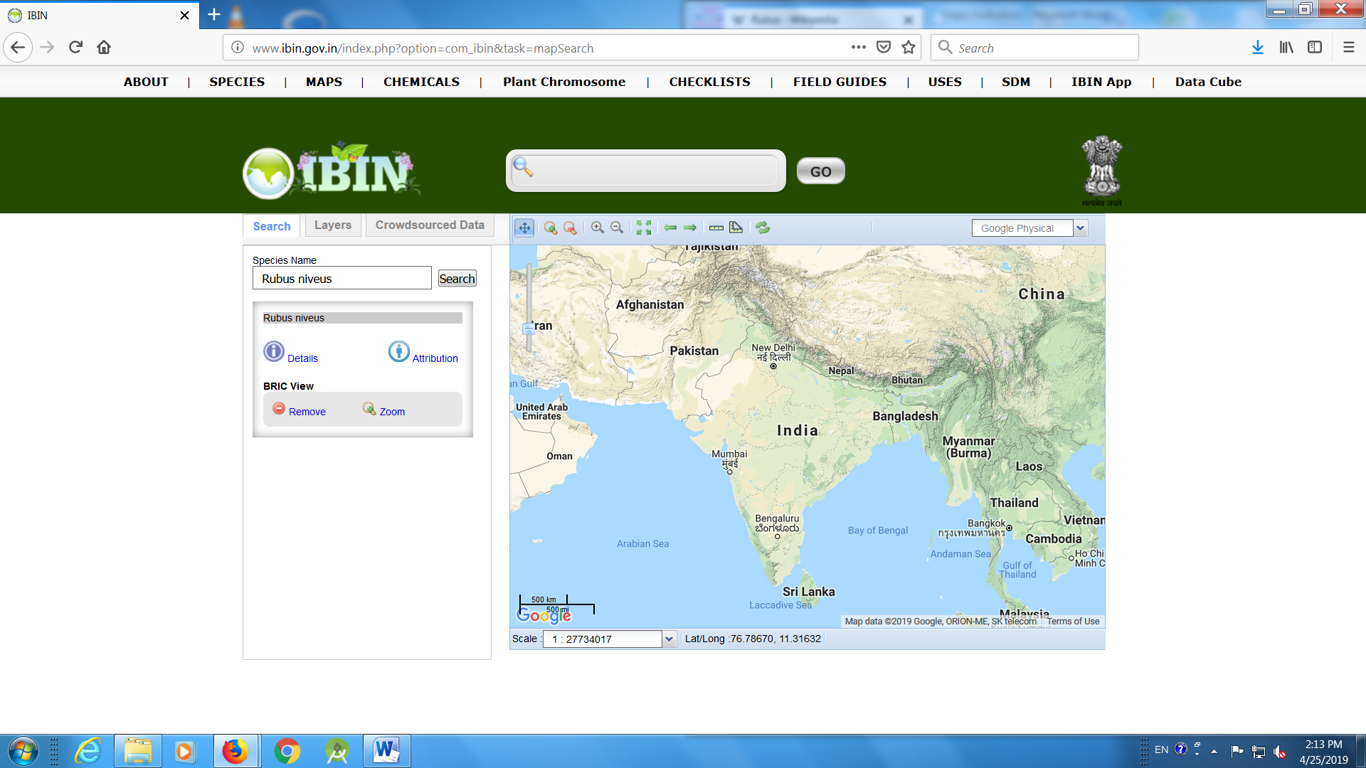
Rubus rosaefolius
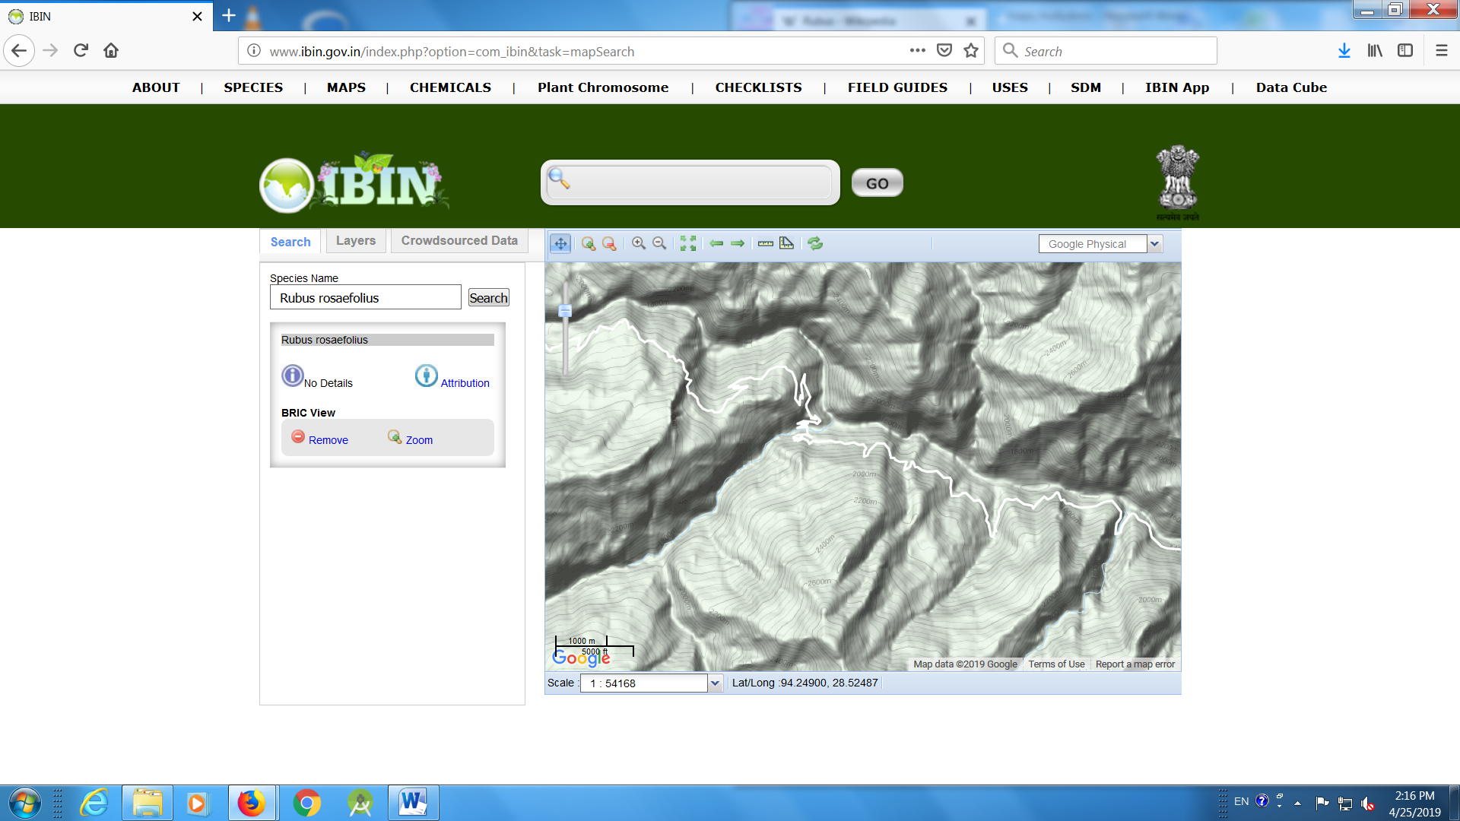

Rubus lucens
