India-Centre of Diversity of Horticultural Crops

Flowers:
- Orchids
https://www.gbif.org/species/2849312
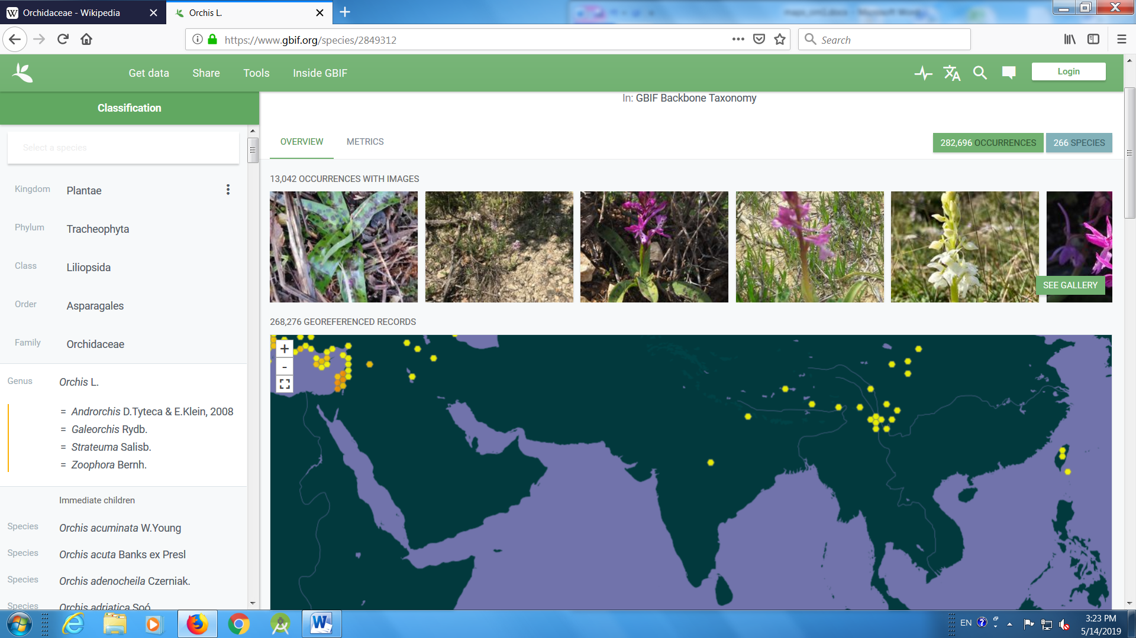

- Rhododendrons
https://www.gbif.org/species/2883073
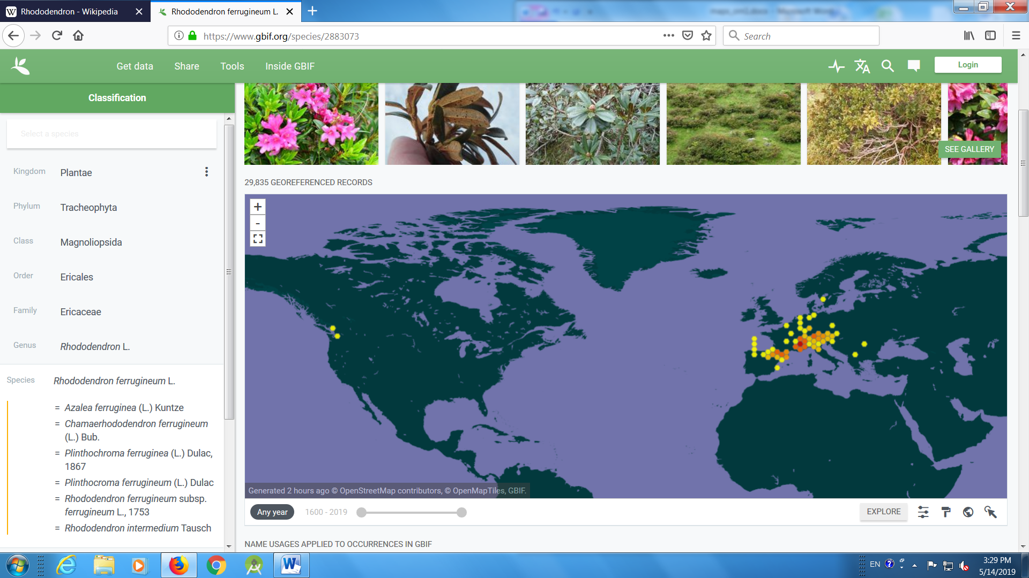

- Musk Rose
https://www.gbif.org/species/3005529
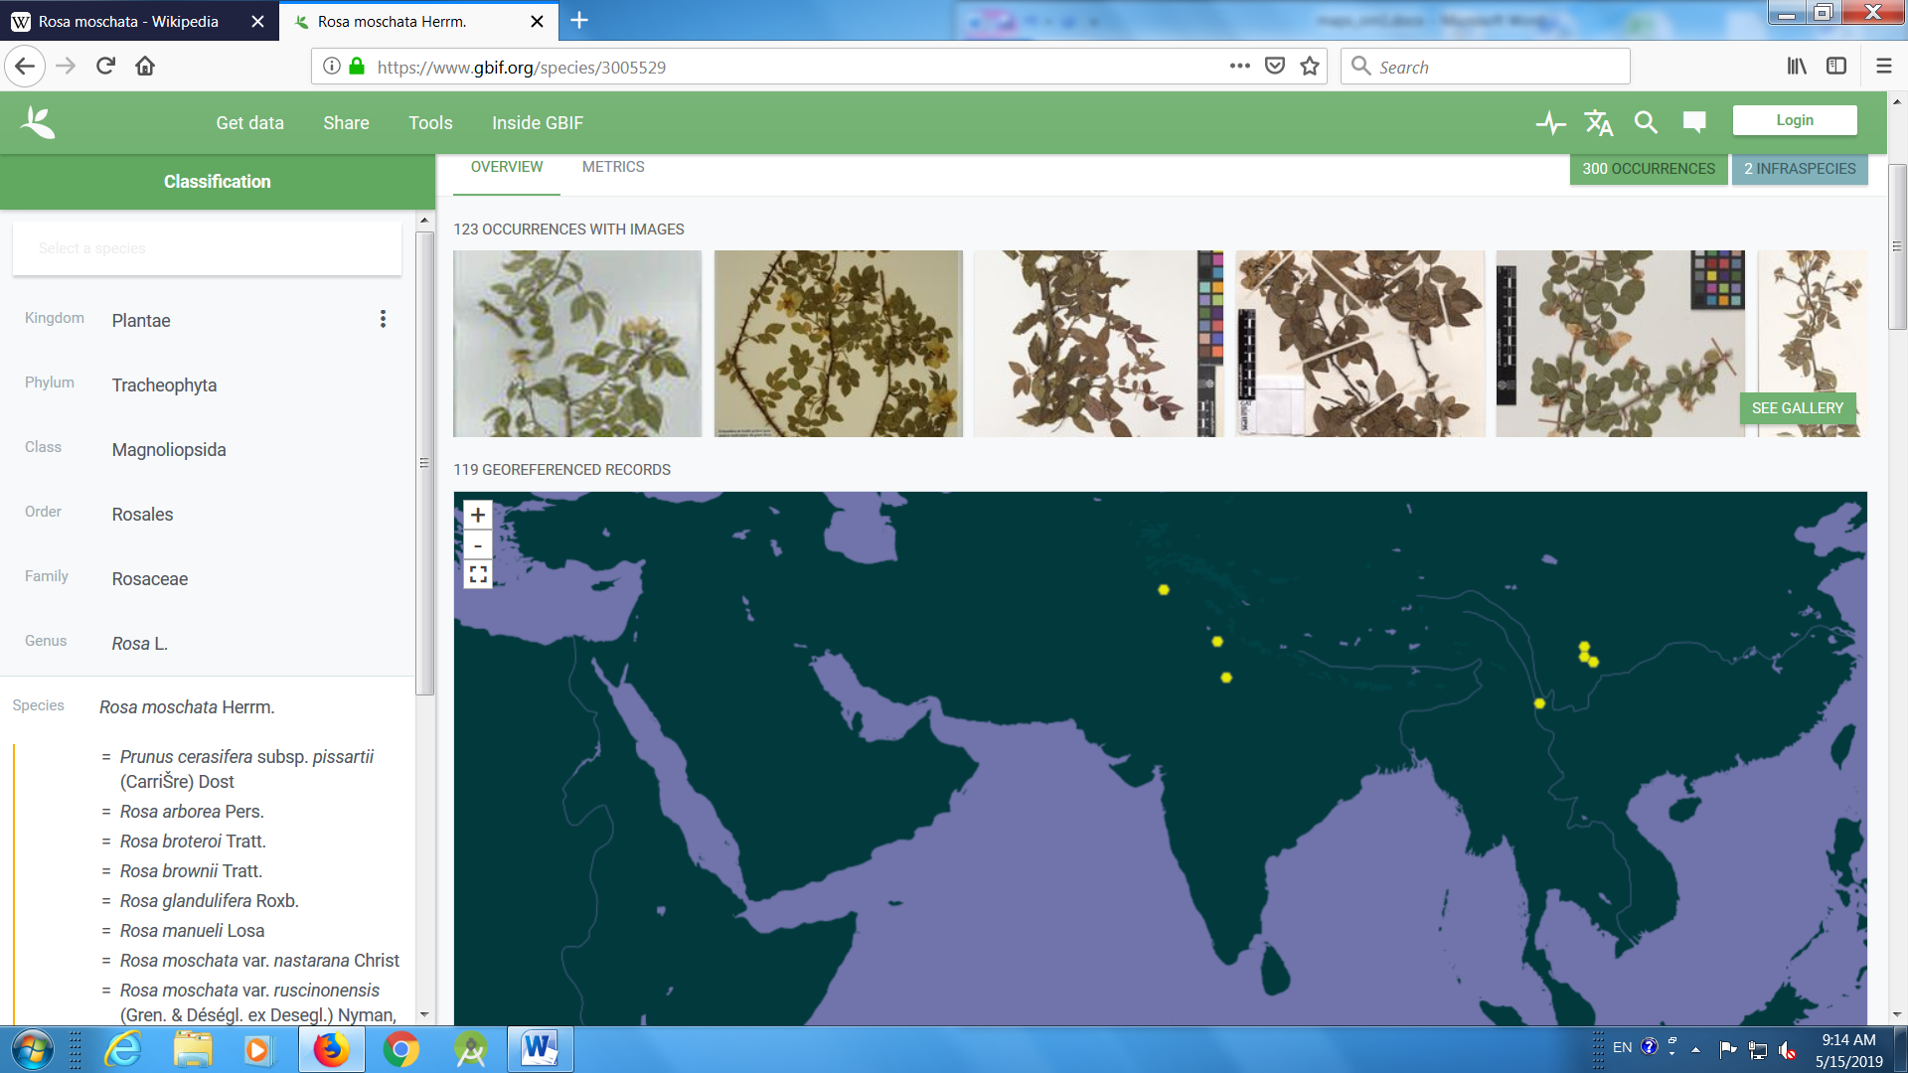

- Begonia
https://www.gbif.org/species/2874710
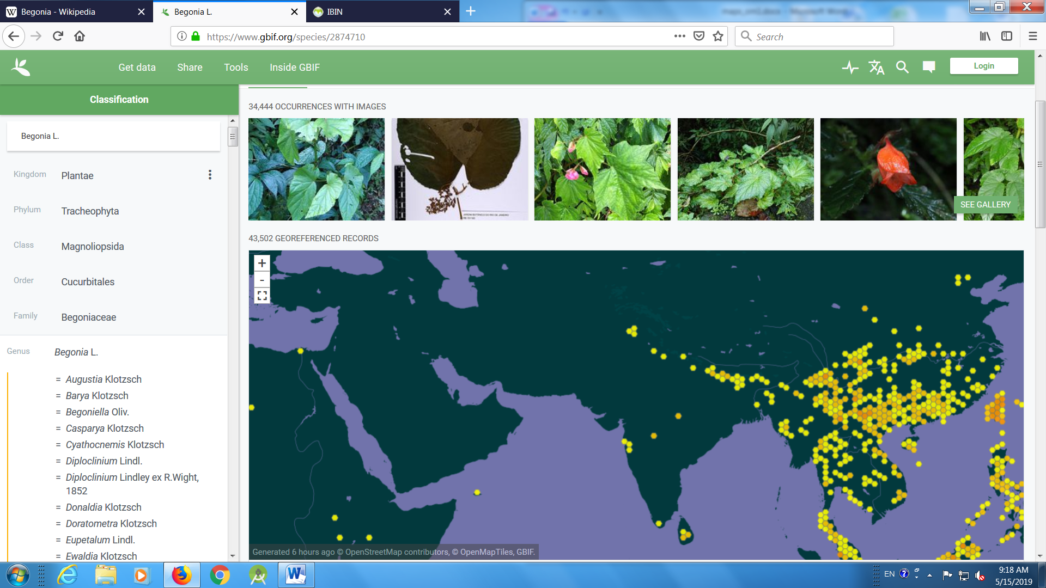

- Balsam
https://www.gbif.org/species/2891773
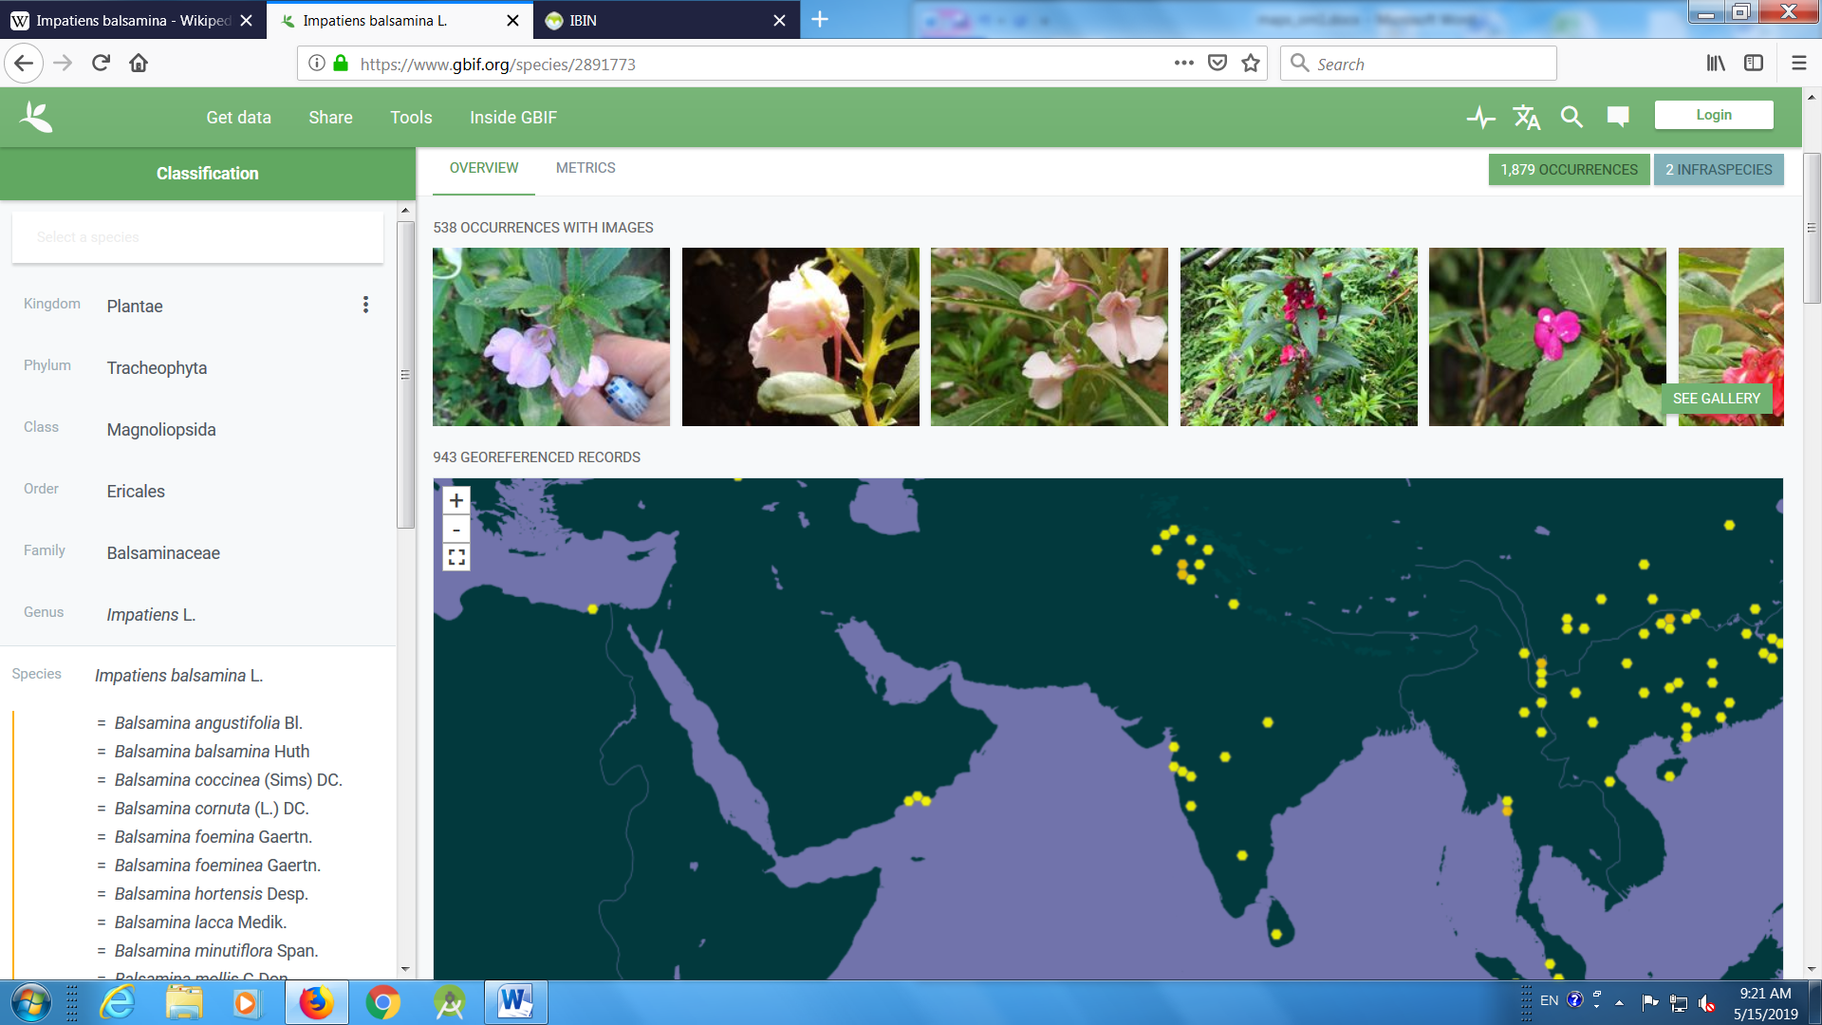

- Globe Amaranth
https://www.gbif.org/species/3084908
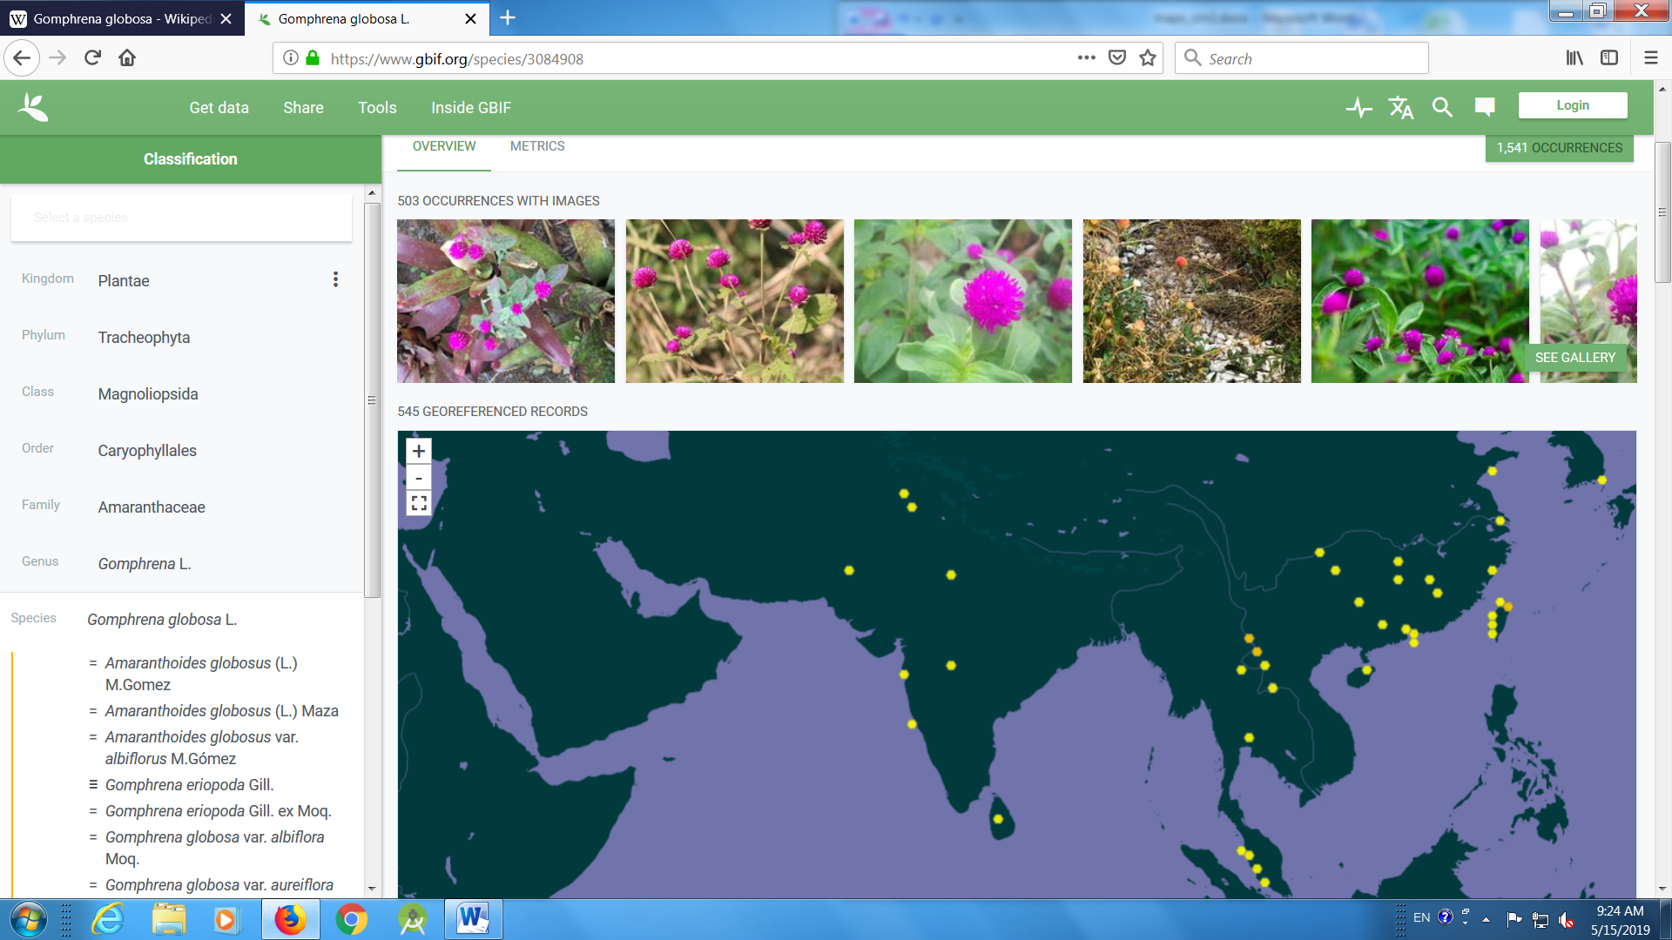

- Glory Lily
https://www.gbif.org/species/2740022
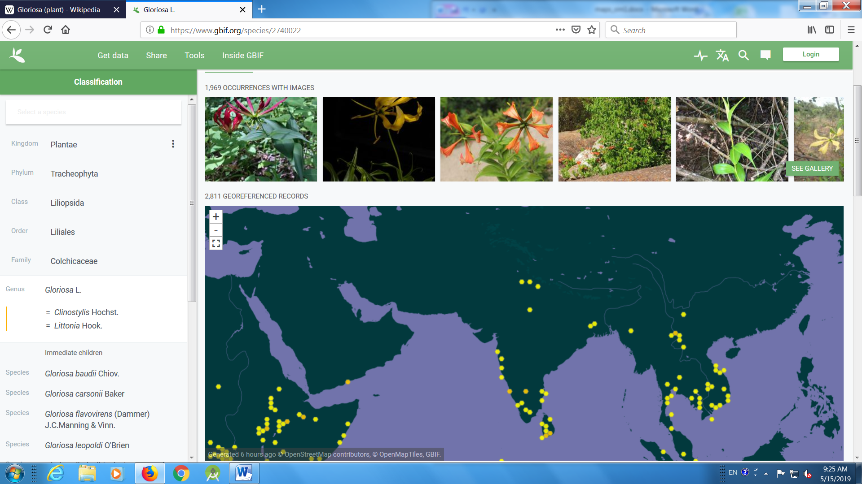

- Foxtail Lily
https://www.gbif.org/species/2778813
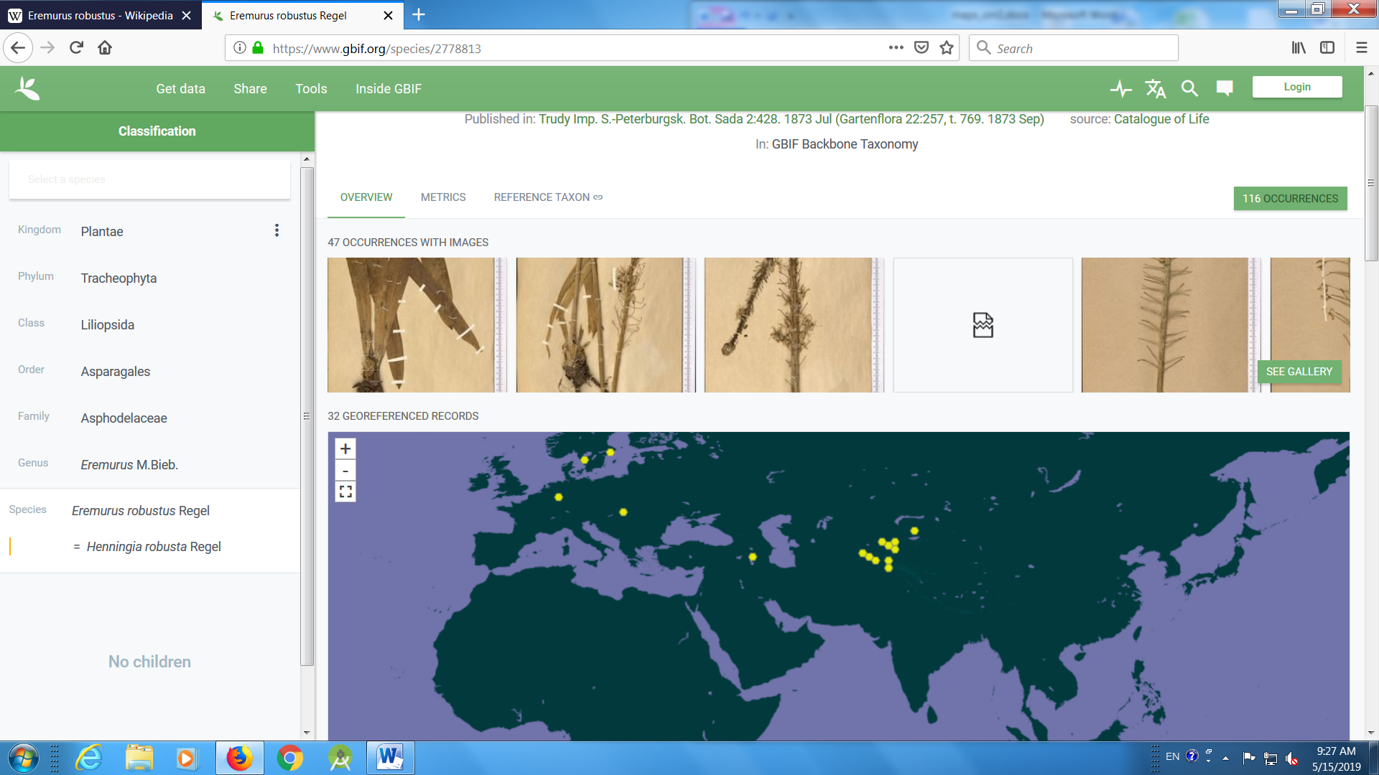

- Primula
https://www.gbif.org/species/8026112

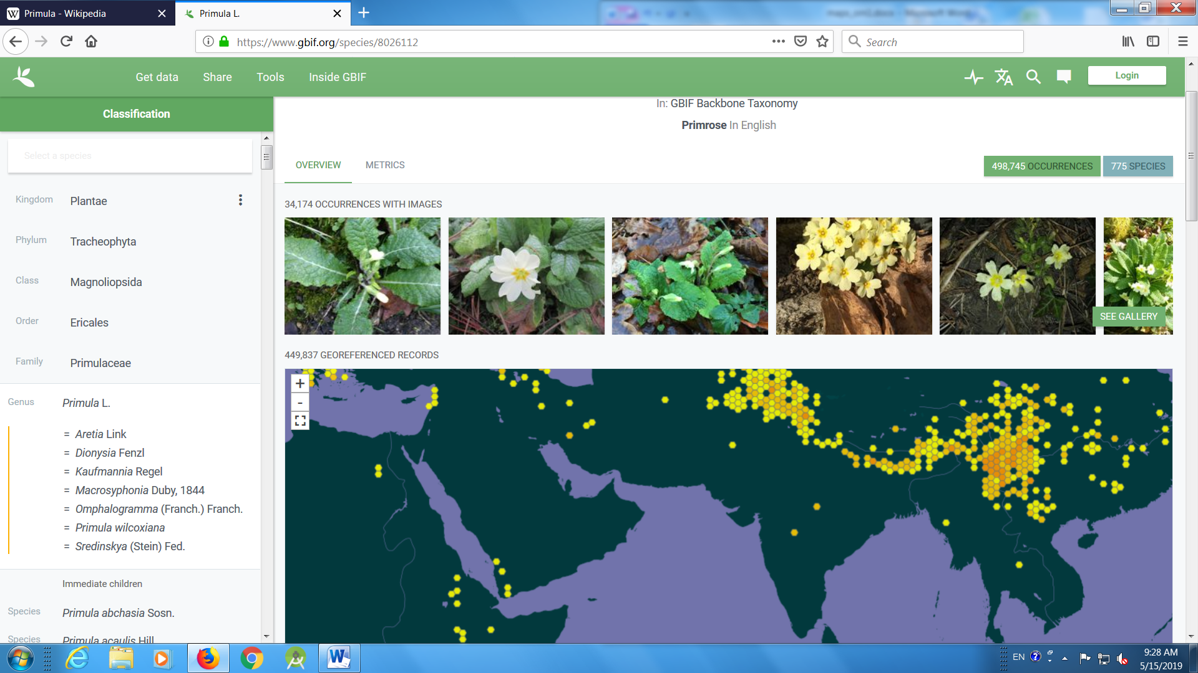

- Blue Poppy
https://www.gbif.org/species/7153468
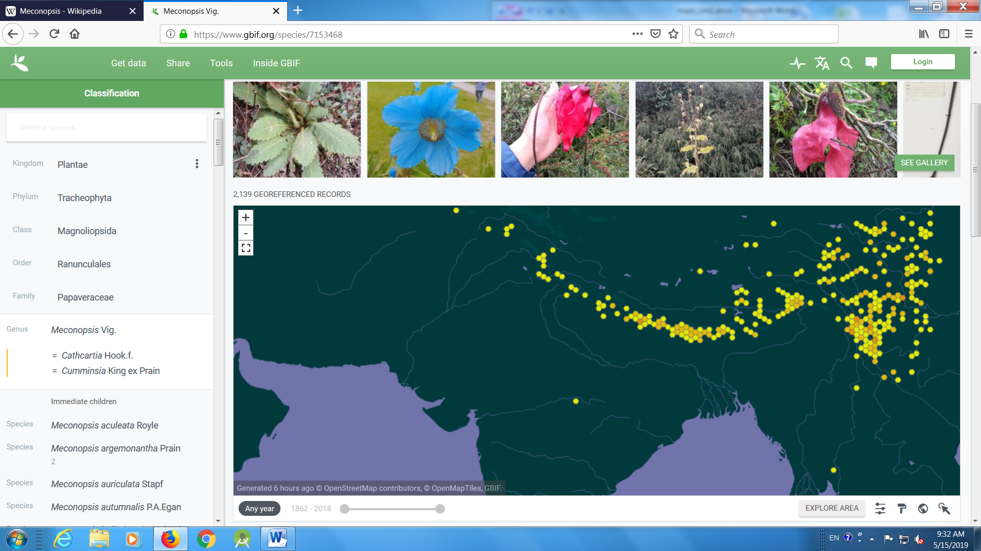

- Lotus
https://www.gbif.org/species/2882449

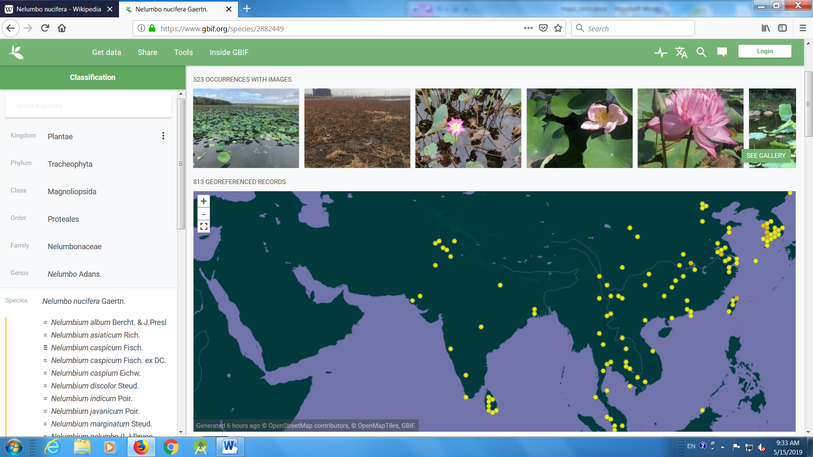

- Water Lily
https://www.gbif.org/species/2423
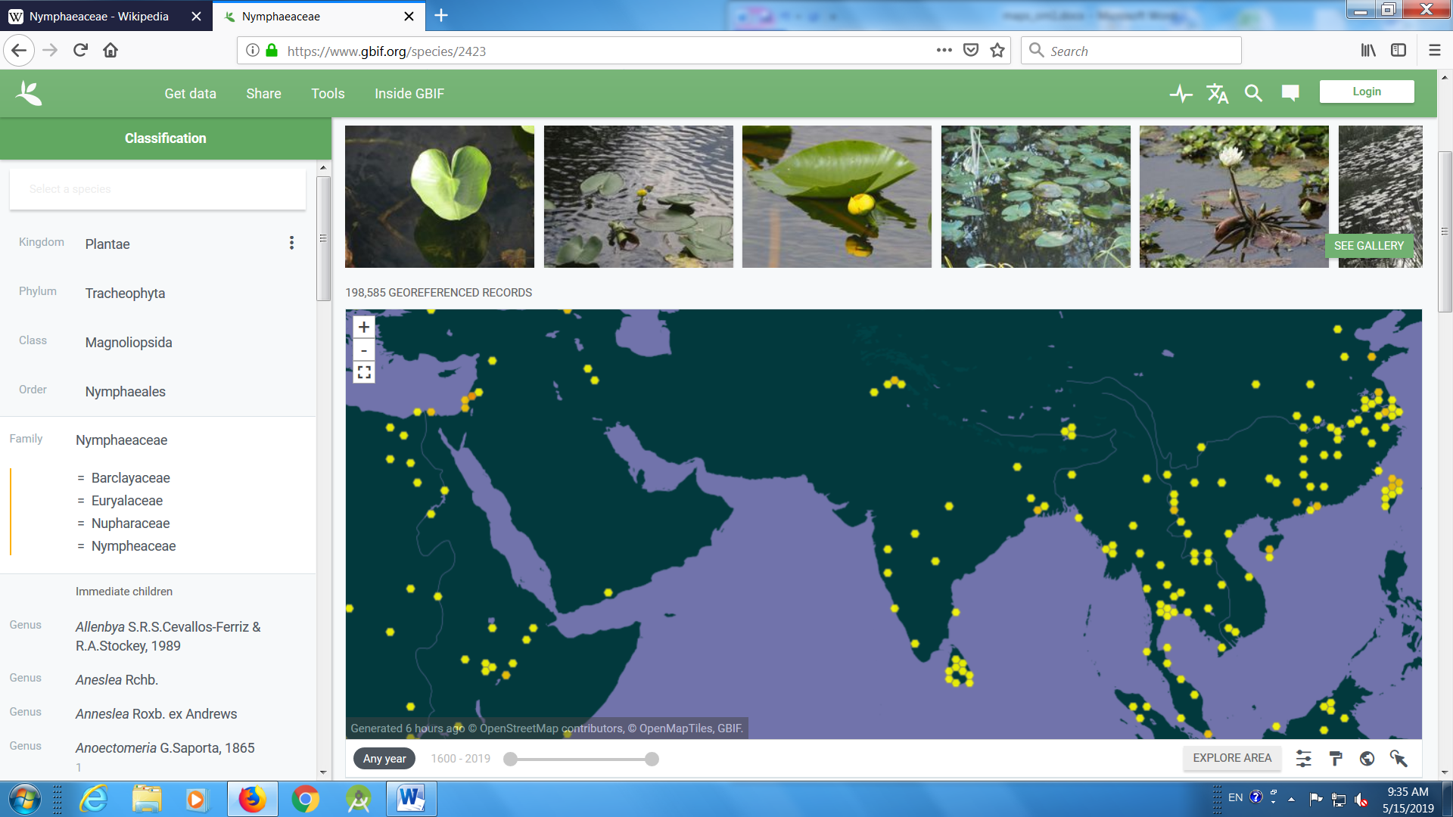

- Clematis
https://www.gbif.org/species/3033512
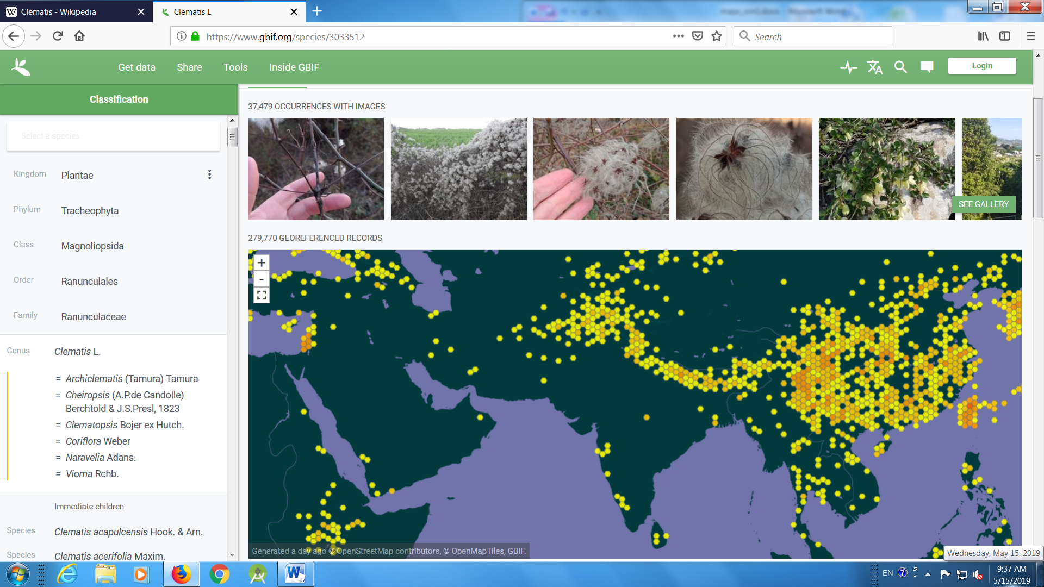

- Tulip
https://www.gbif.org/species/2750913
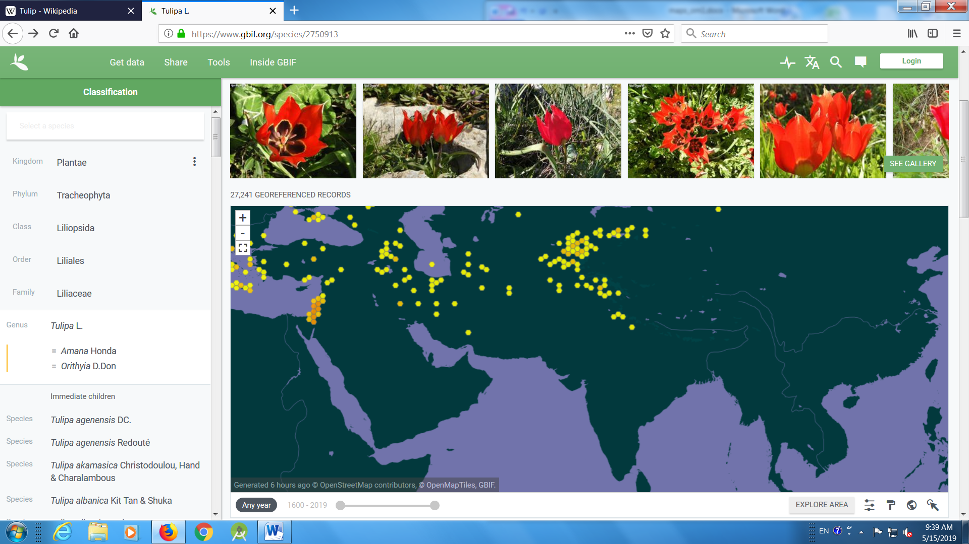

Trees
- Kachnar
https://www.gbif.org/species/2953251
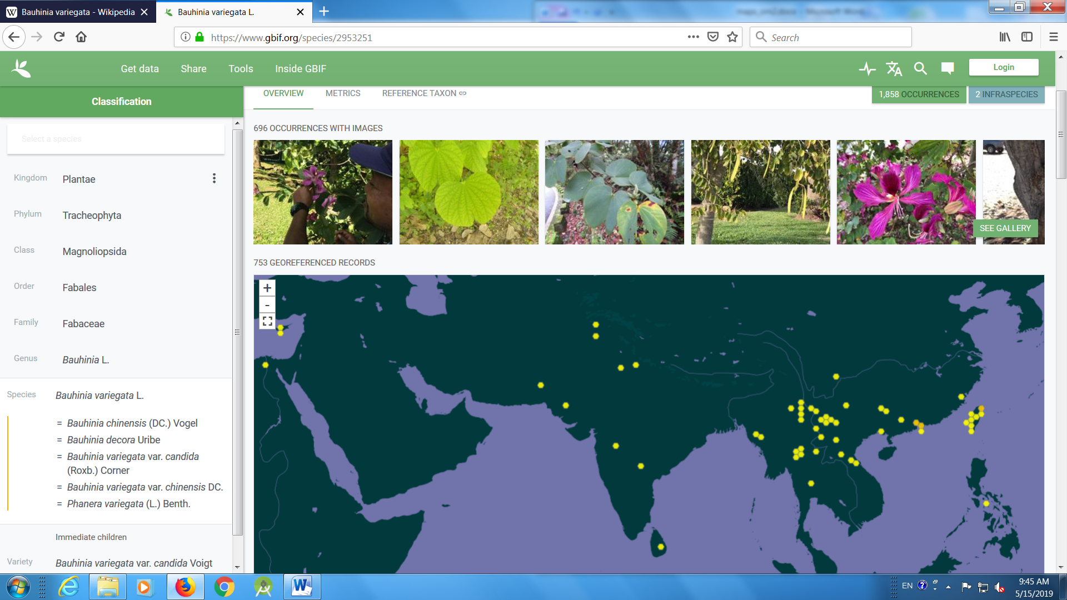
- Amaltas
https://www.gbif.org/species/5357108
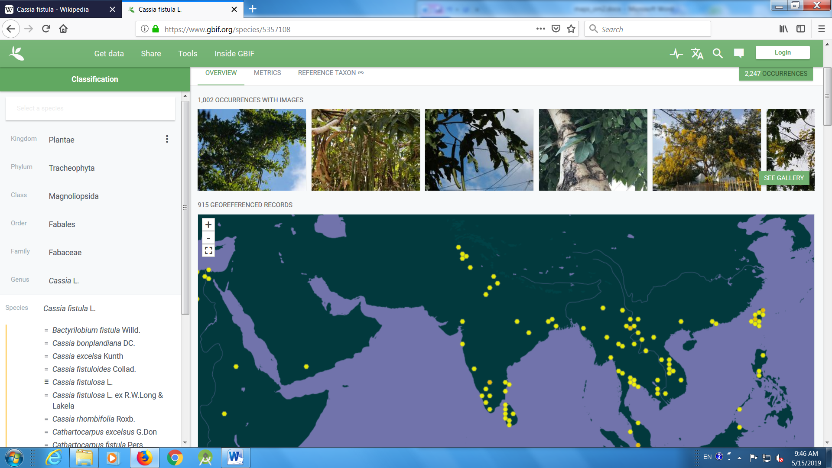

- Pink cassia
https://www.gbif.org/species/5357125
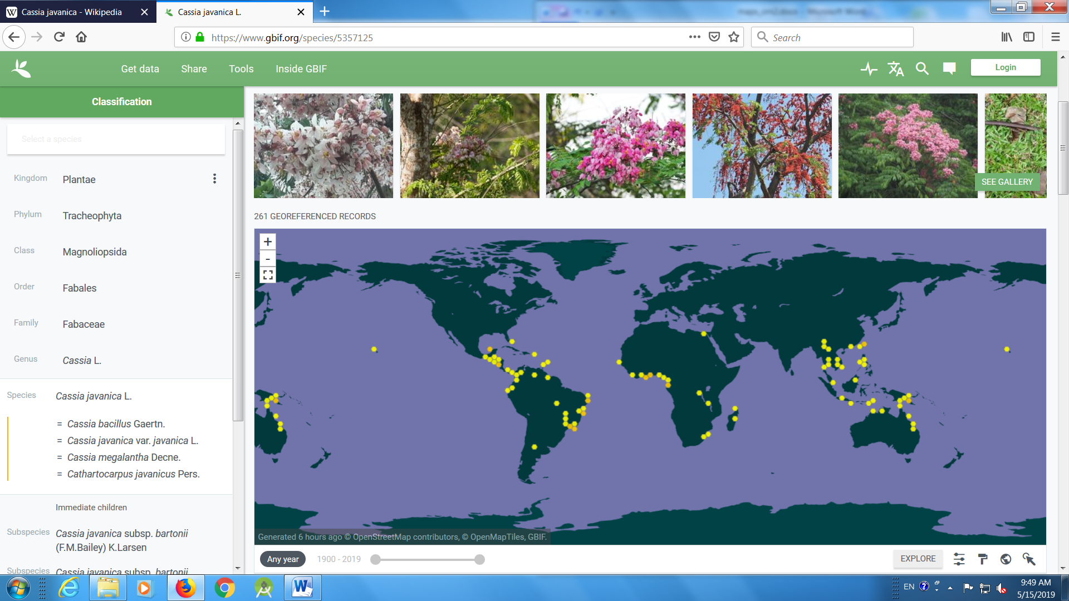
- Butera
- India coral tree
https://www.gbif.org/species/5349581
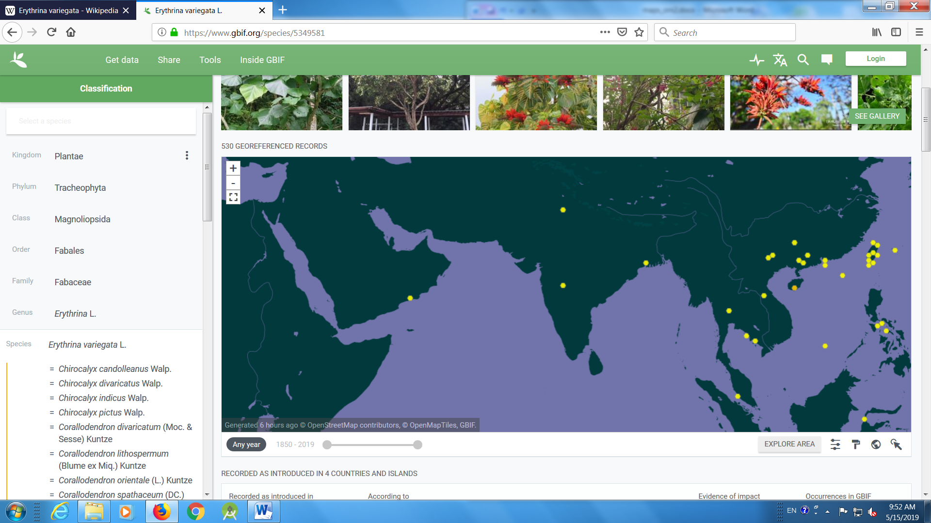

- Pride of India
https://www.gbif.org/species/3188724

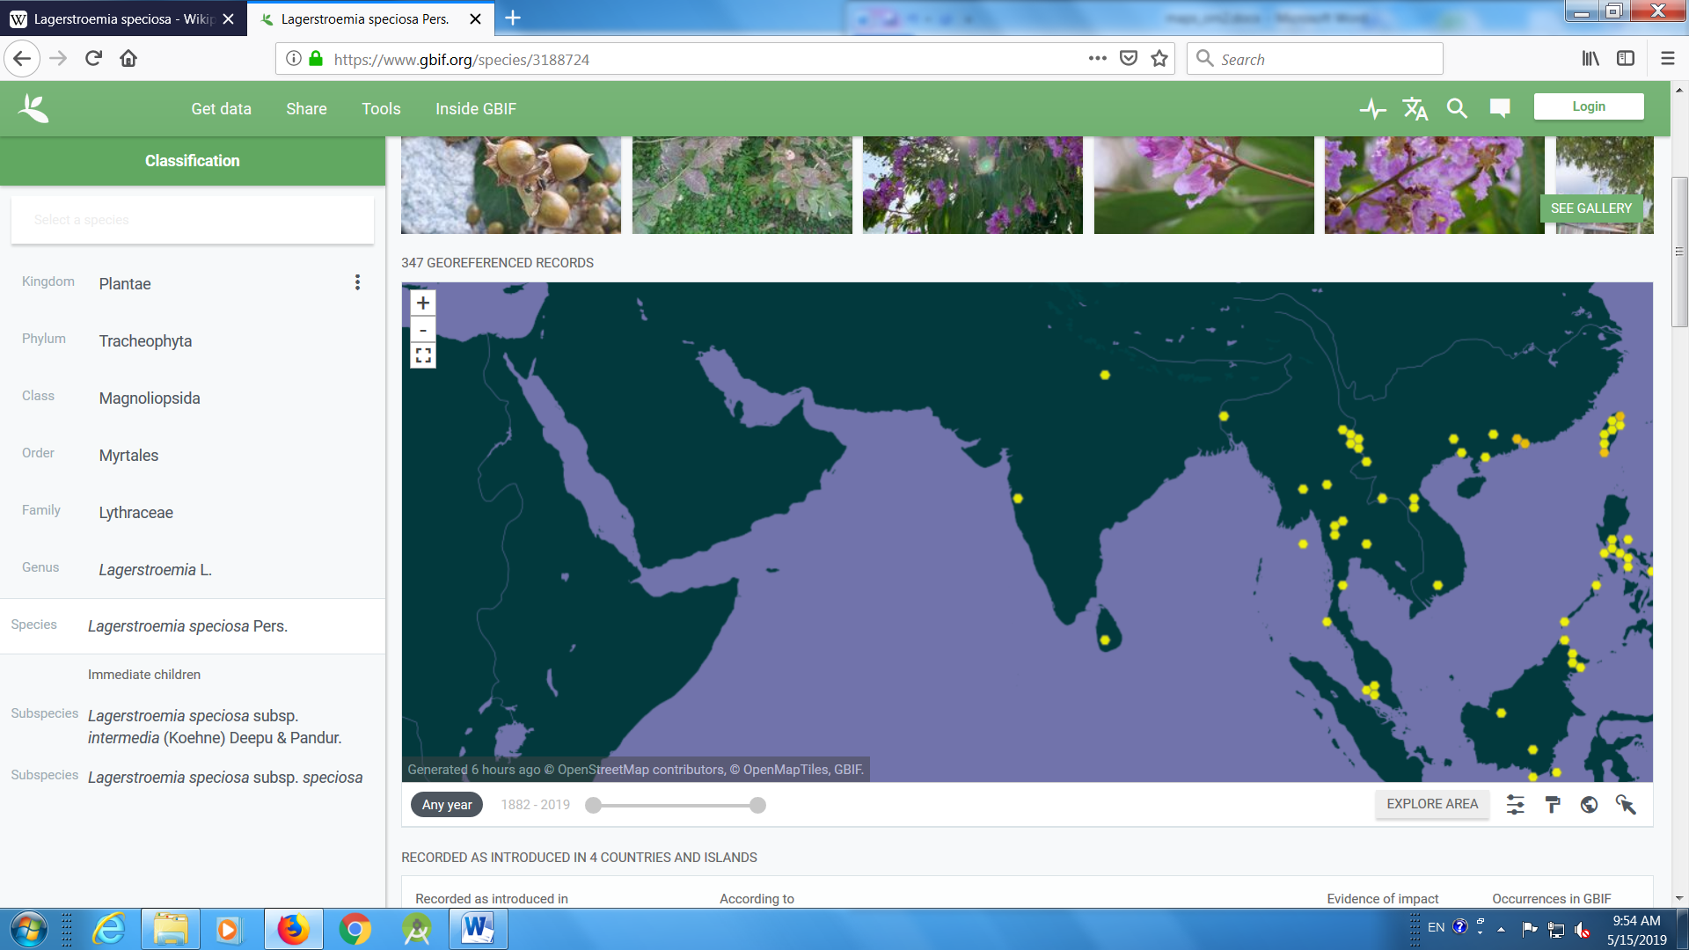
- Scarlet cordial
https://www.gbif.org/species/5341289
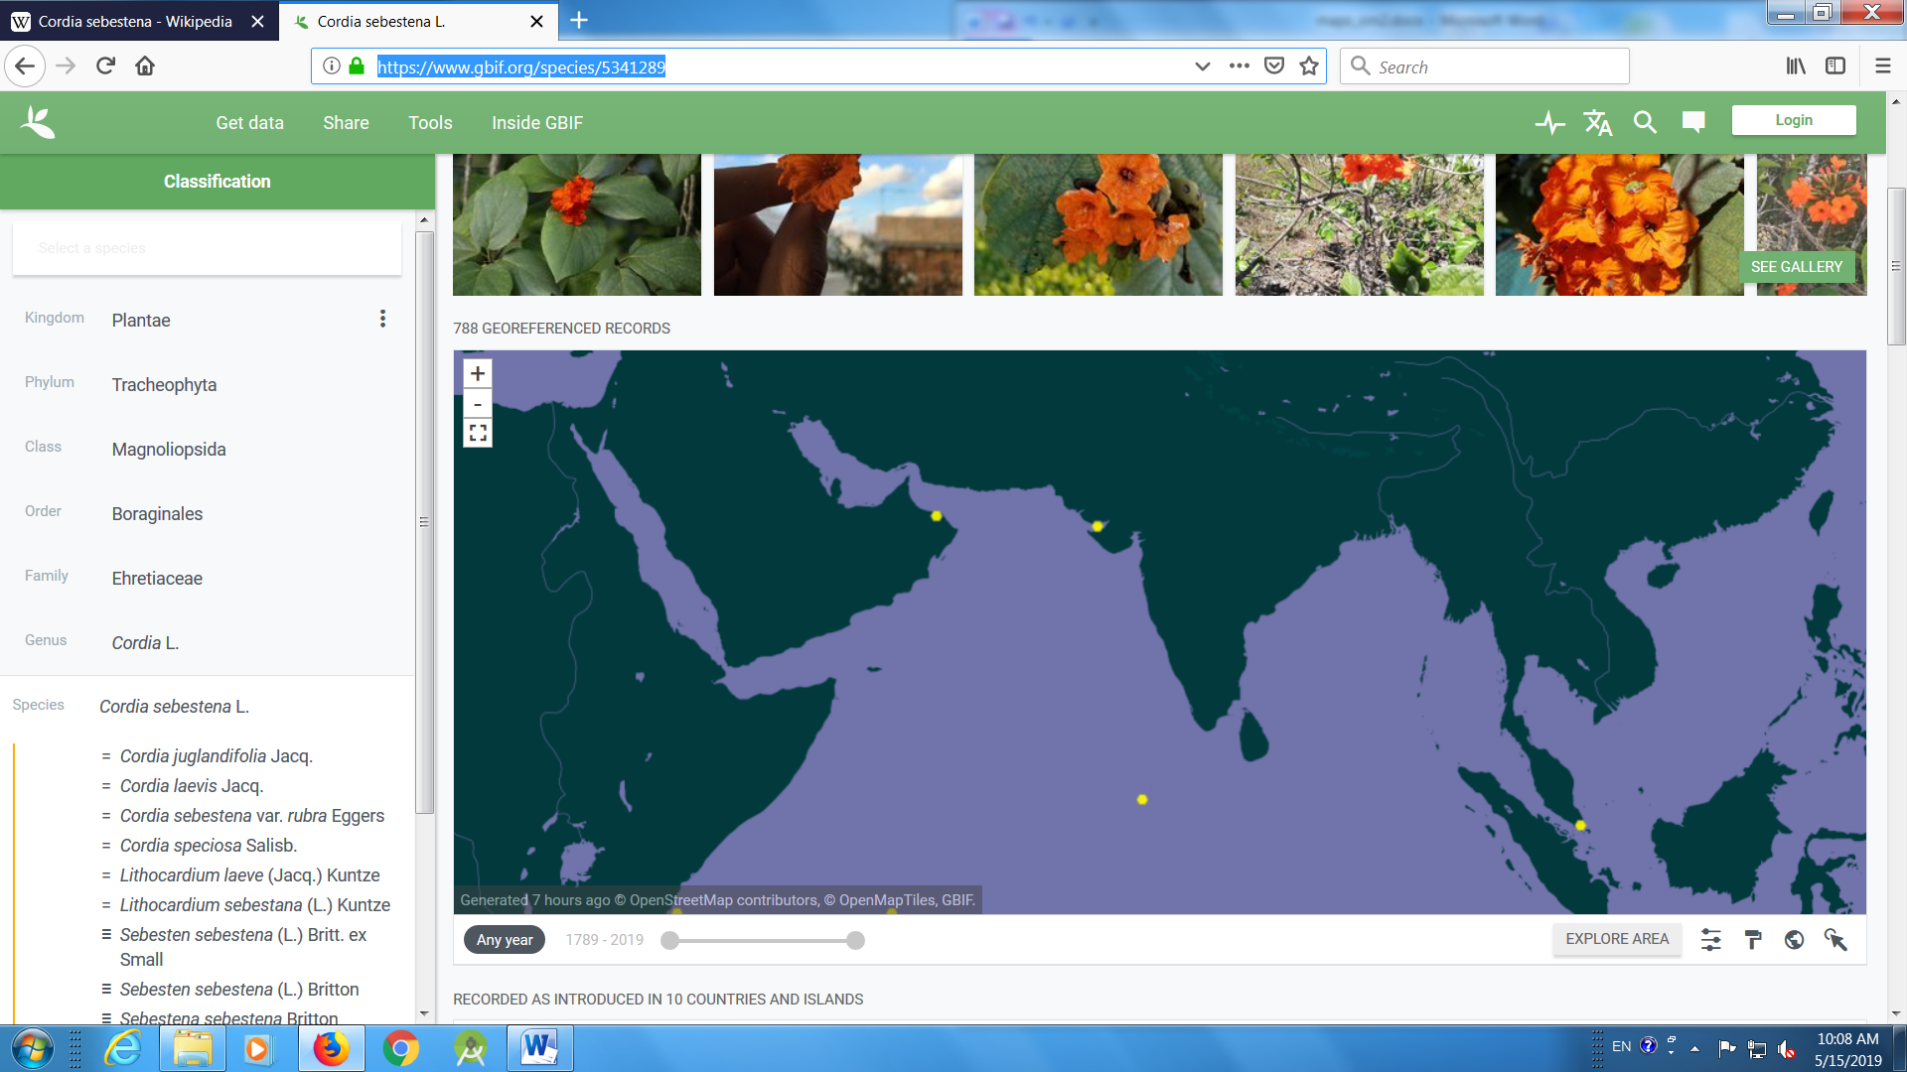

- Yellow silk cotton tree
https://www.gbif.org/species/2874867
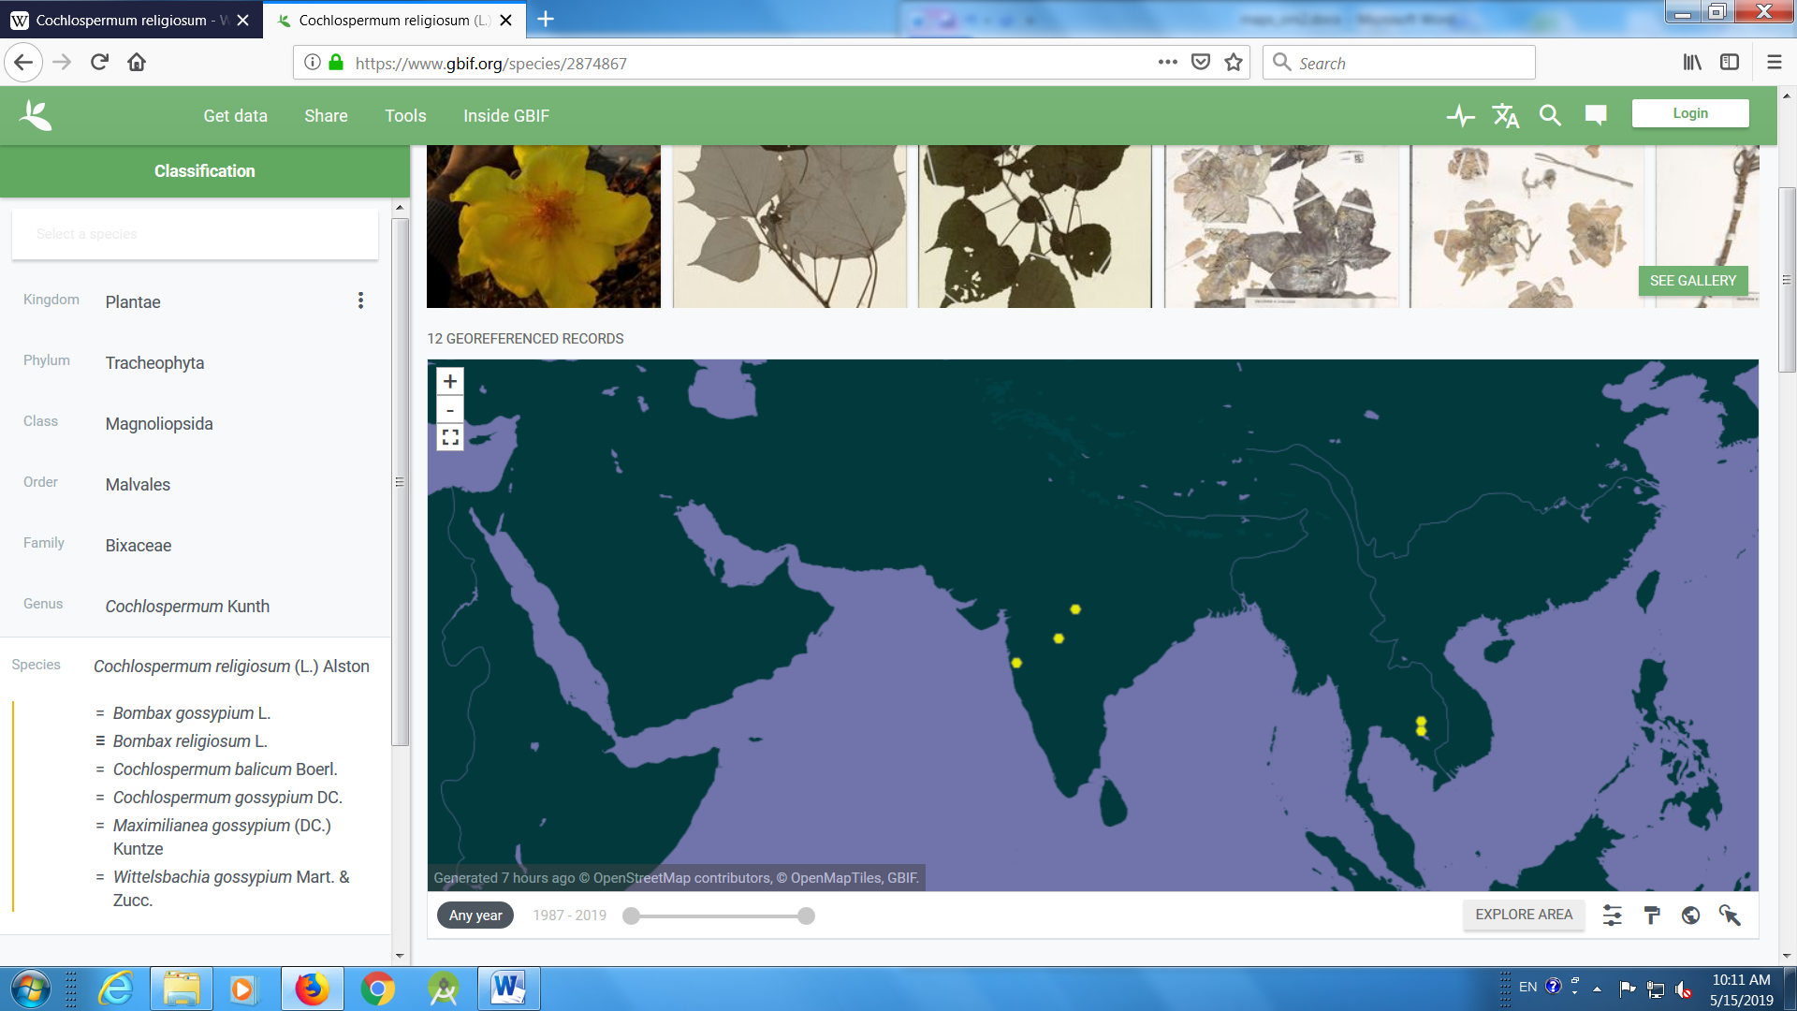
- Karanj
https://www.gbif.org/species/5357476
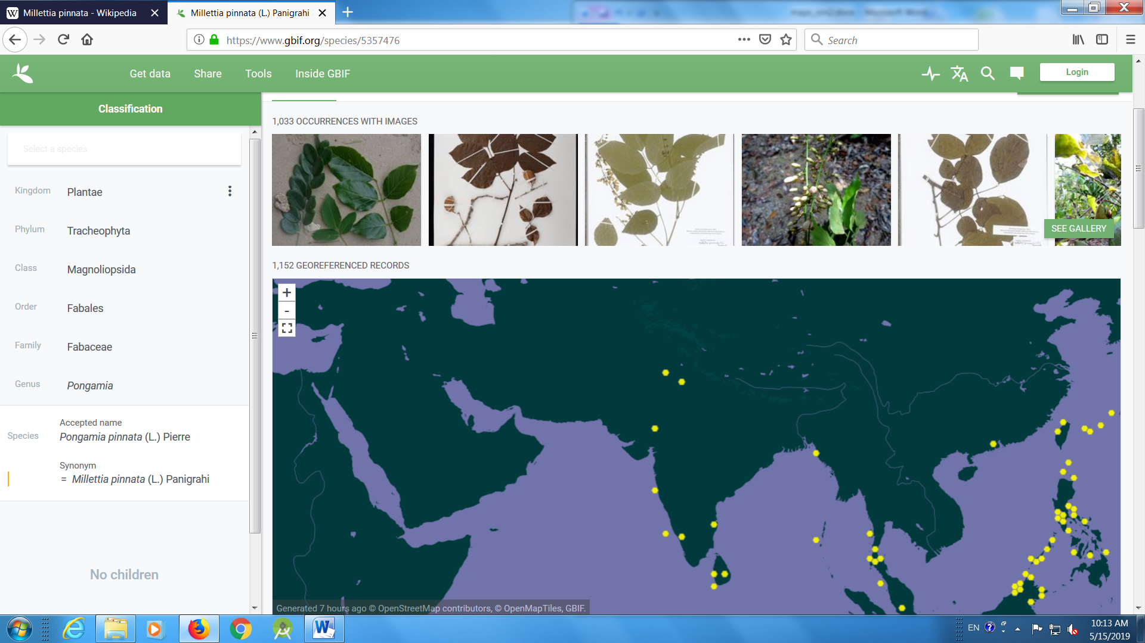

- Tecomella
https://www.gbif.org/species/4093643
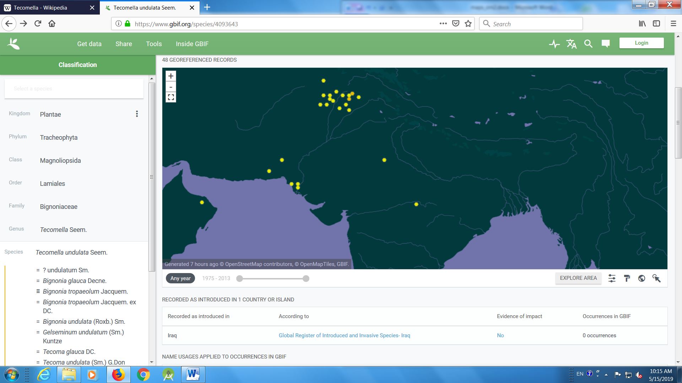
- Tulip tree
https://www.gbif.org/species/3152860
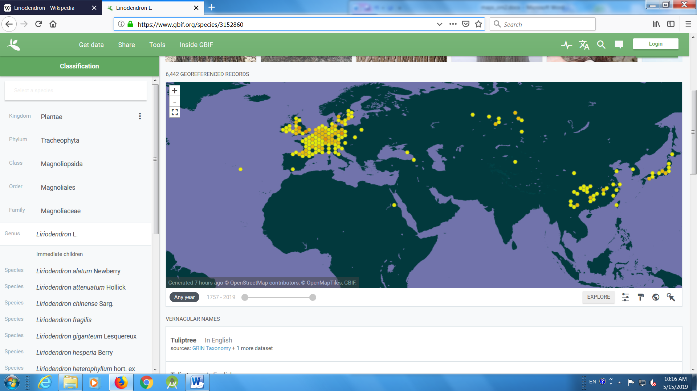

- Chalta
https://www.gbif.org/species/5383898
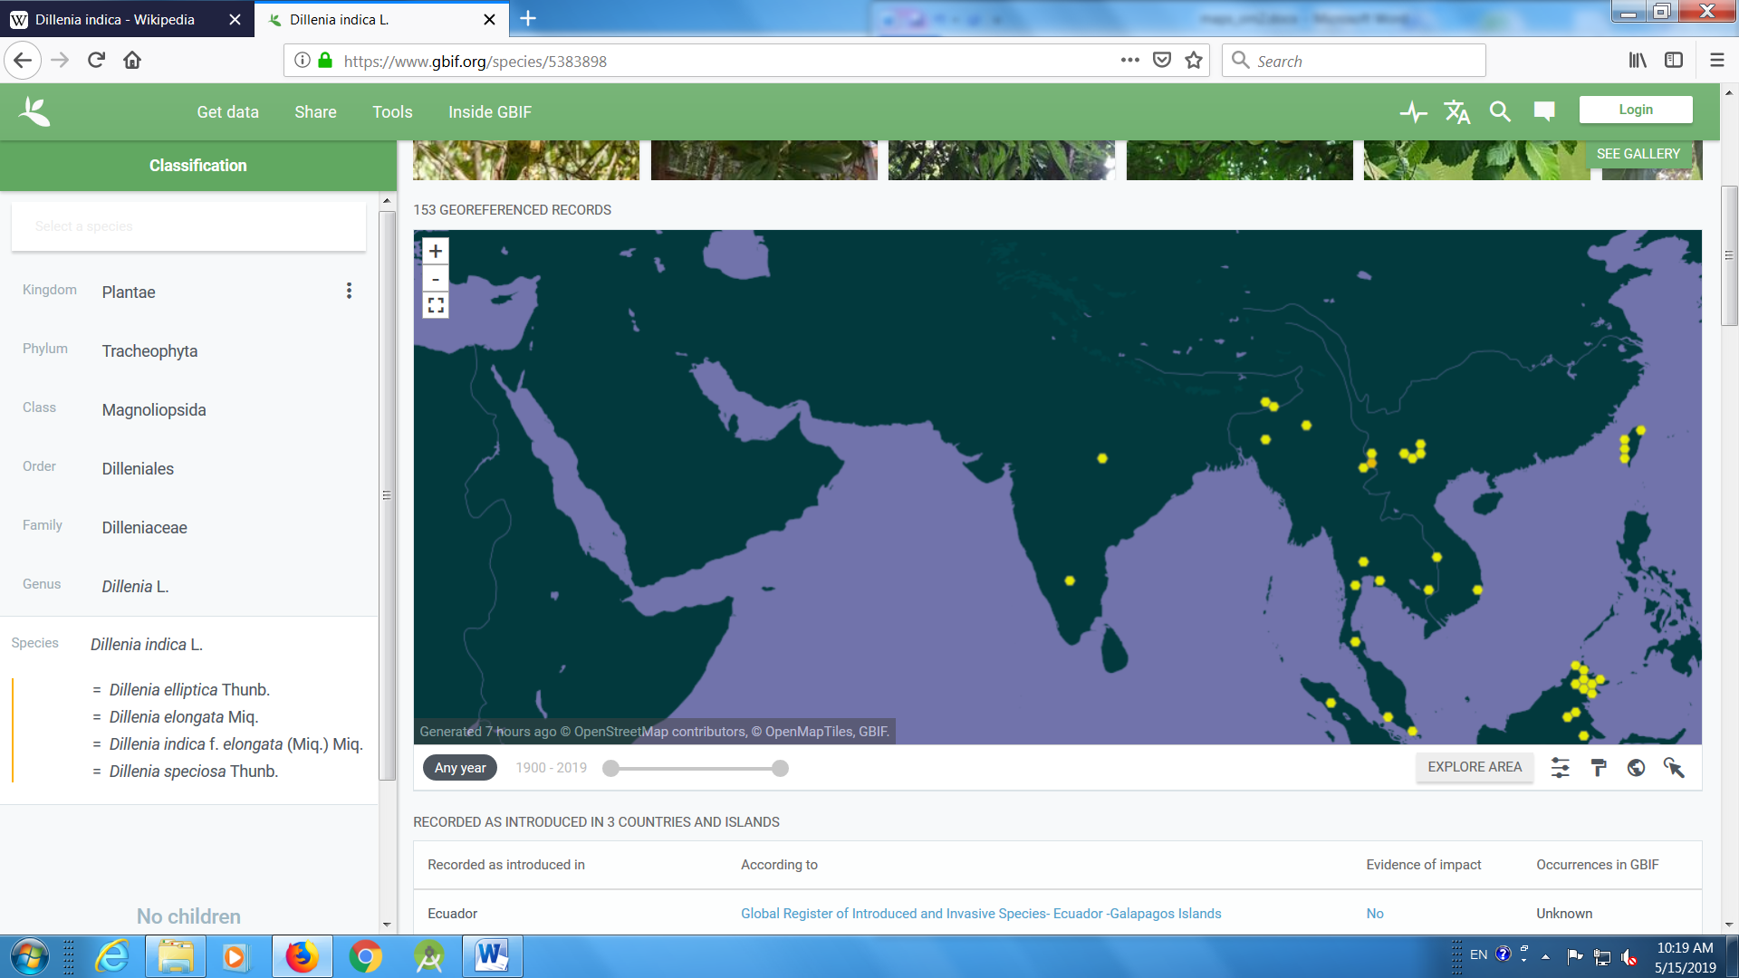
- Sita ashok
https://www.gbif.org/species/5359545
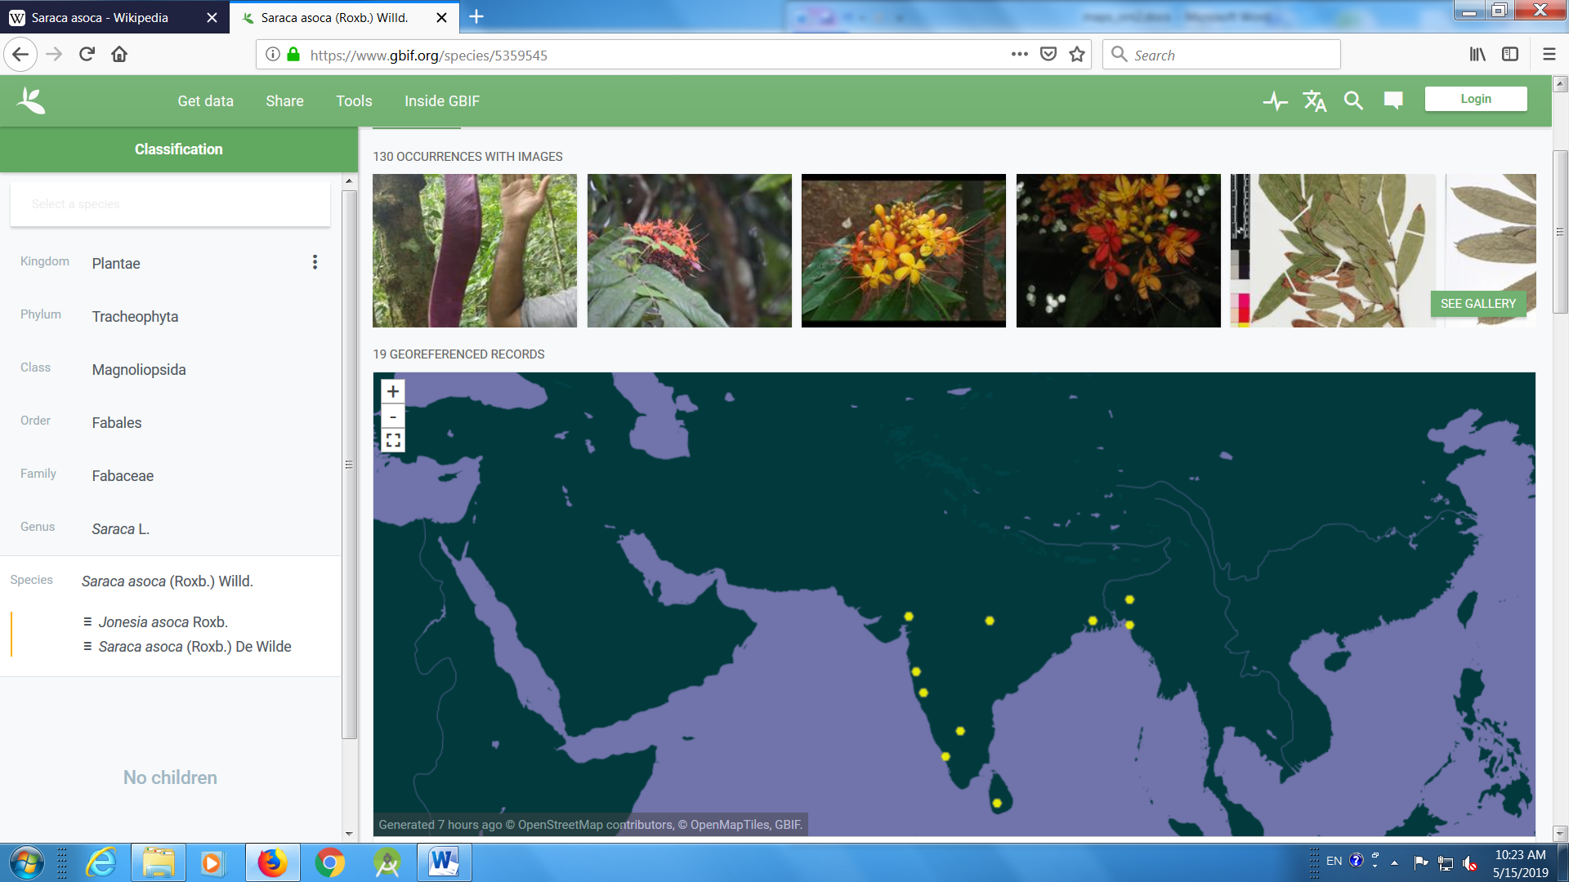

- Arjun
https://www.gbif.org/species/3699548
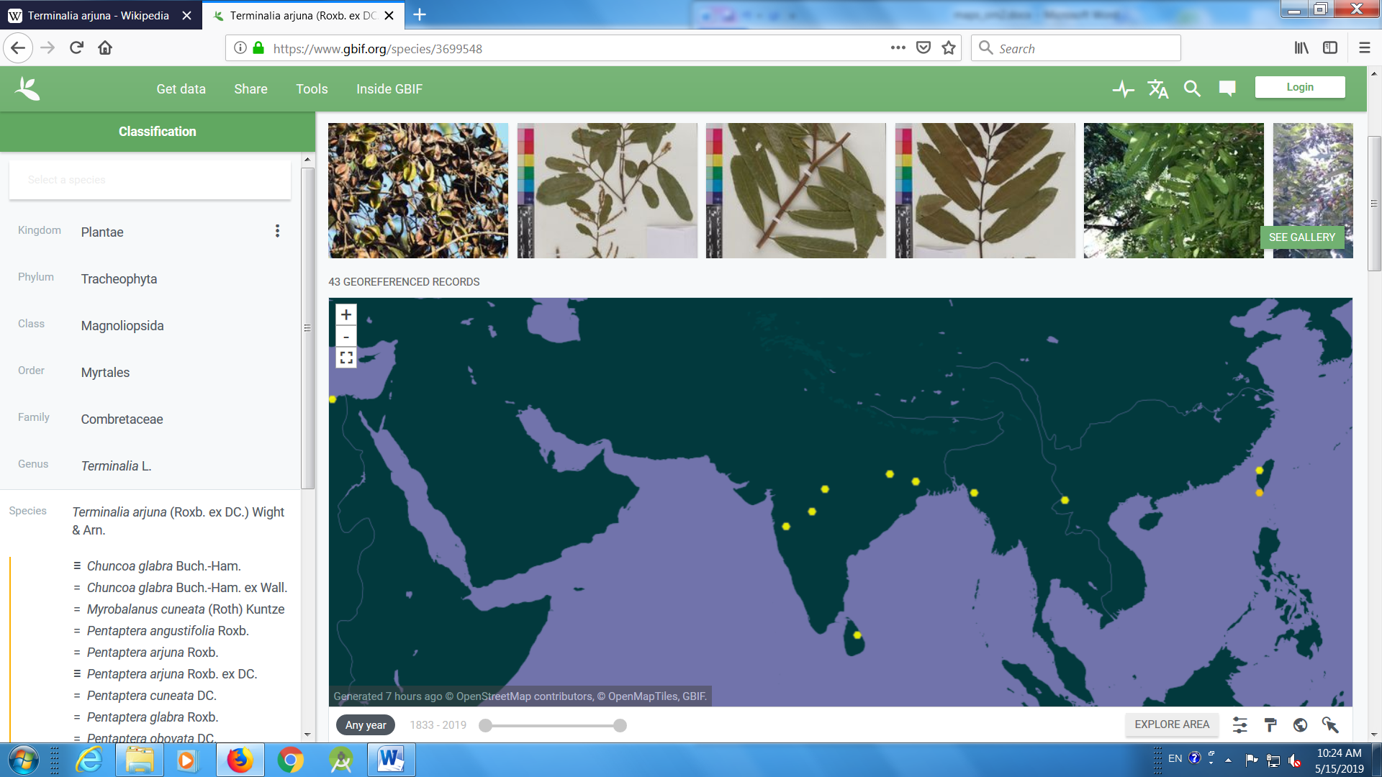
- Milchelia
https://www.gbif.org/species/3153099
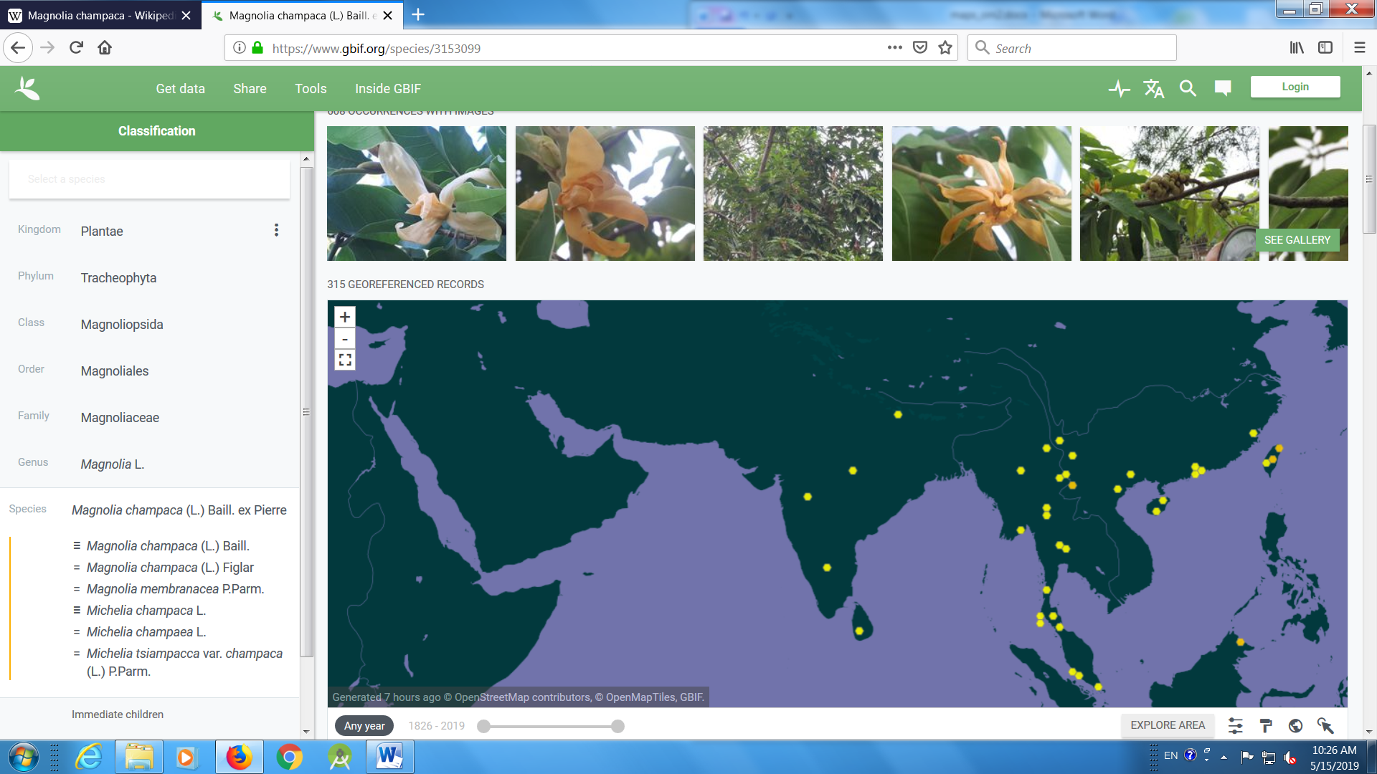

- Kadamba
https://www.gbif.org/species/2896888
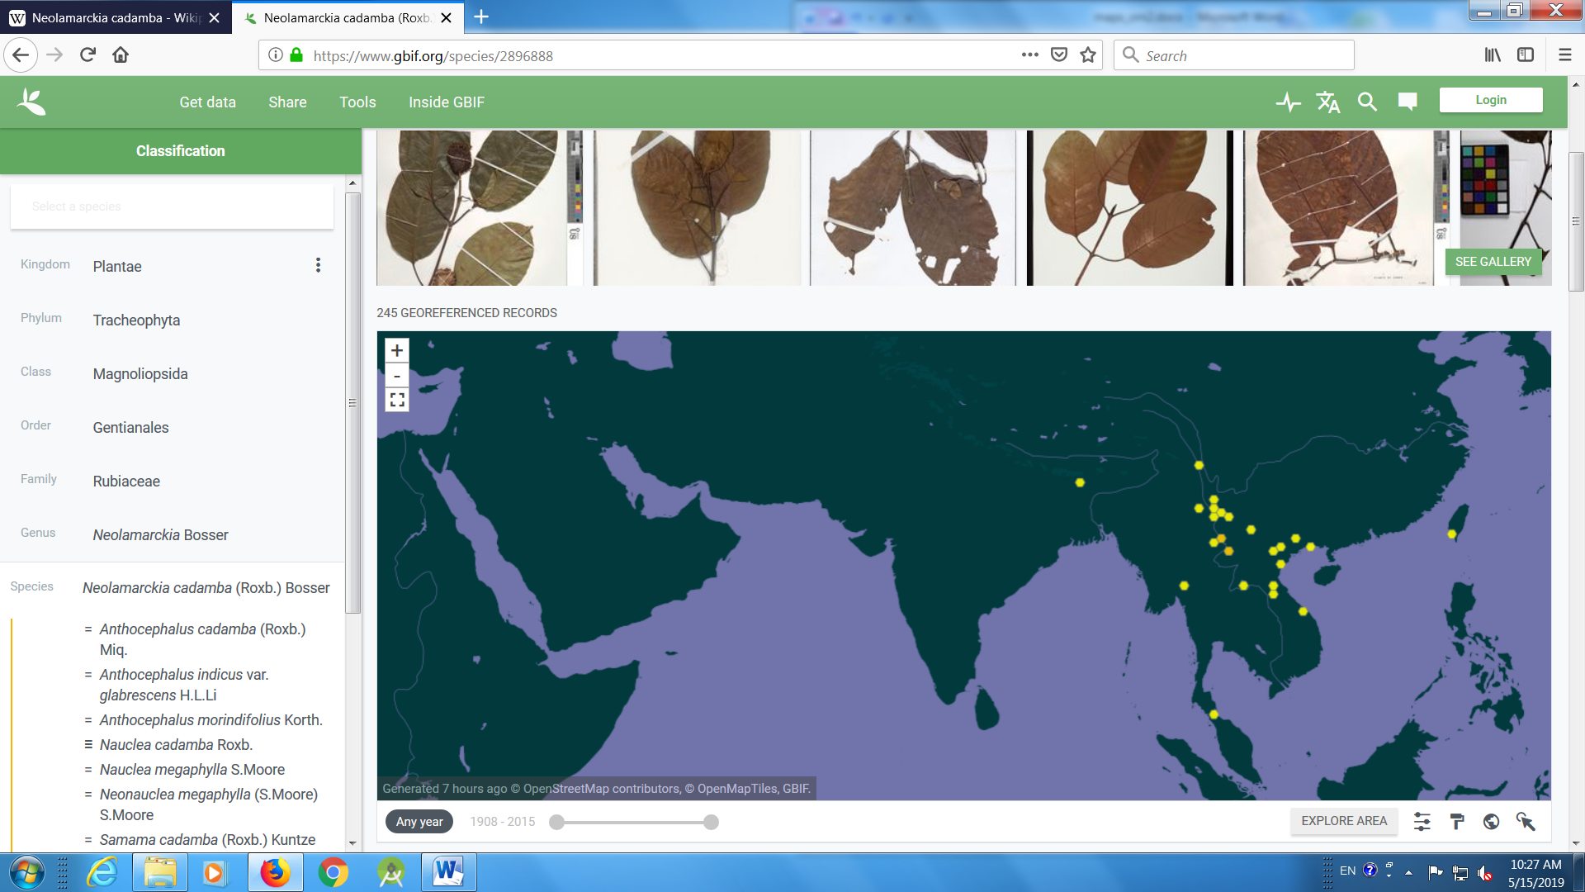
- Maulsari
https://www.gbif.org/species/2883768
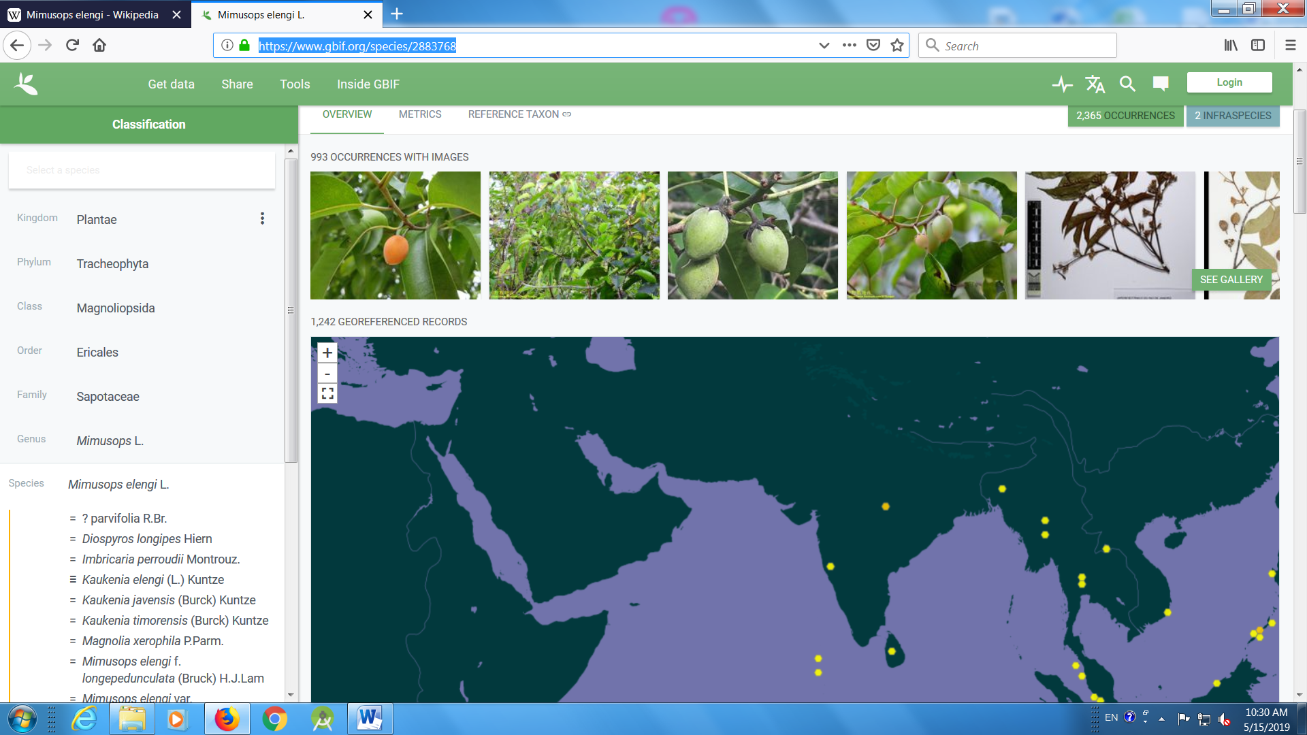

Shrubs and climbers
- Jasmine
https://www.gbif.org/species/3172260

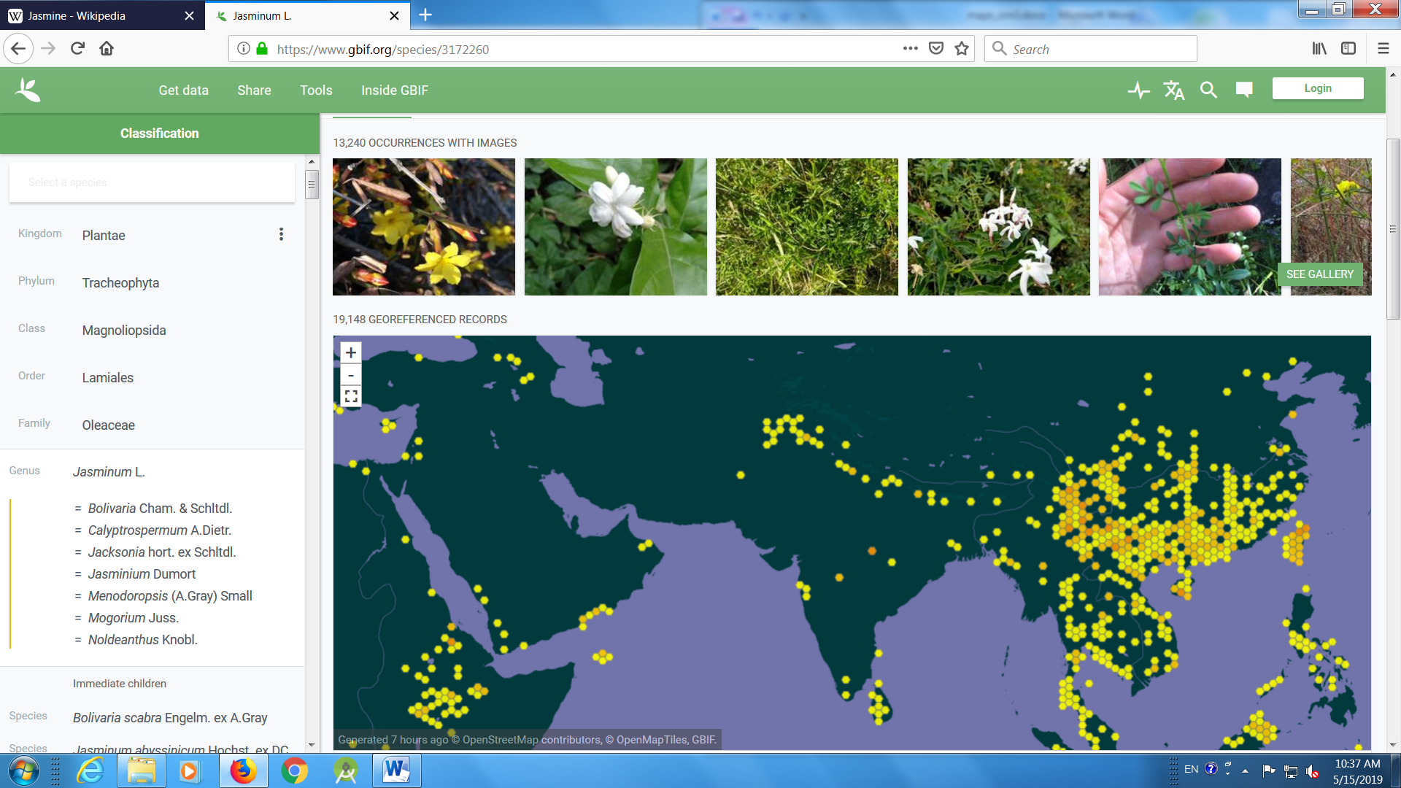
- Ixora
https://www.gbif.org/species/2905224

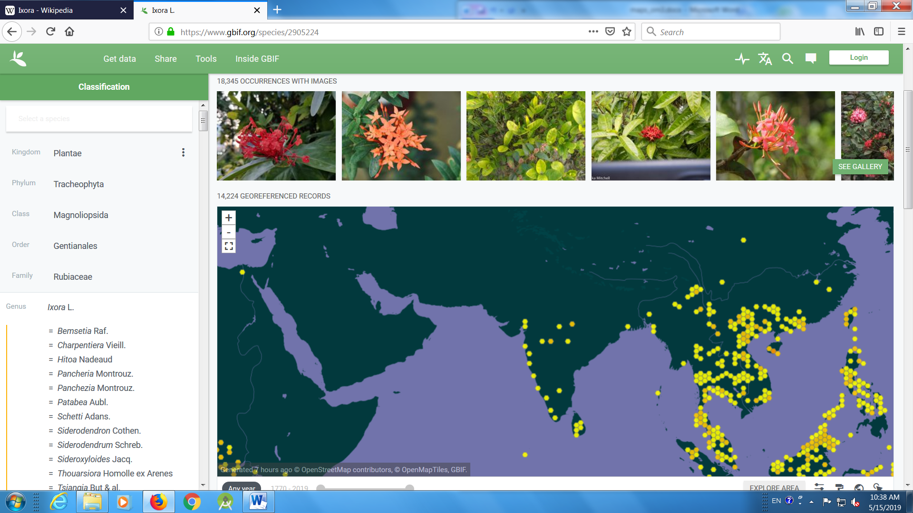
- Hamiltonia
https://www.gbif.org/occurrence/search?taxon_key=7270888

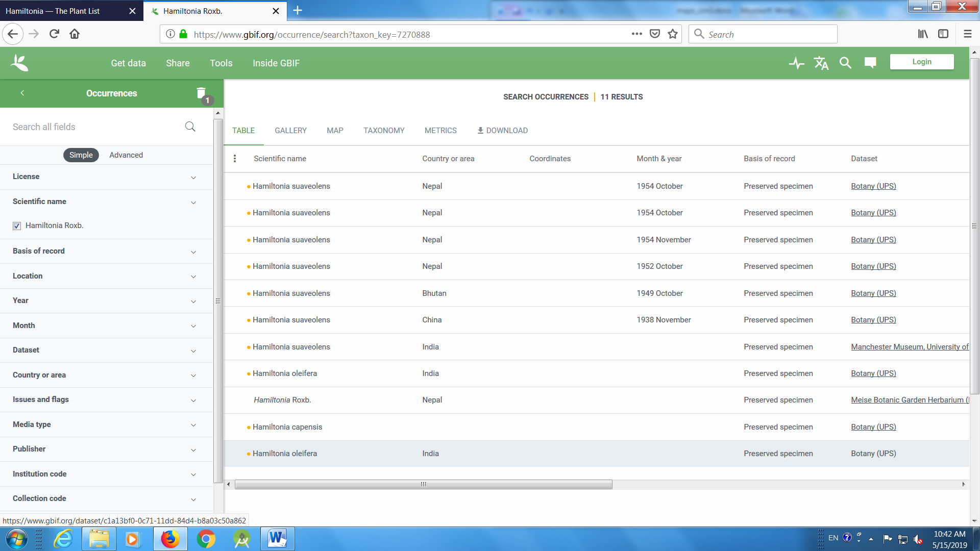

- Clerodendron
https://www.gbif.org/species/2925347

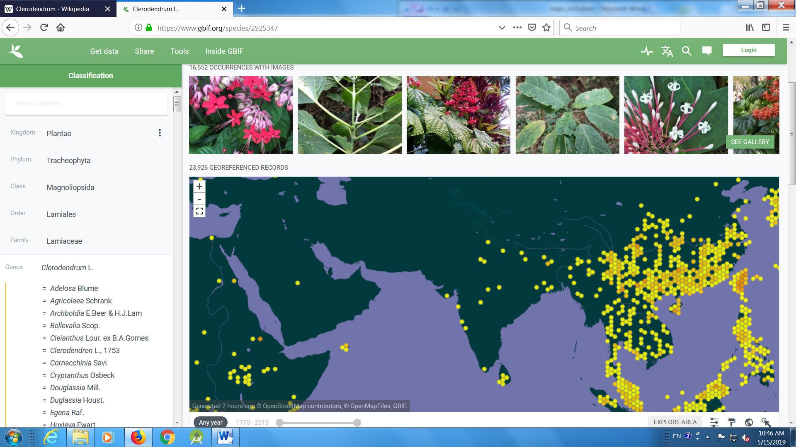

- Crossandra
https://www.gbif.org/species/6359788

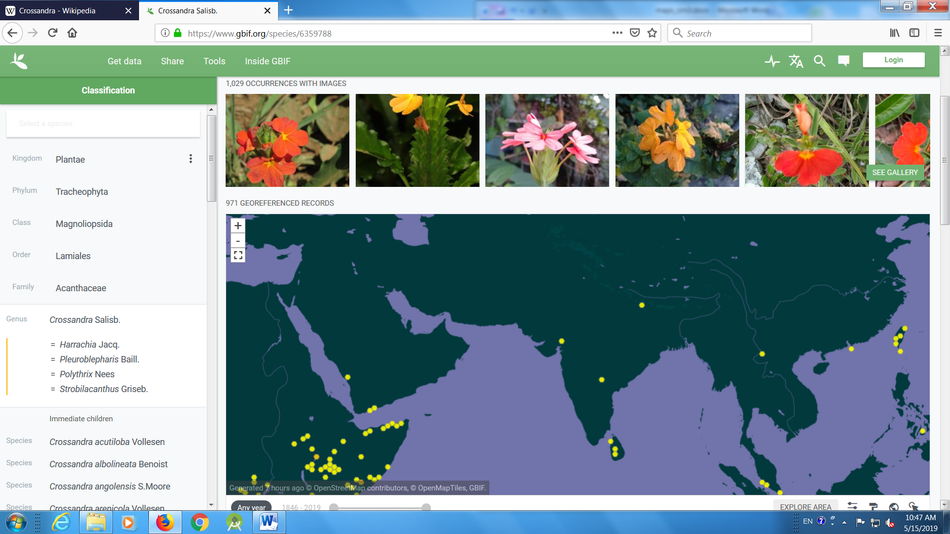

- Plumbago
https://www.gbif.org/species/3082281
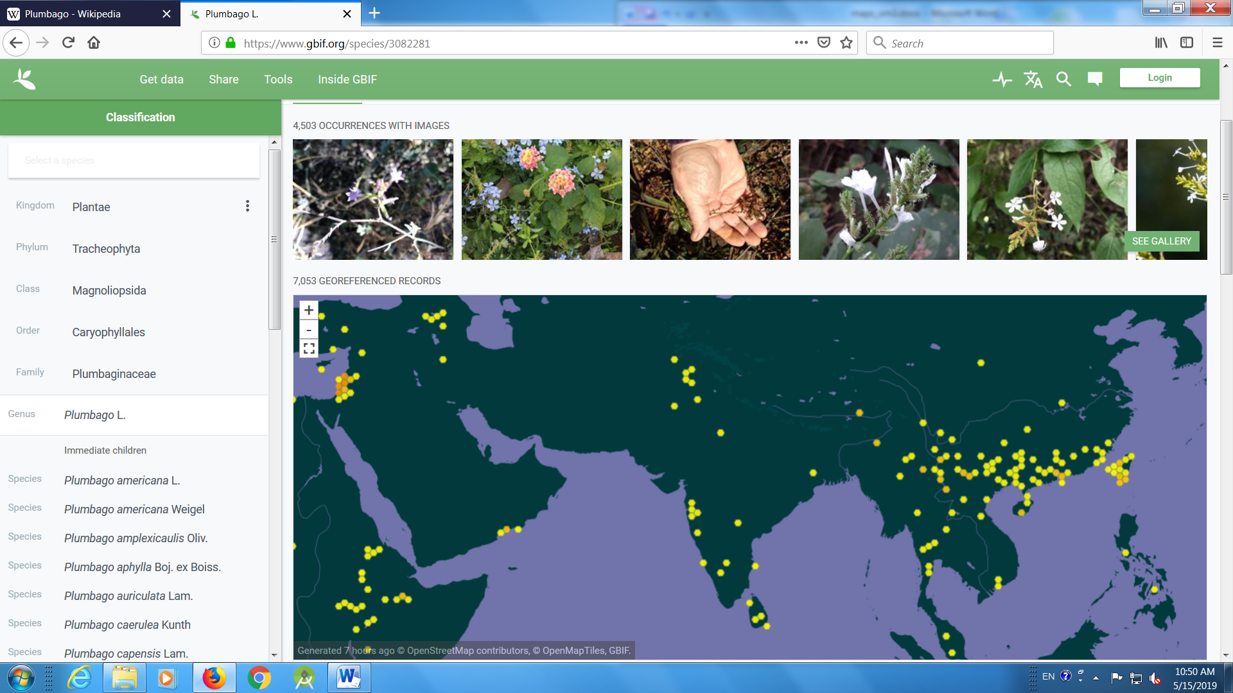

- Tabernamontana
https://www.gbif.org/species/3169624

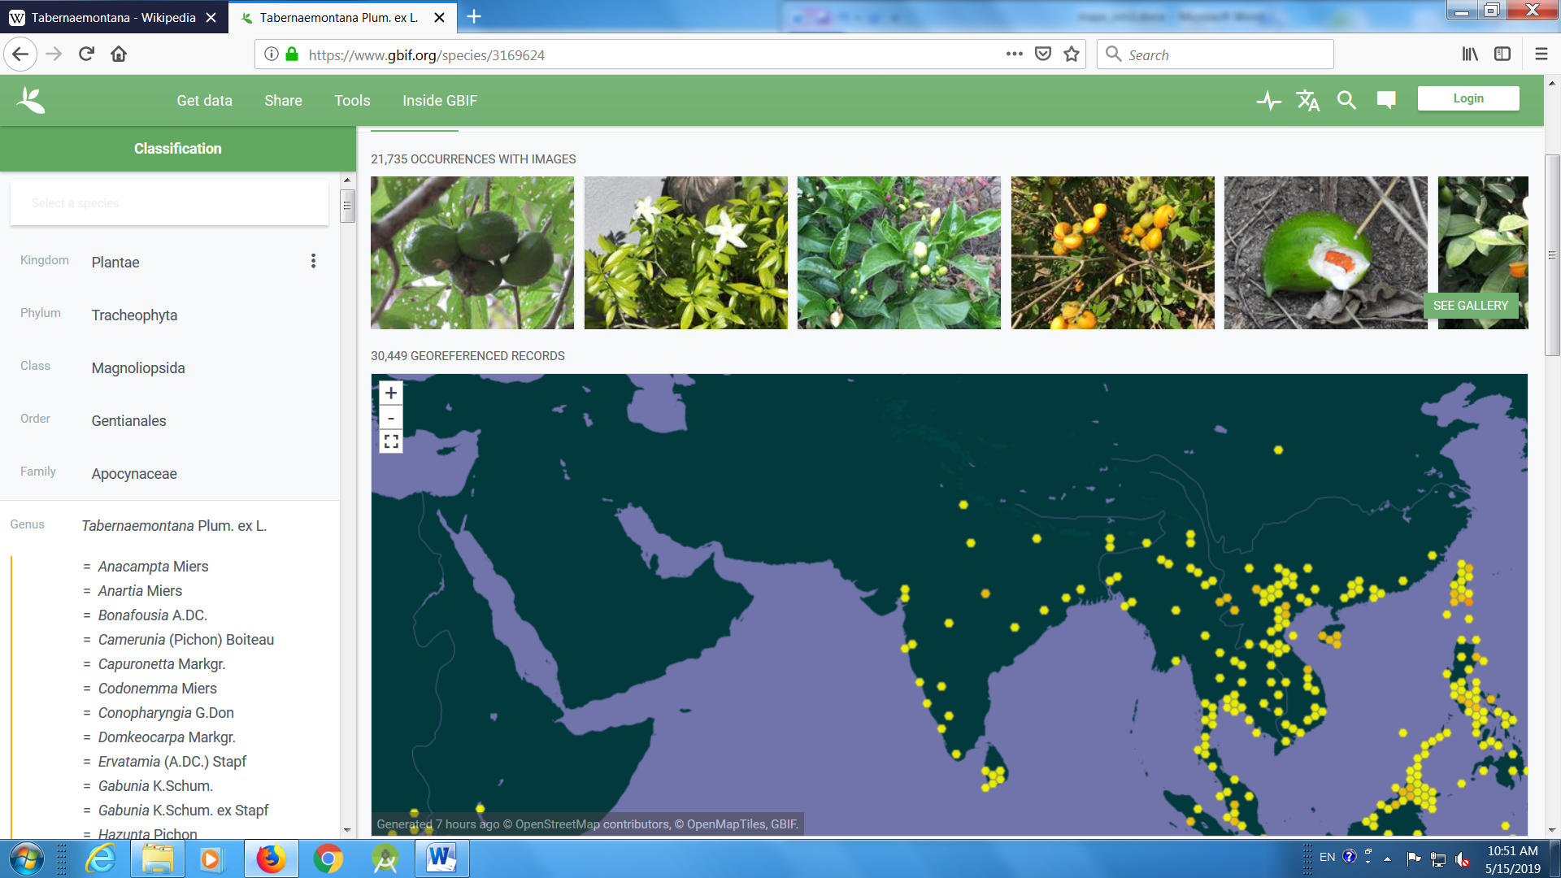

- Trachlospermum
https://www.gbif.org/species/3169711
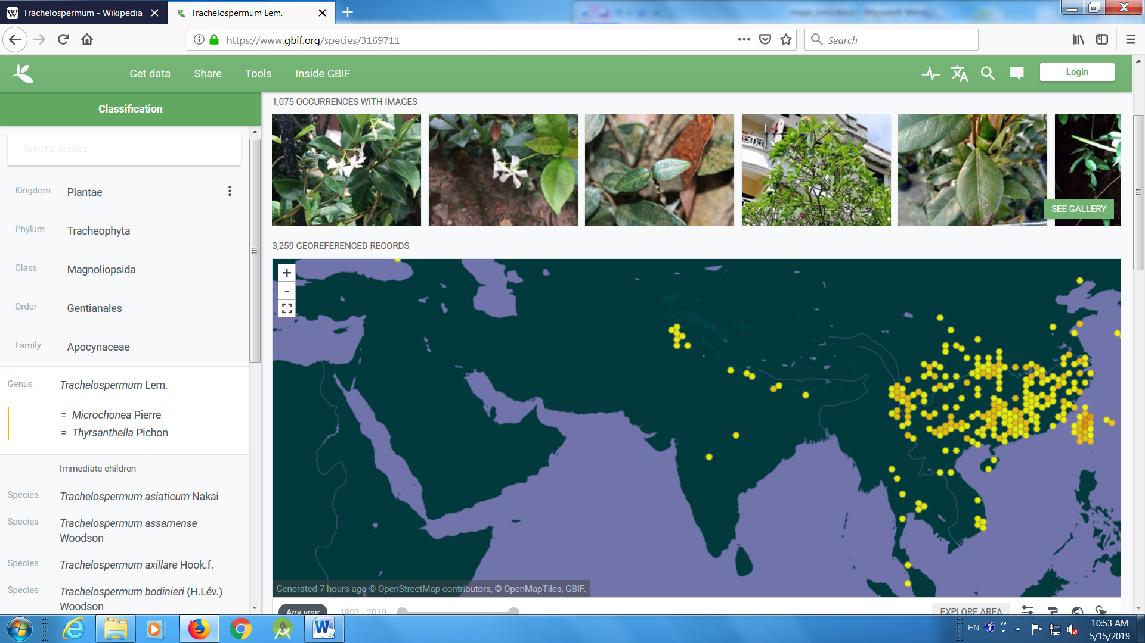

- Passiflora
https://www.gbif.org/species/2874172

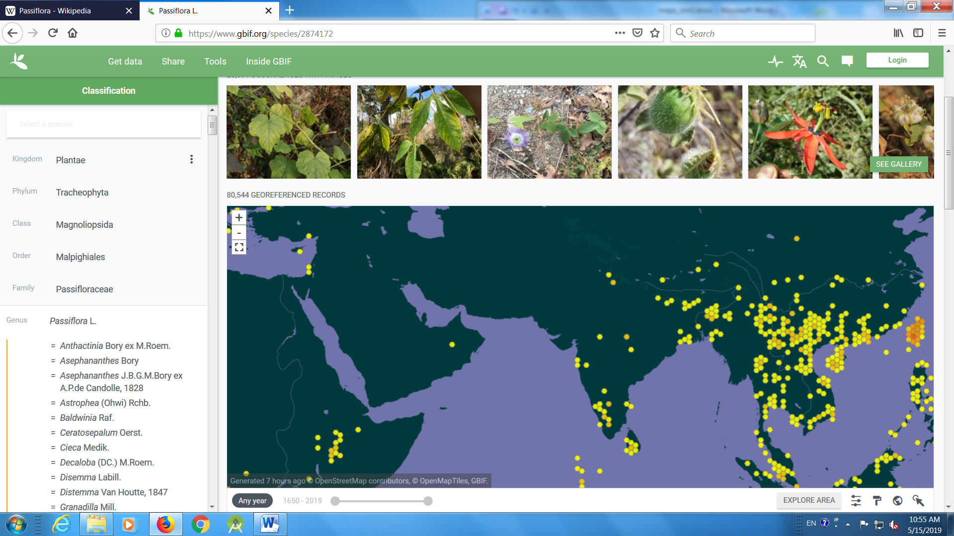

- Clitoria
https://www.gbif.org/species/2946499
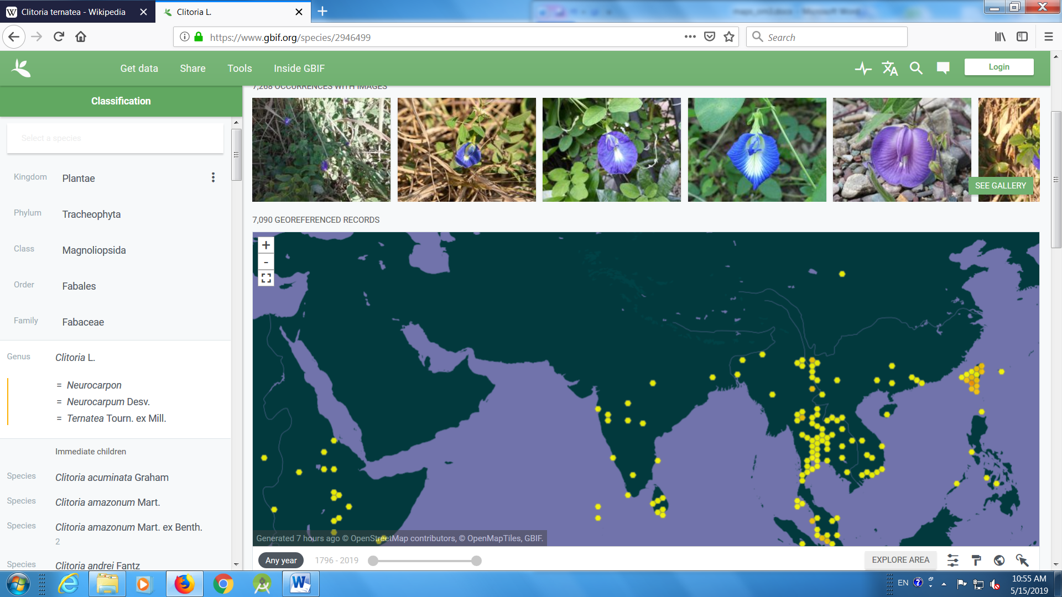
- Porana
https://www.gbif.org/species/6430539

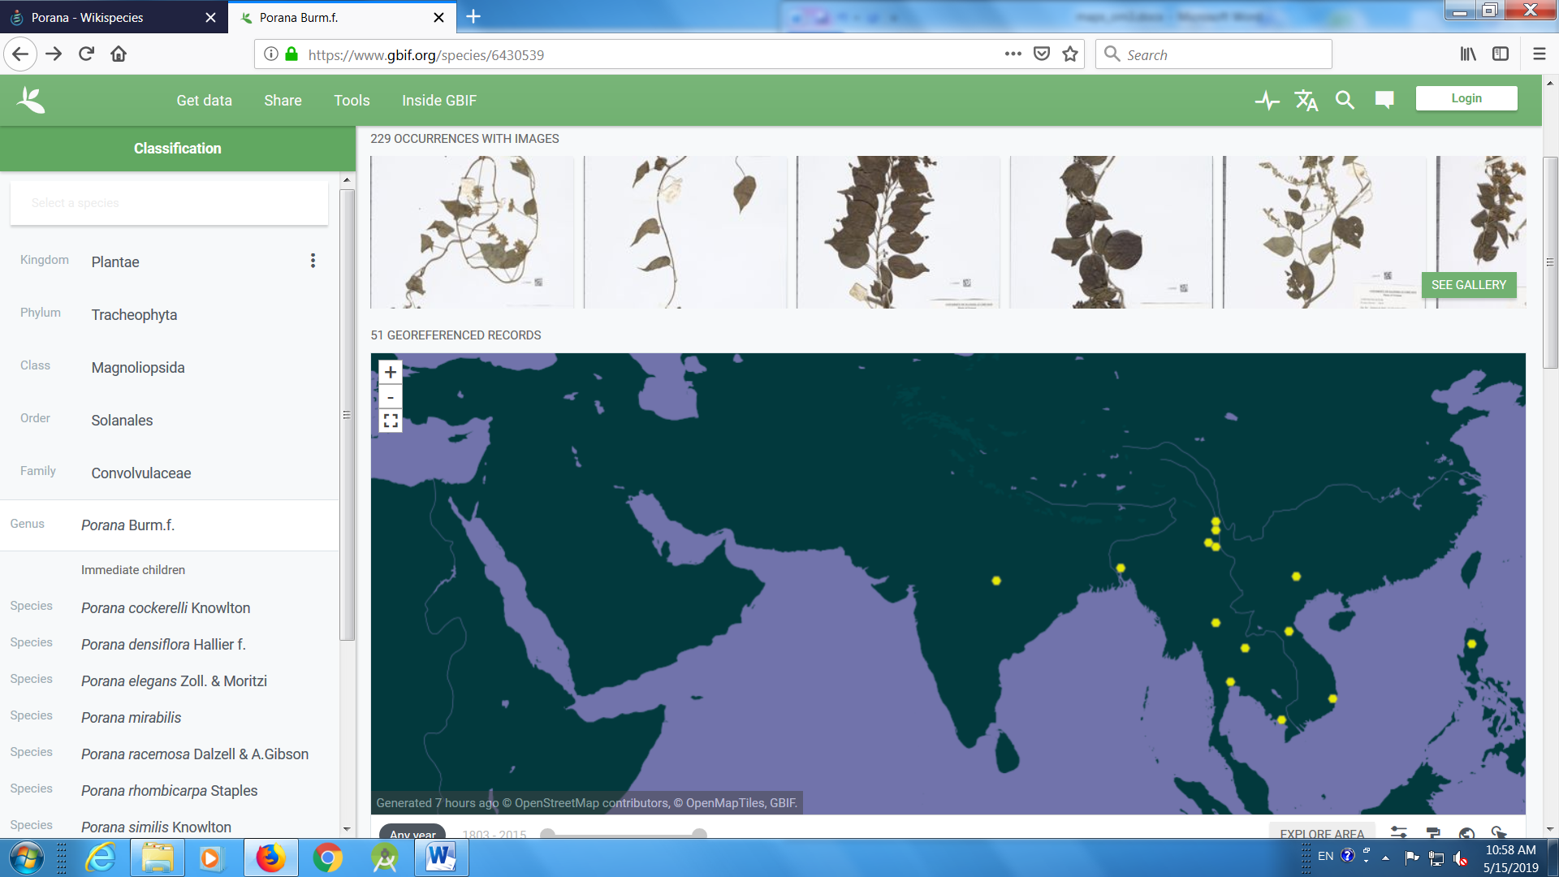
- Gloriosa
https://www.gbif.org/species/2740022

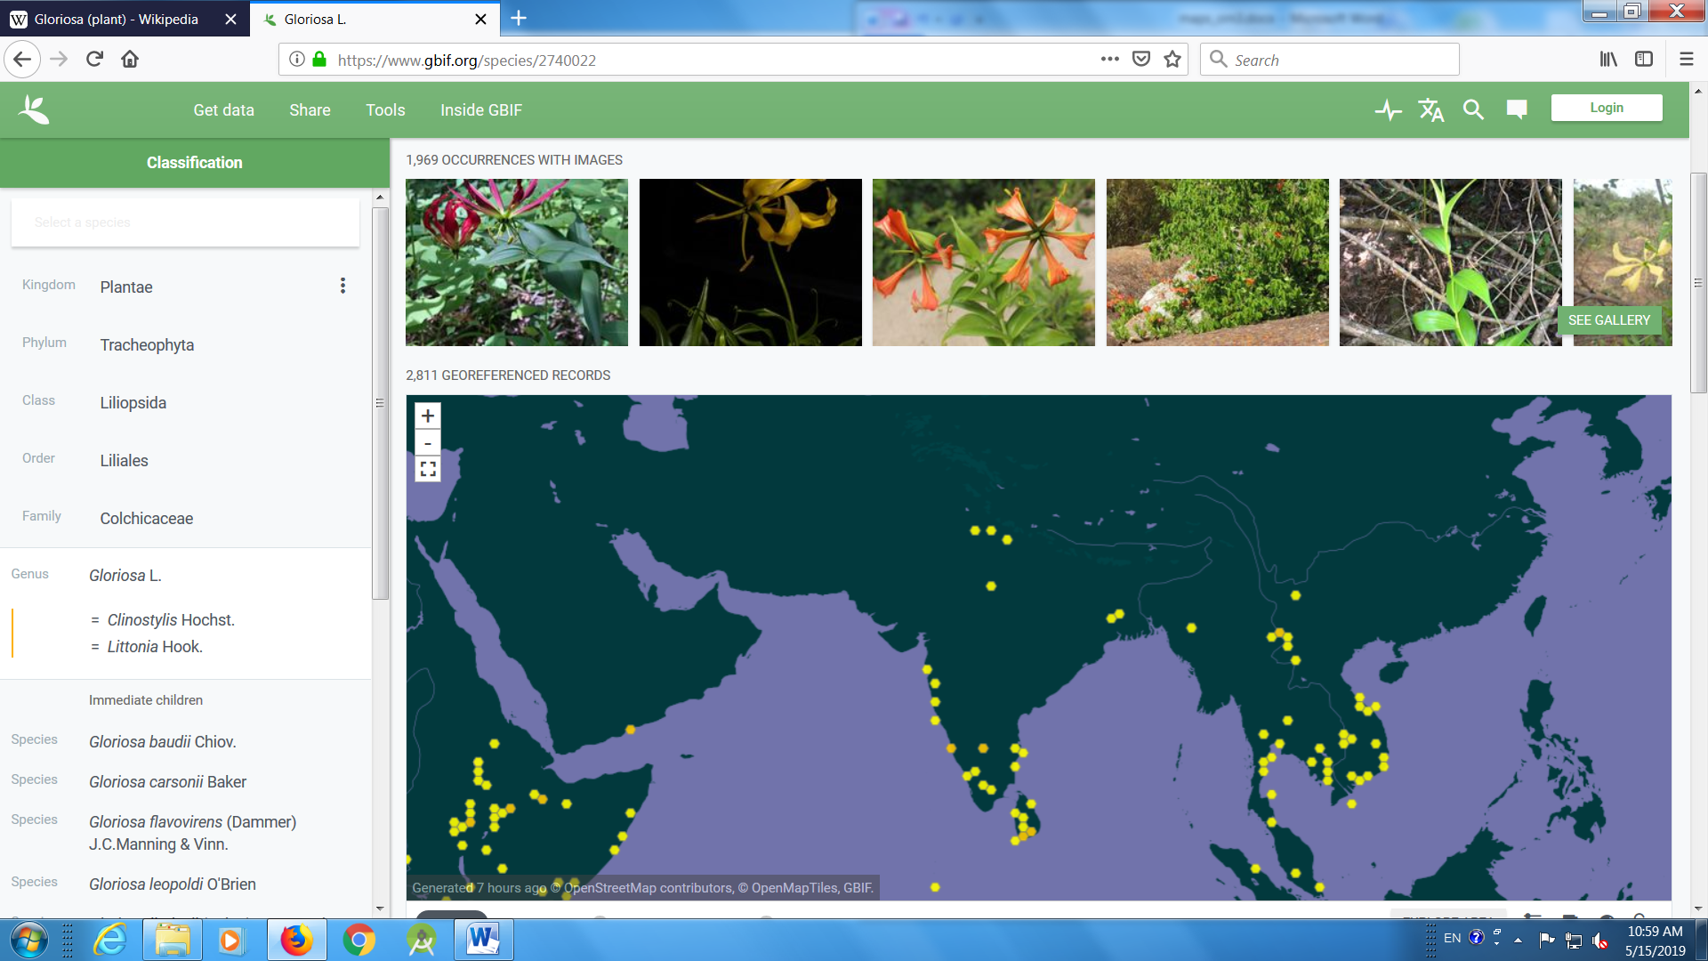

- Clematis
https://www.gbif.org/species/3033512

