India-Centre of Diversity of Horticultural Crops
- Brinjal
https://www.gbif.org/species/2930617
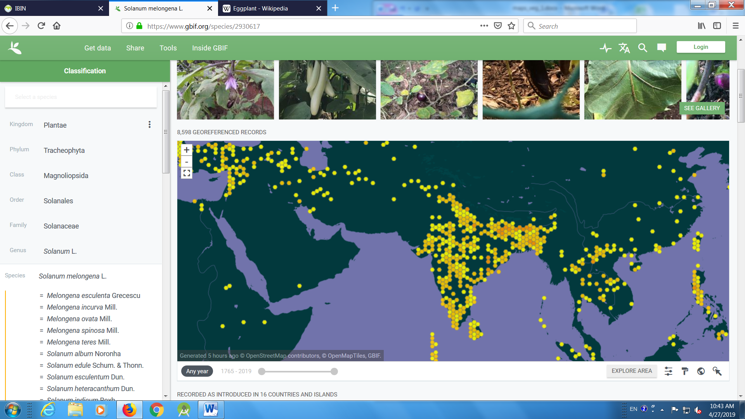
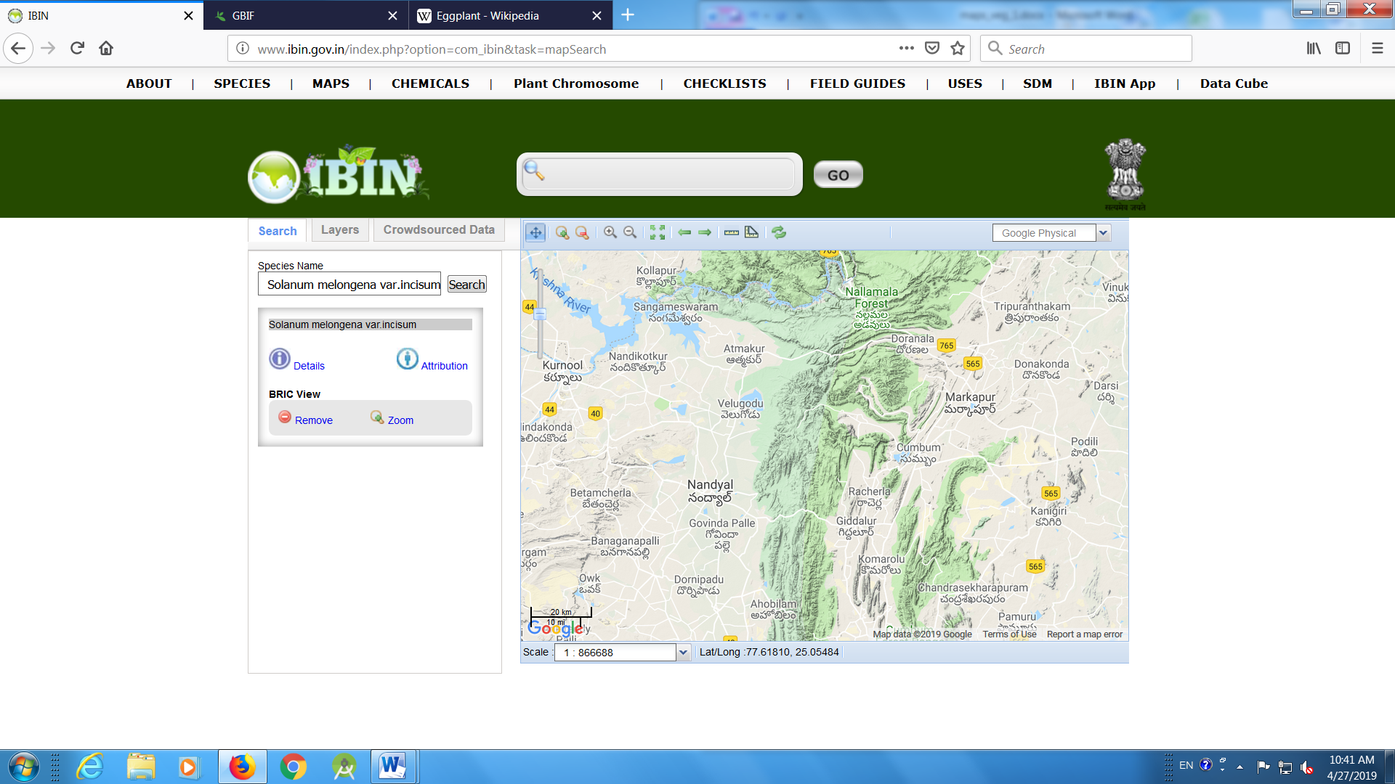
- Smooth gourd
https://www.gbif.org/species/2874598

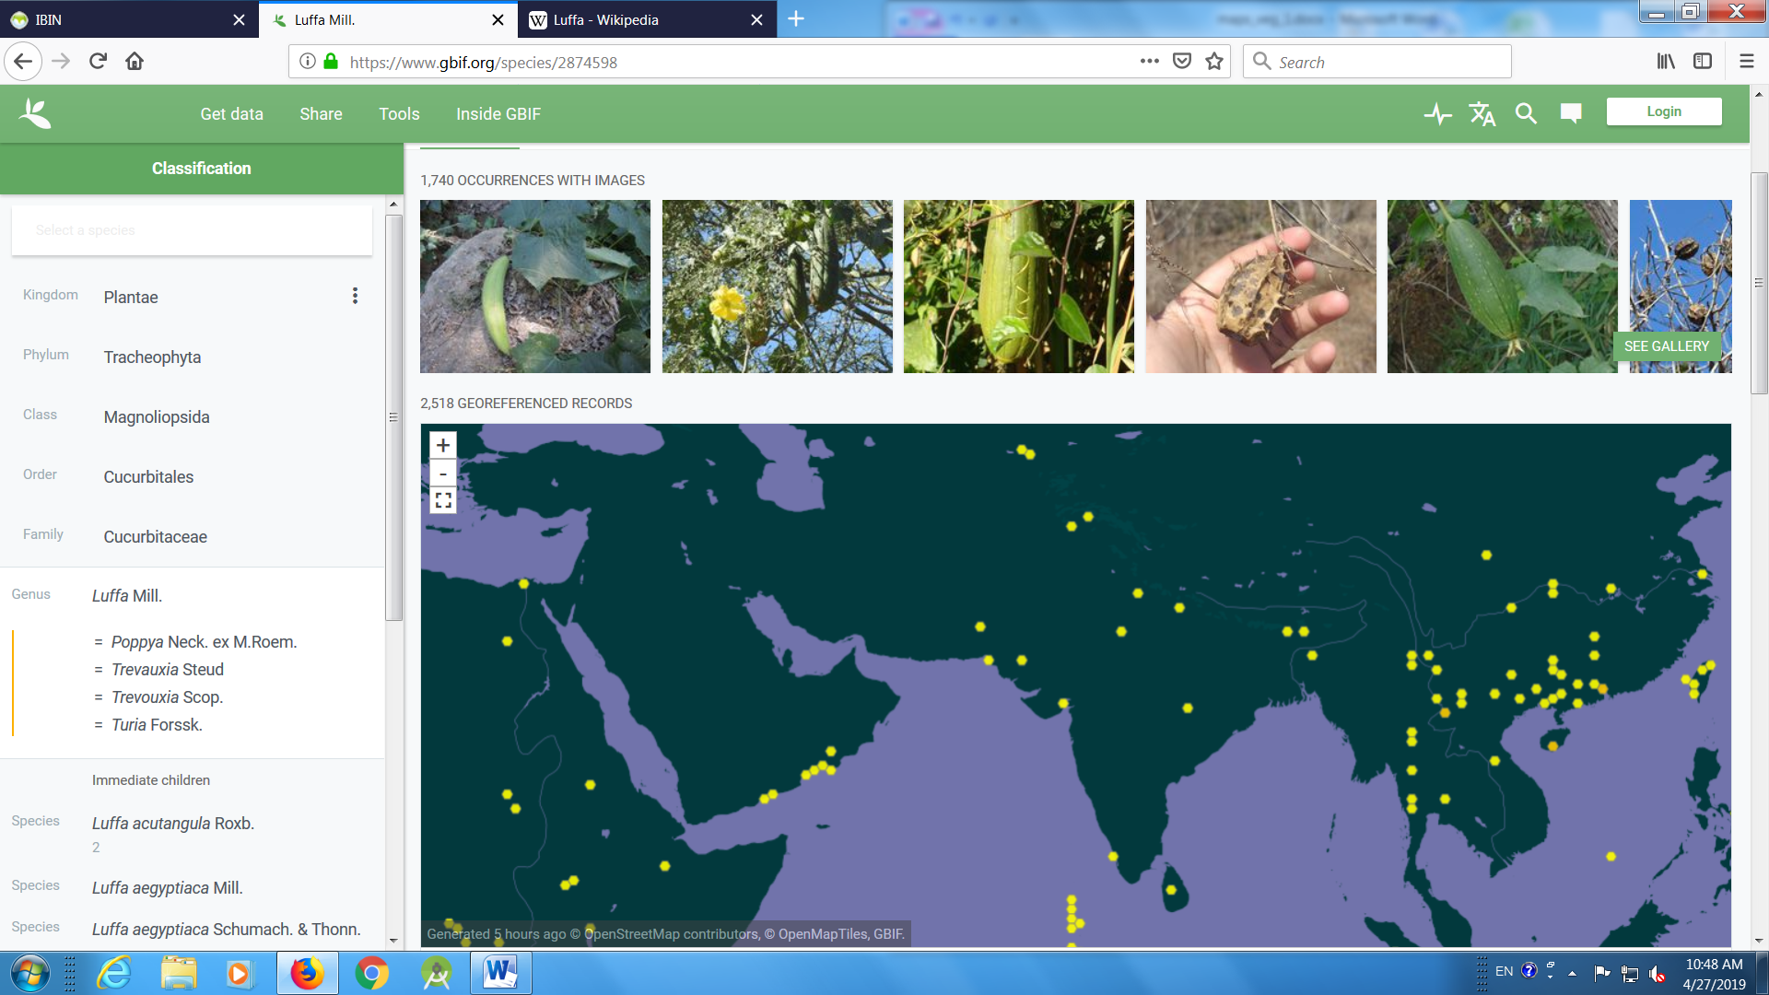
- Ridge gourd
https://www.gbif.org/species/2874601
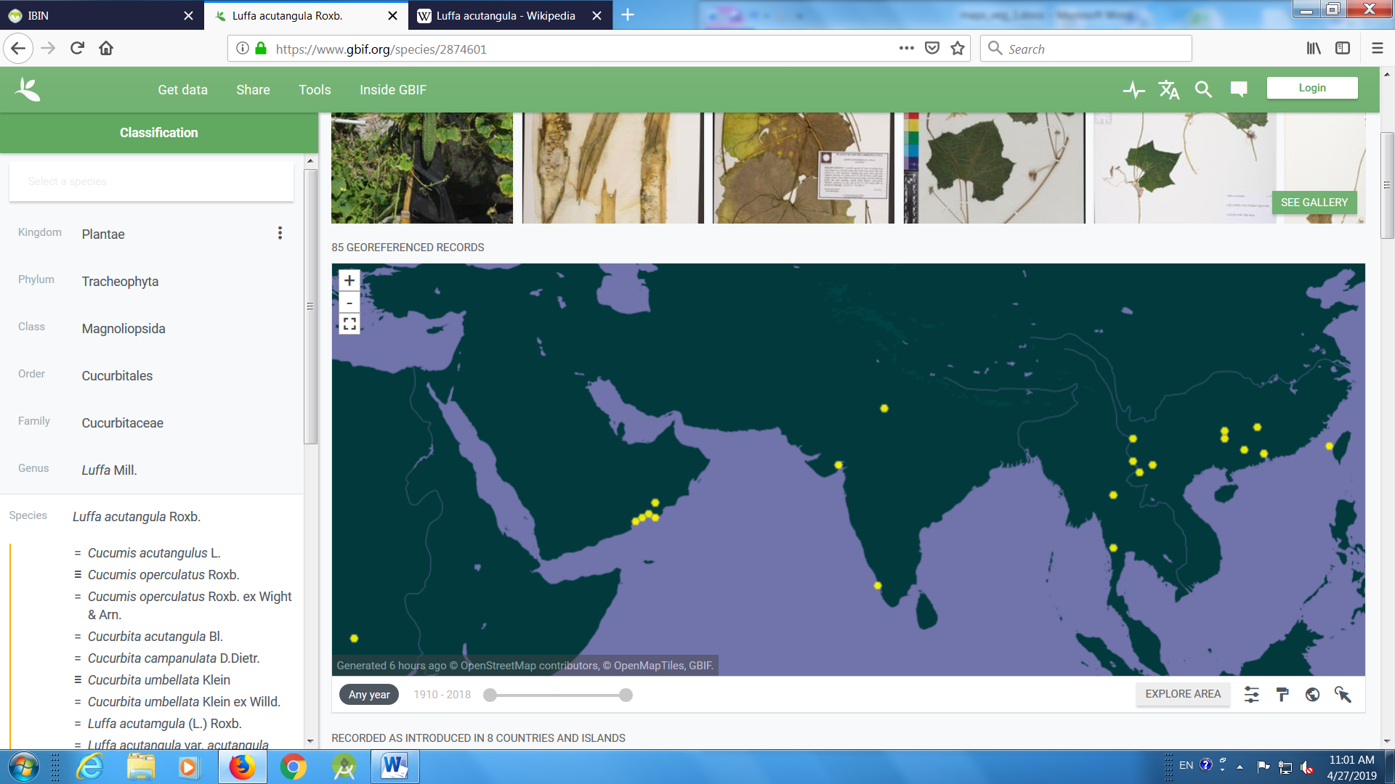
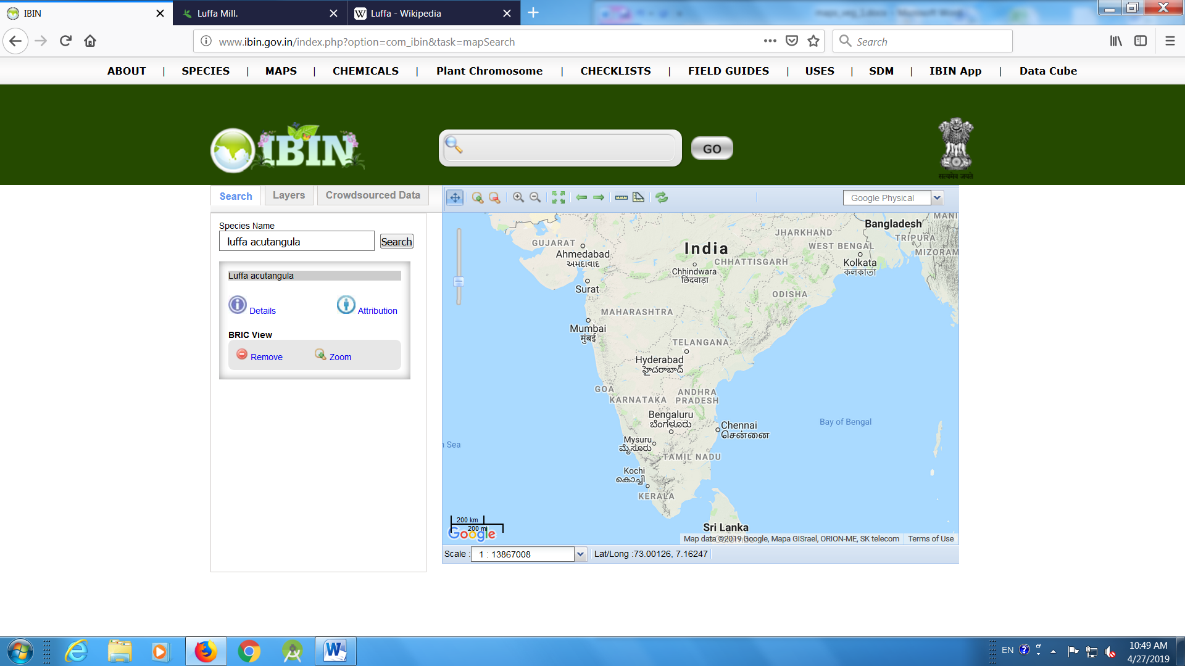
- Cucumber
https://www.gbif.org/species/2874569

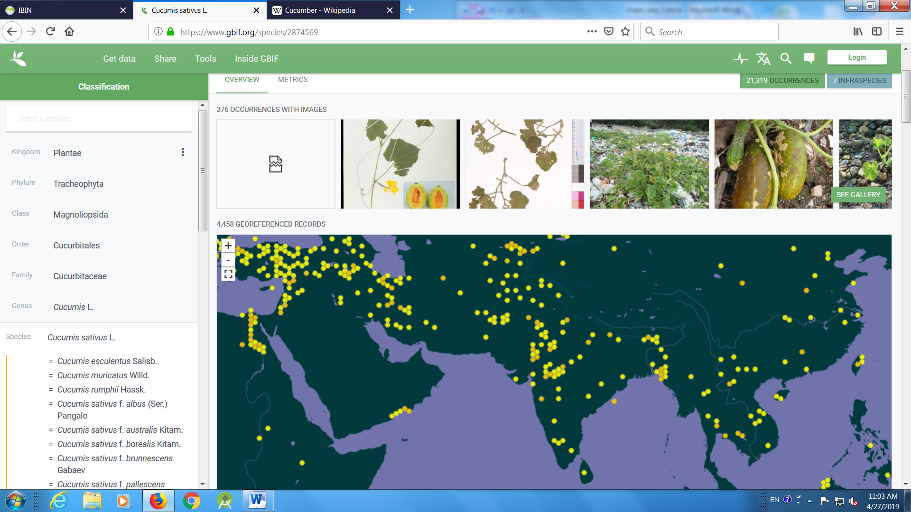
Cucumis setosus
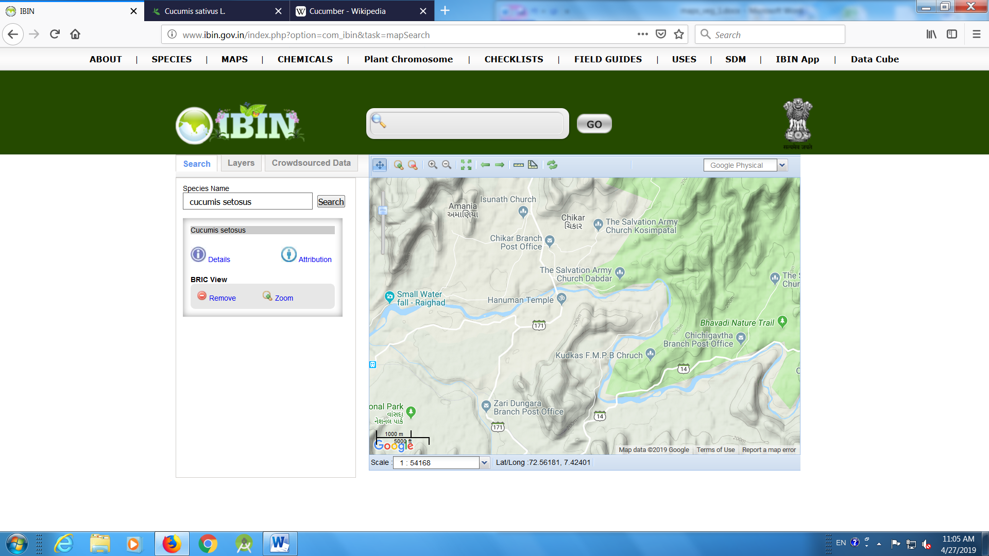
- Parwal

https://www.gbif.org/species/2874607
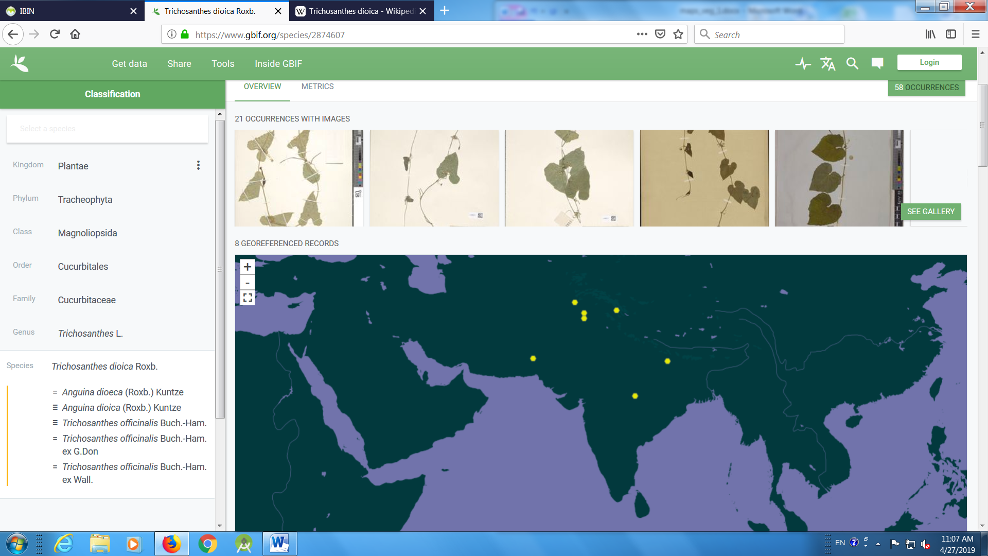

- Amaranthus
https://www.gbif.org/species/3085074
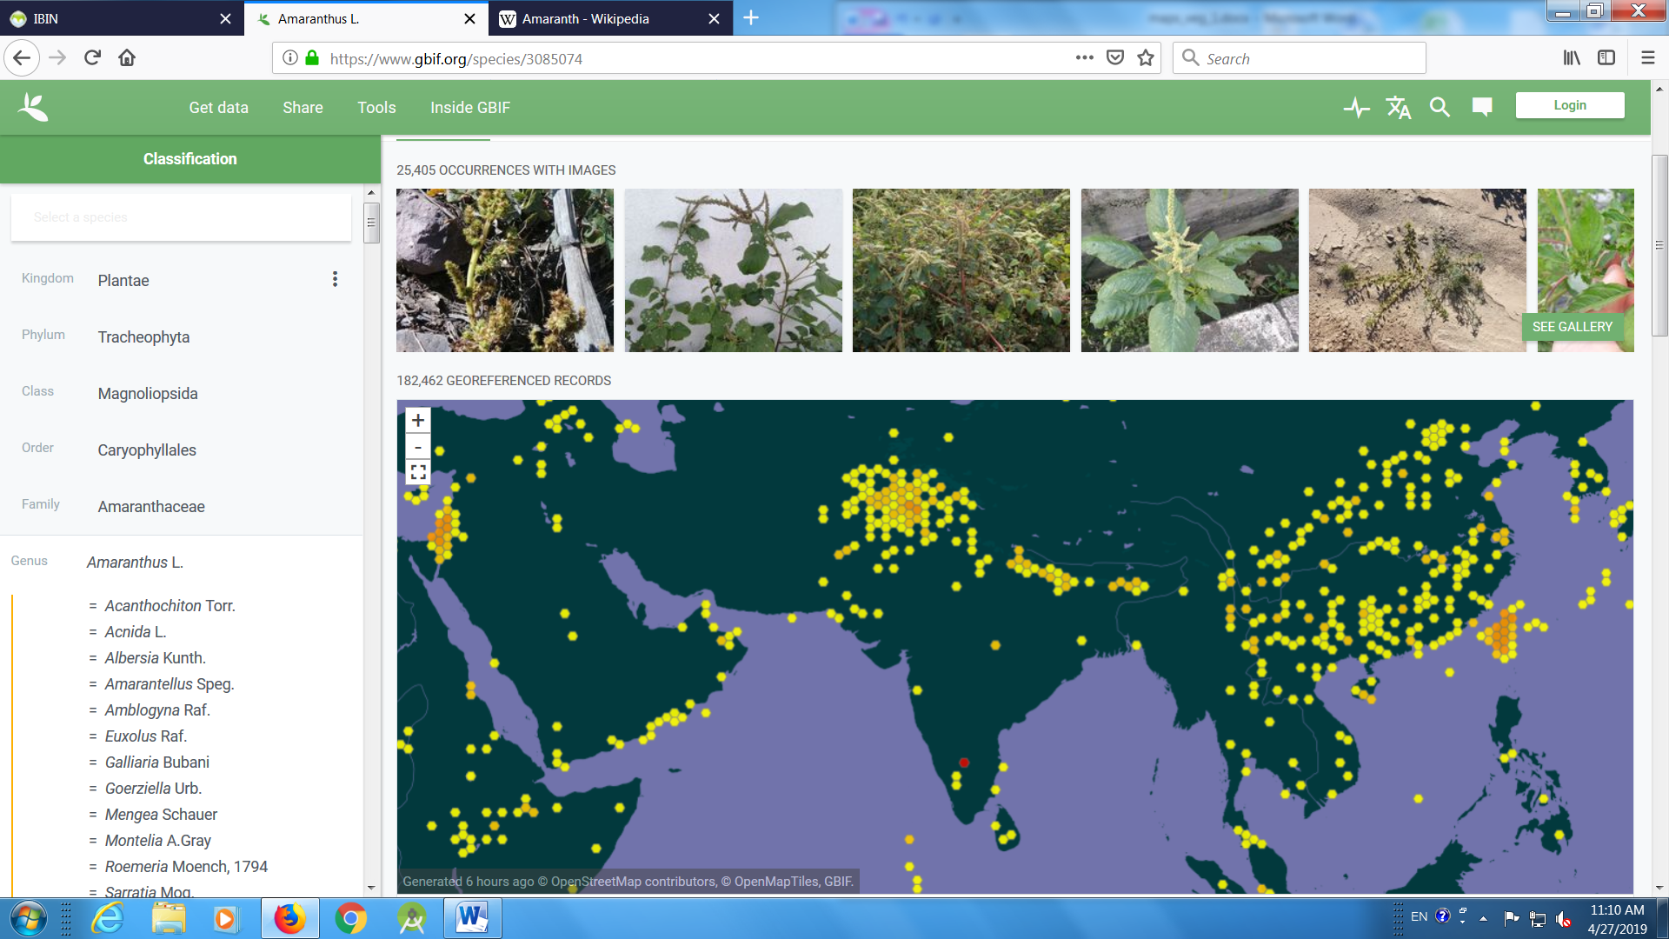
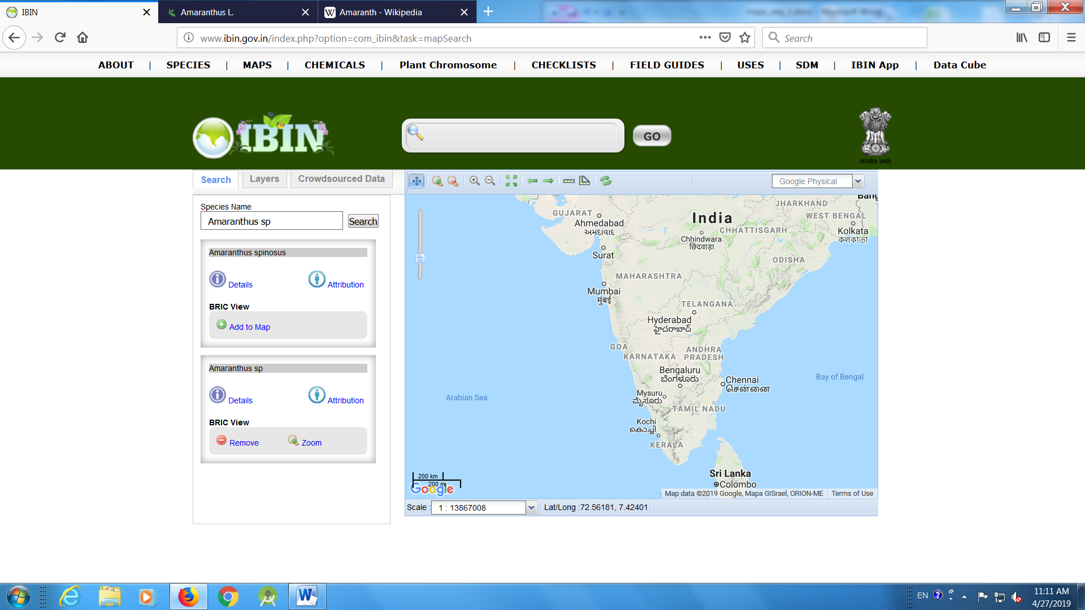

- Basella
https://www.gbif.org/species/3083504

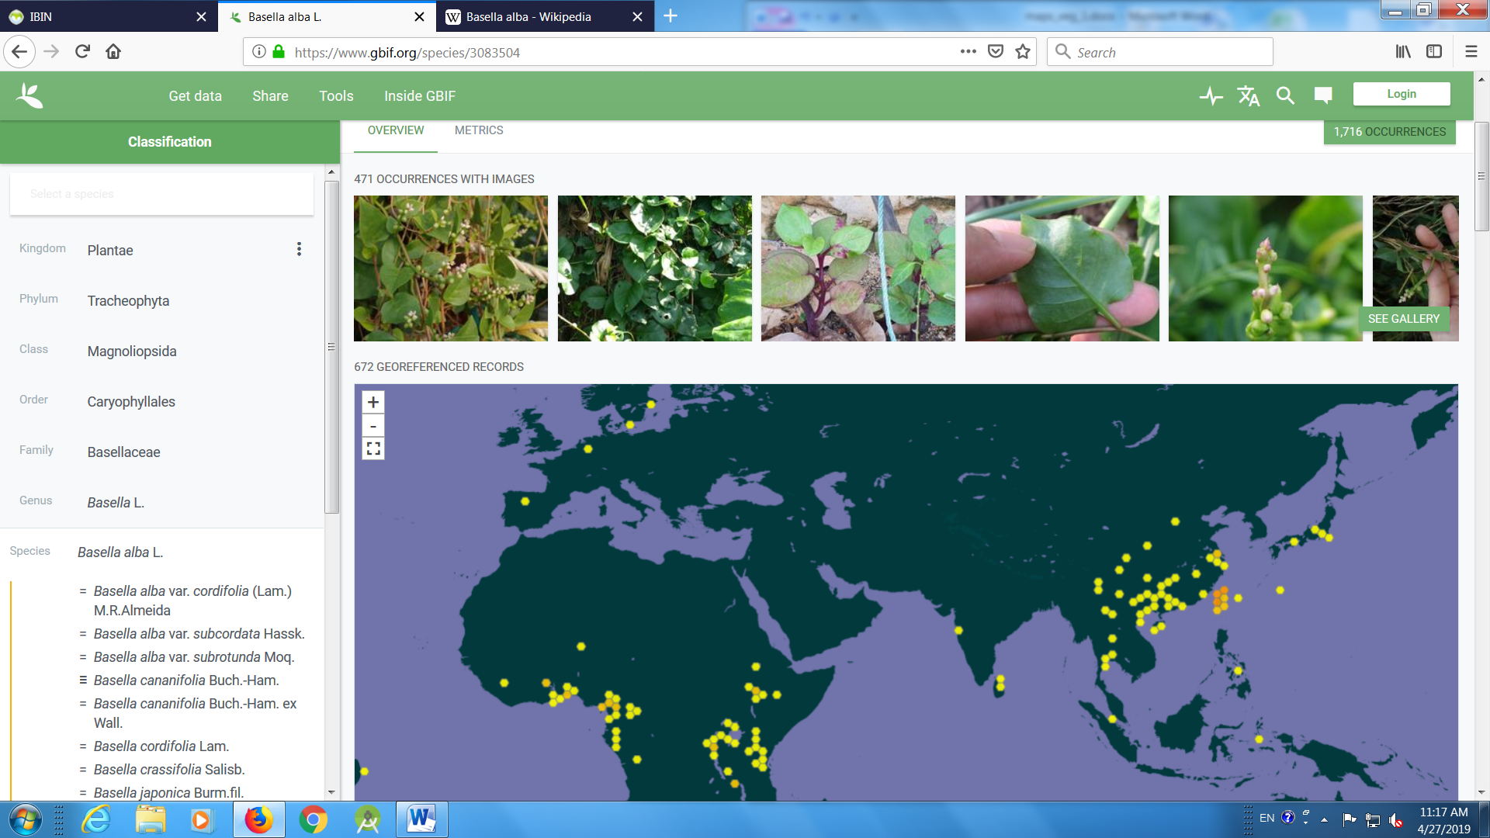

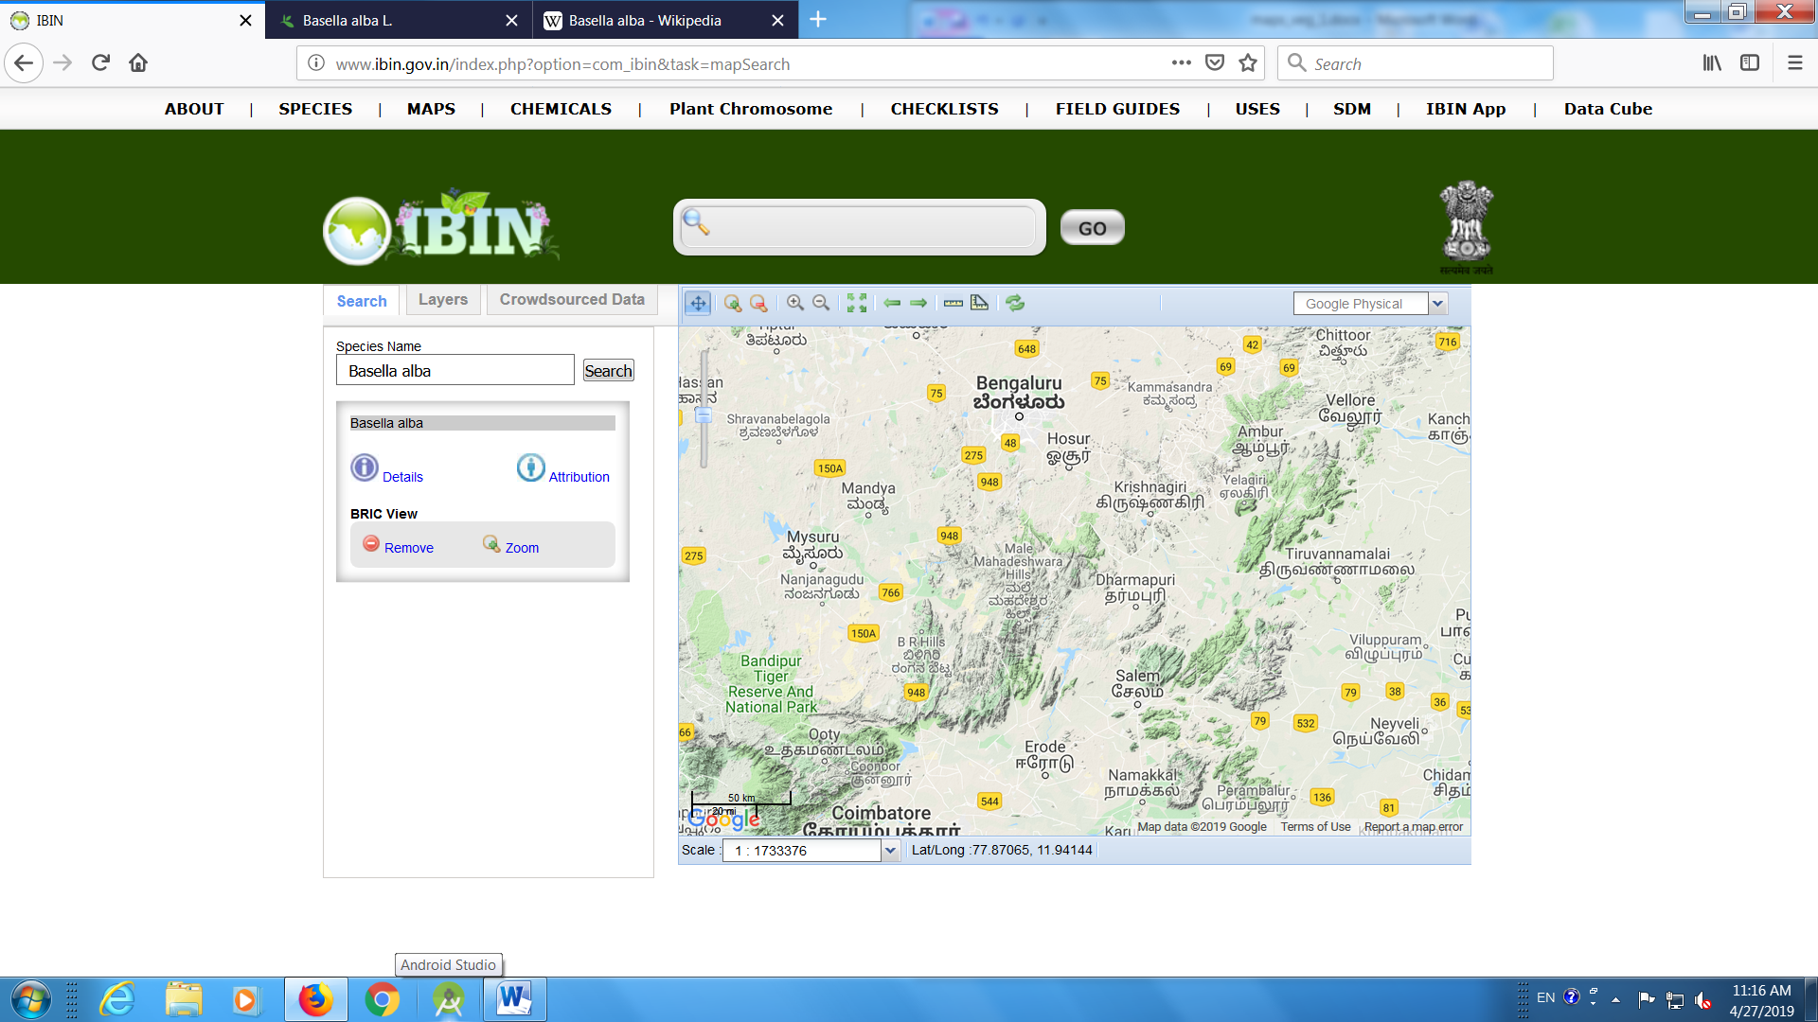

- Sword bean
https://www.gbif.org/species/2962057
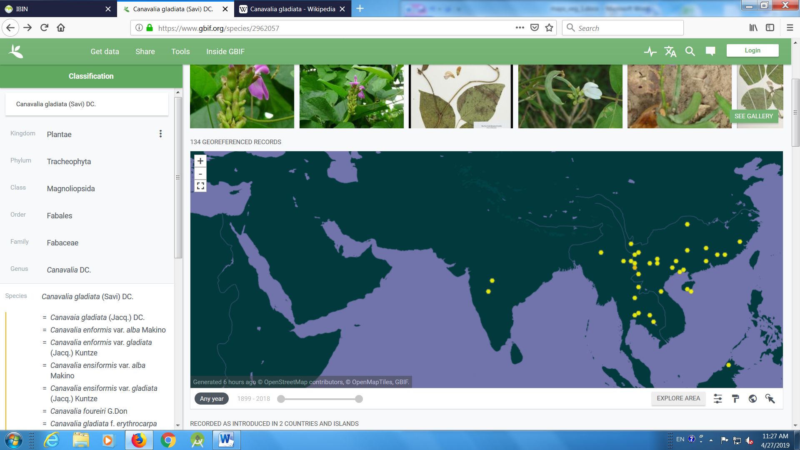

- Winged bean
https://www.gbif.org/species/2944683

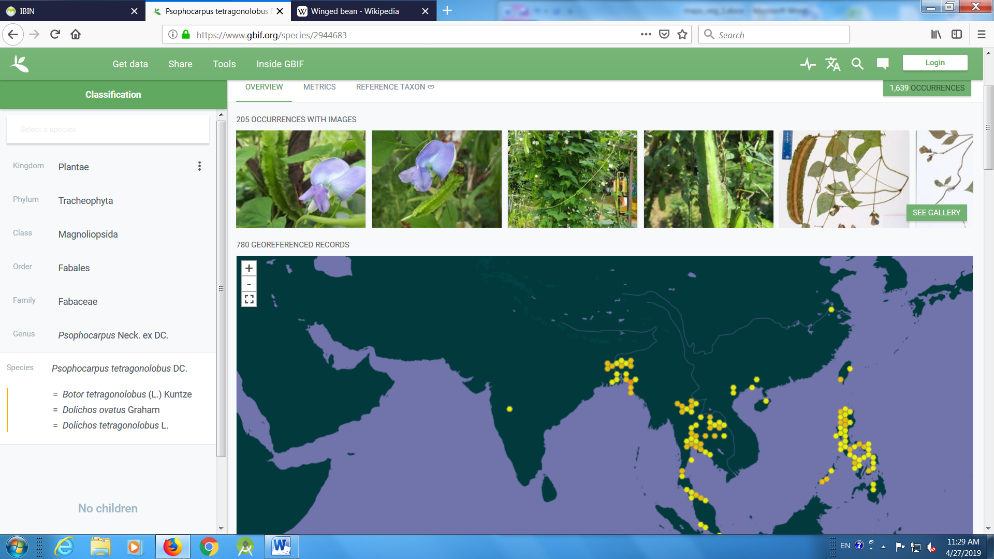

- Kundru
https://www.gbif.org/species/2874564

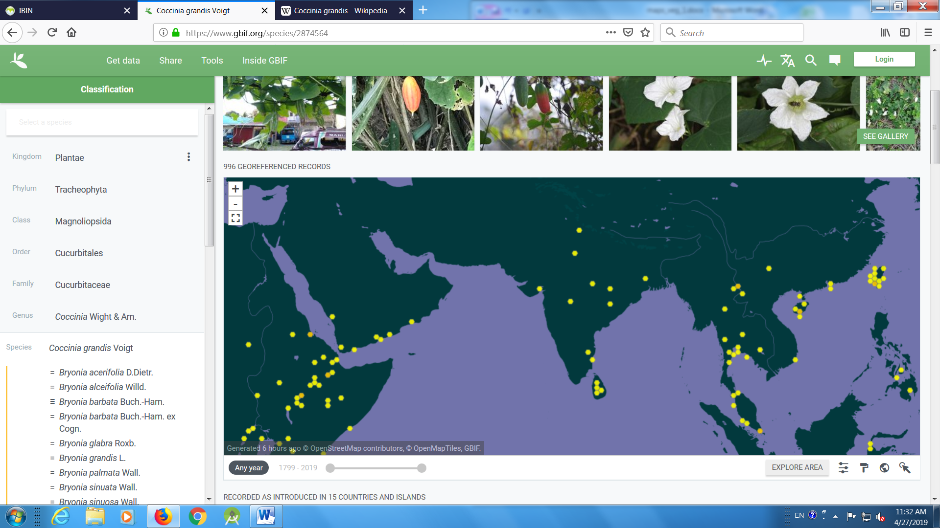
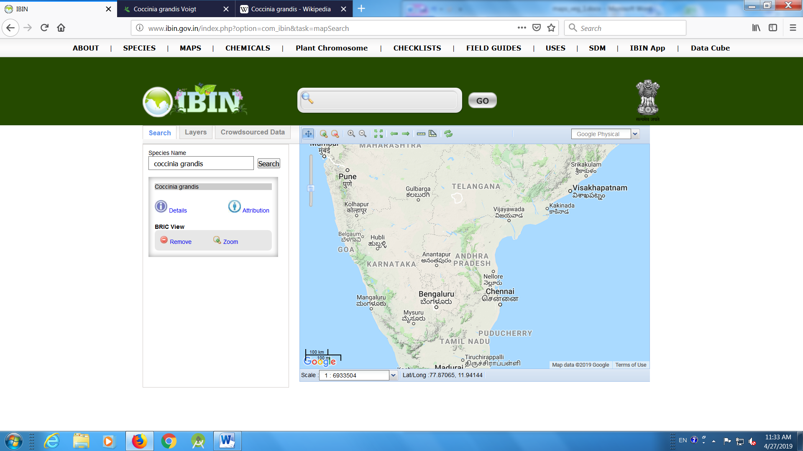
- Dolichos bean
https://www.gbif.org/species/2952236

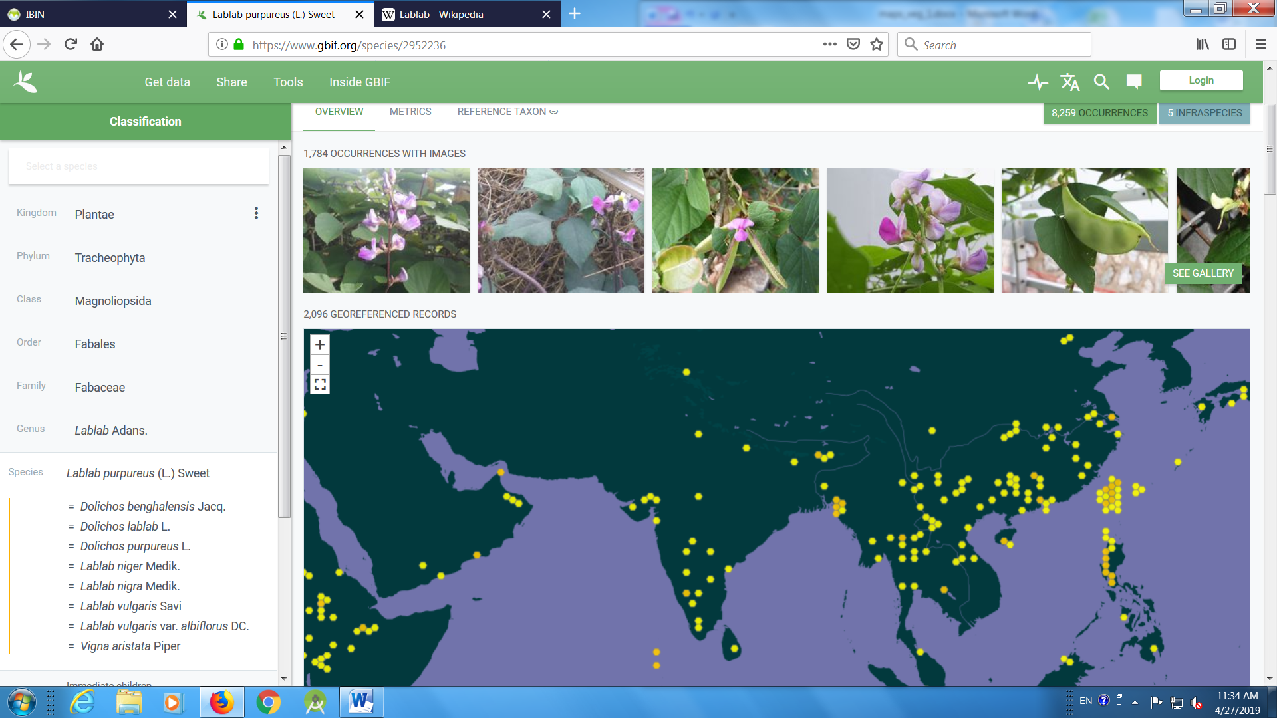
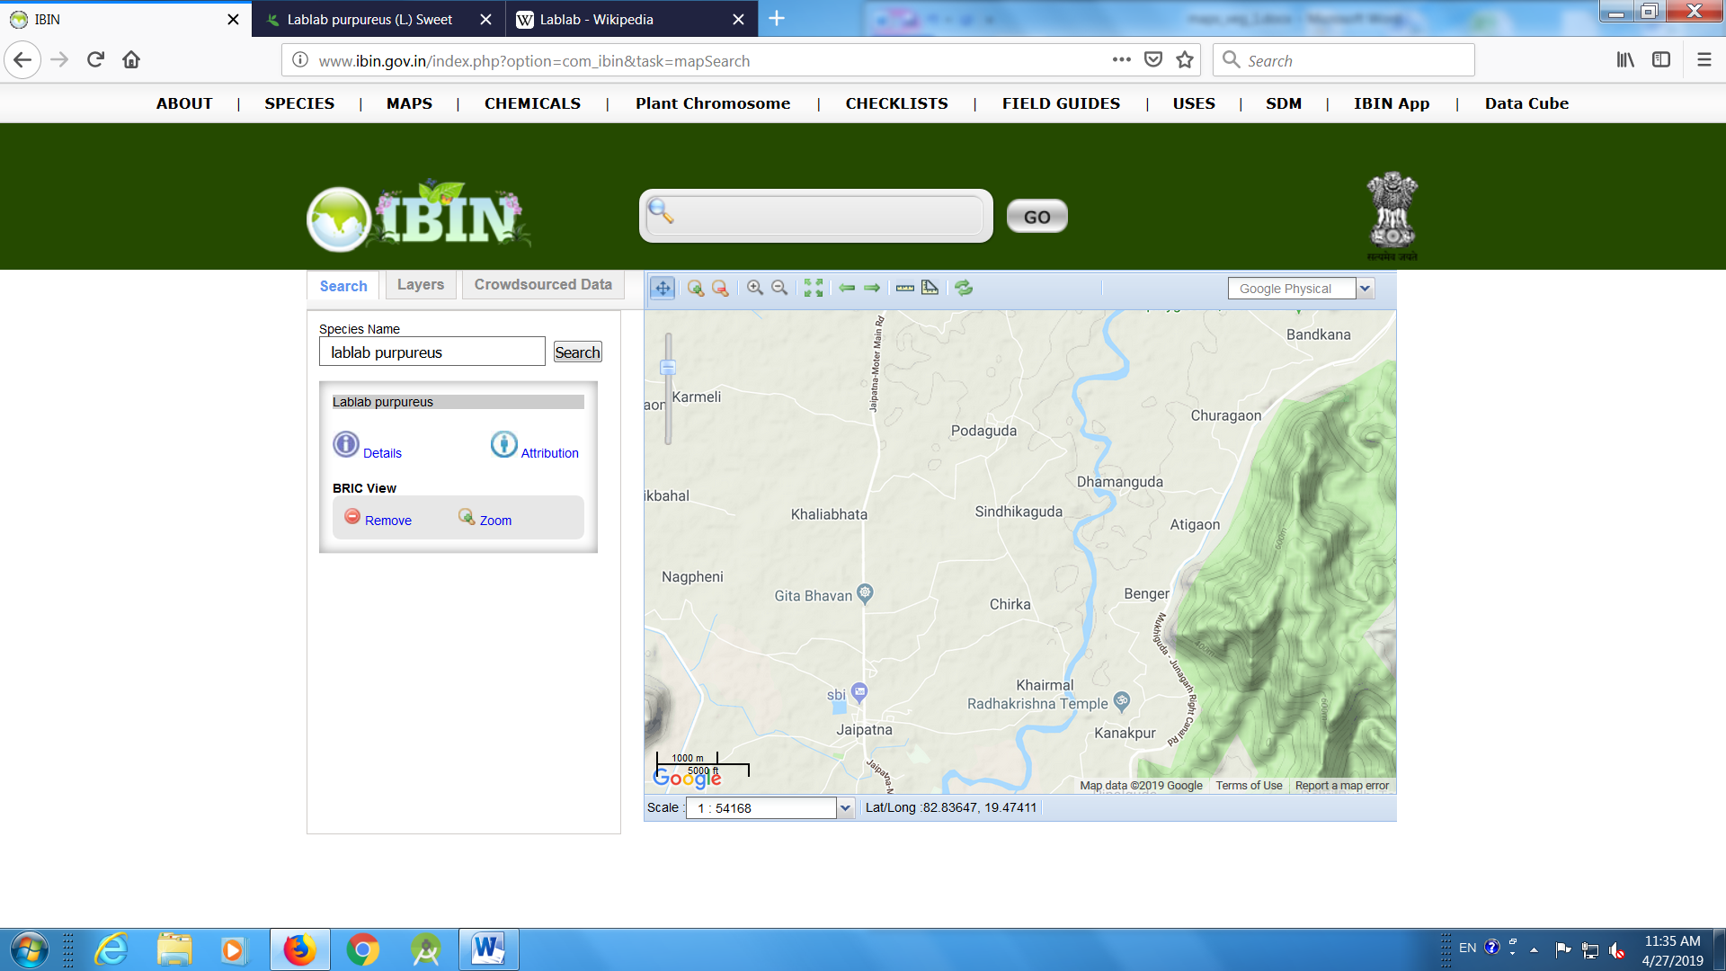
- Indian lettuce

nil

- Drumstick
https://www.gbif.org/species/3054181

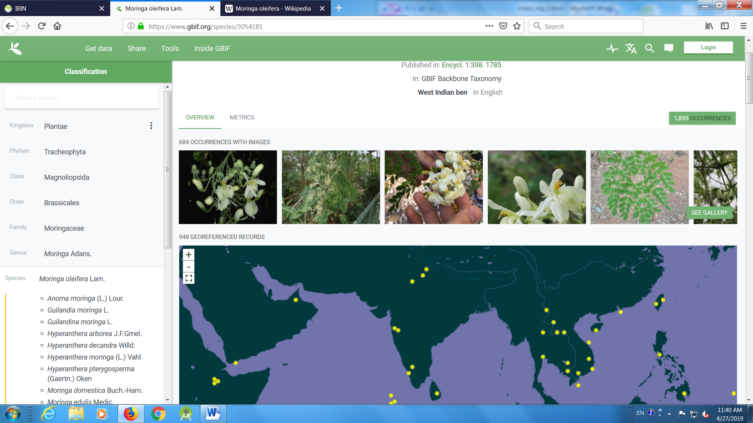

Secondary centre
- Cowpea
https://www.gbif.org/species/2982583
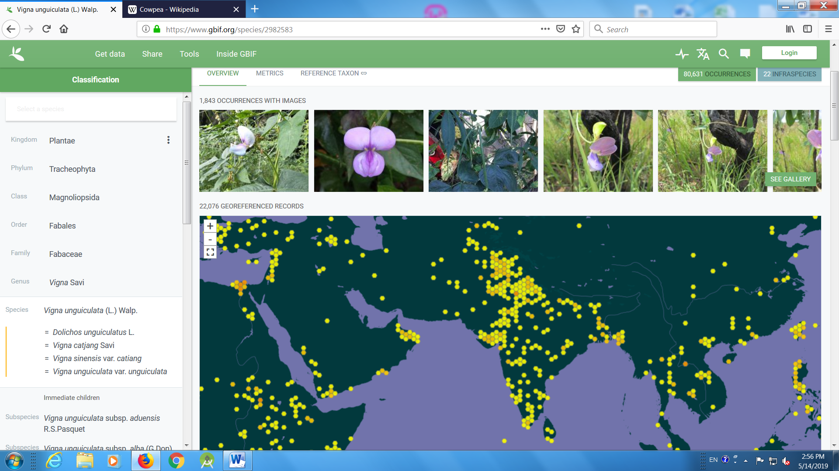
- Okra
https://www.gbif.org/species/3152707
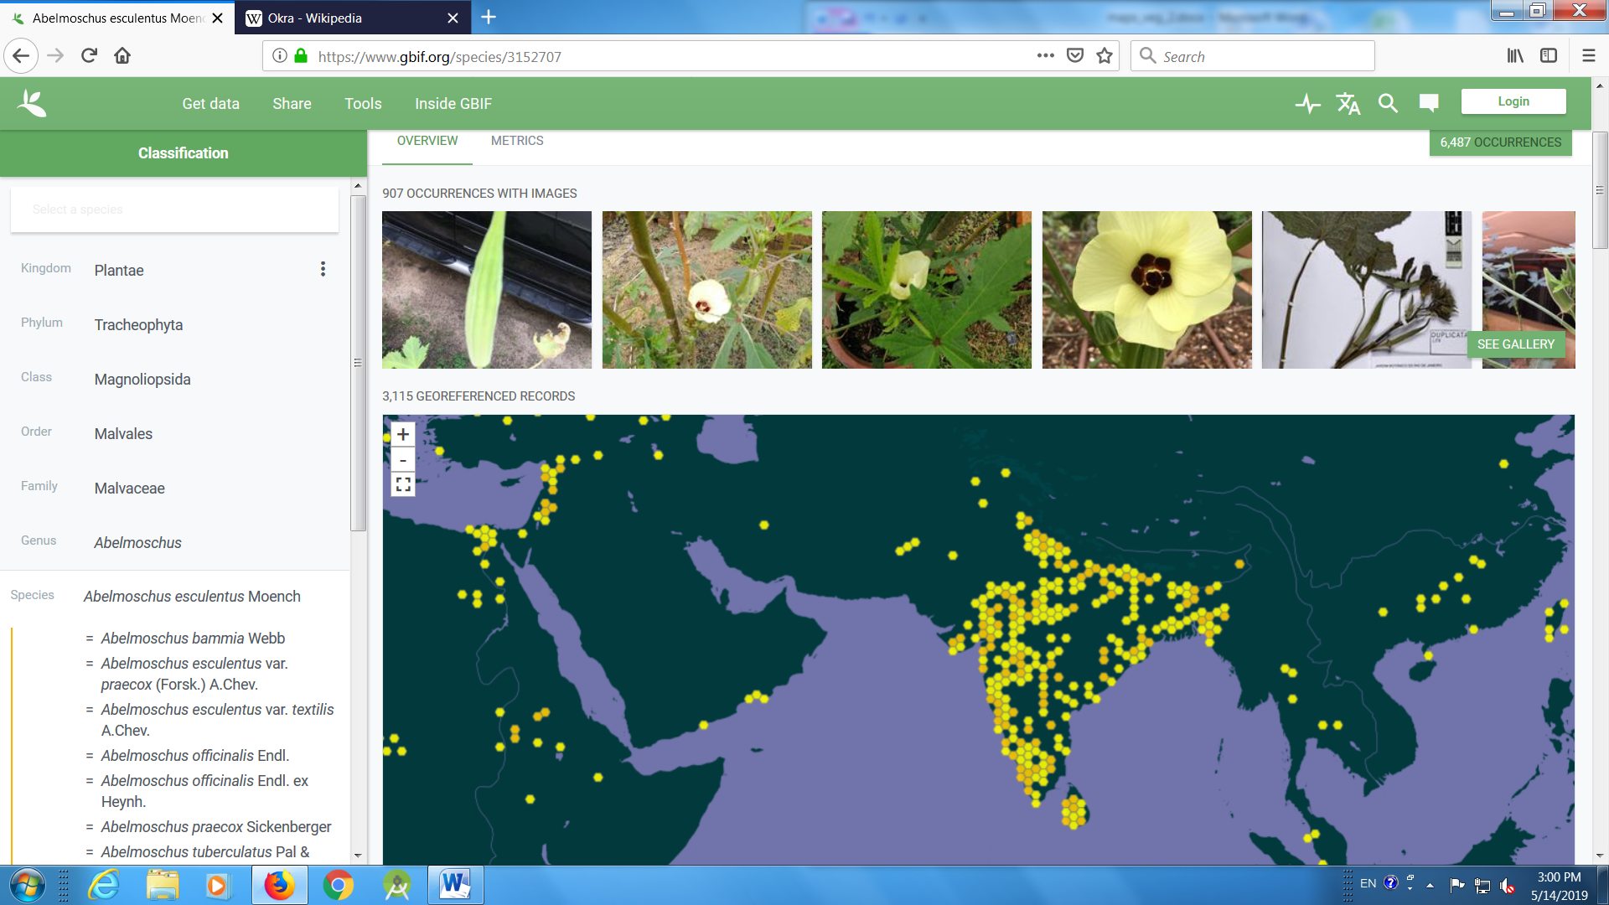

- Chilli
https://www.gbif.org/species/2932944

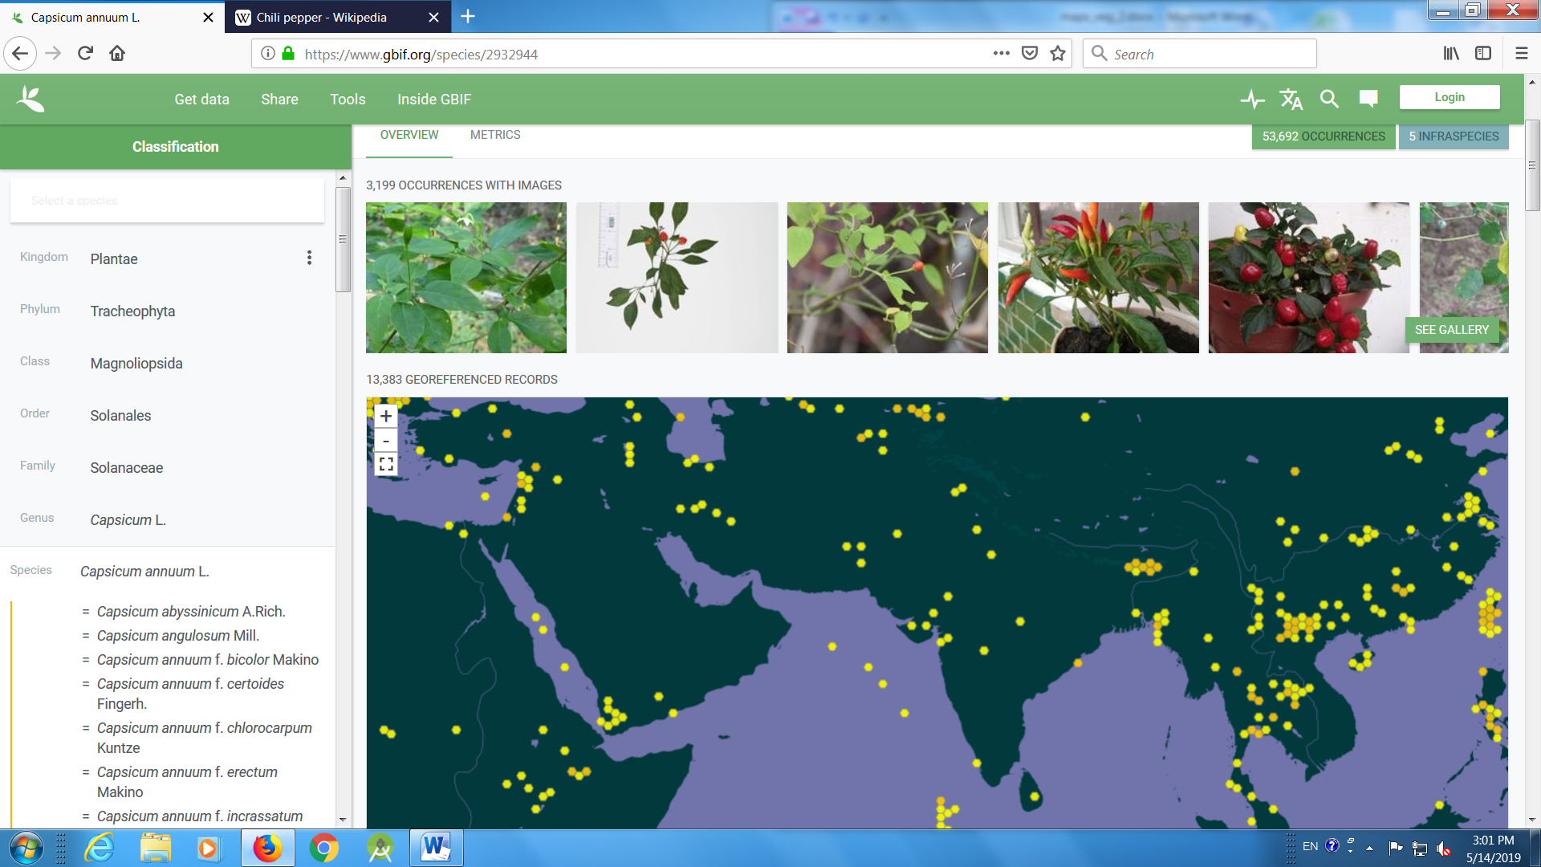

- Pumpkin
https://www.gbif.org/species/2874508

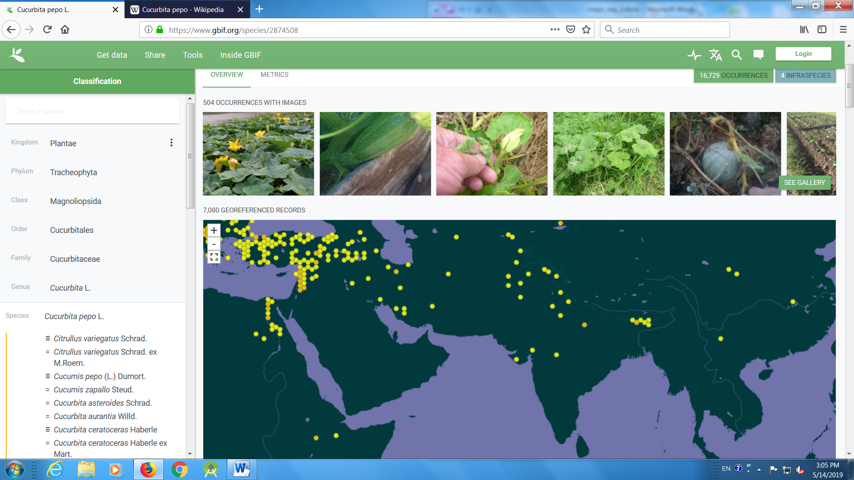
- Brassica
https://www.gbif.org/species/3042506

